Get started with Voice REST APIs
A quick guide for users on how to register on the Developer Portal, request for APPs and use the new ‘Try it out’ feature for Wholesale SIP (Number Management), Address Management, VAT validation & Billing APIs.

API Developer Portal
Our new API developer portal is a self-registration portal (a user must have a Colt Online login) and it contains detailed information about our APIs, including API endpoints, request and response formats, and usage guidelines. It's a central hub where developers can find all the information they need to understand, develop, and integrate our Wholesale SIP APIs smoothly.
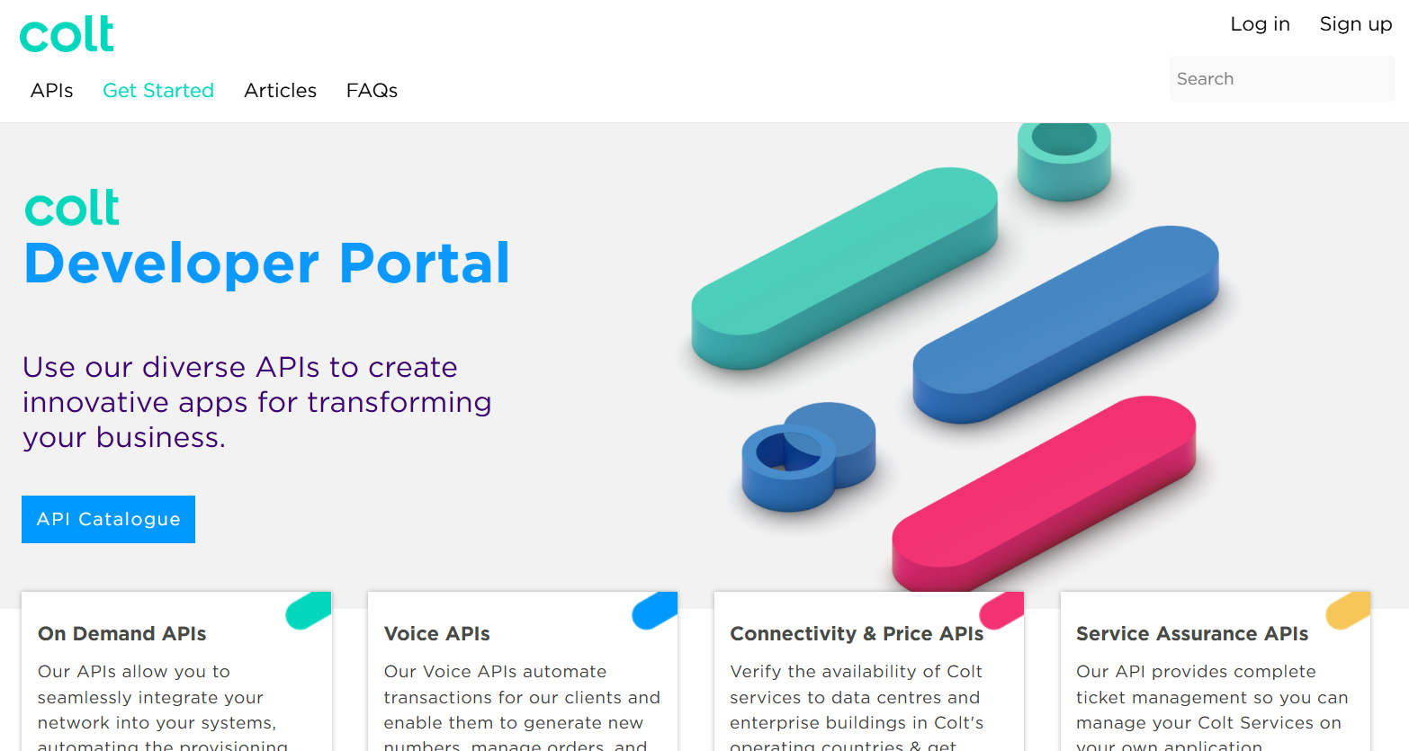
The portal will give guest users an overview of our API catalogue to spark their interest. As a registered API customer, a user can then view each API in detail, as well as try out our APIs in a sandbox (test) environment before launching their integrated service in our production (live) environment.

1.1 User Registration

New User registration
Colt API developer portal gives the option to ‘Sign-up’ and request API portal access.
- If you are already a Colt customer then select the option ‘Colt Customer Registration’. Your Colt Online account will be created and access to Colt’s developer portal will be provided
- If you are not a Colt customer and want to access the portal as a ‘Guest user’, please click on the option ‘Guest Registration’.
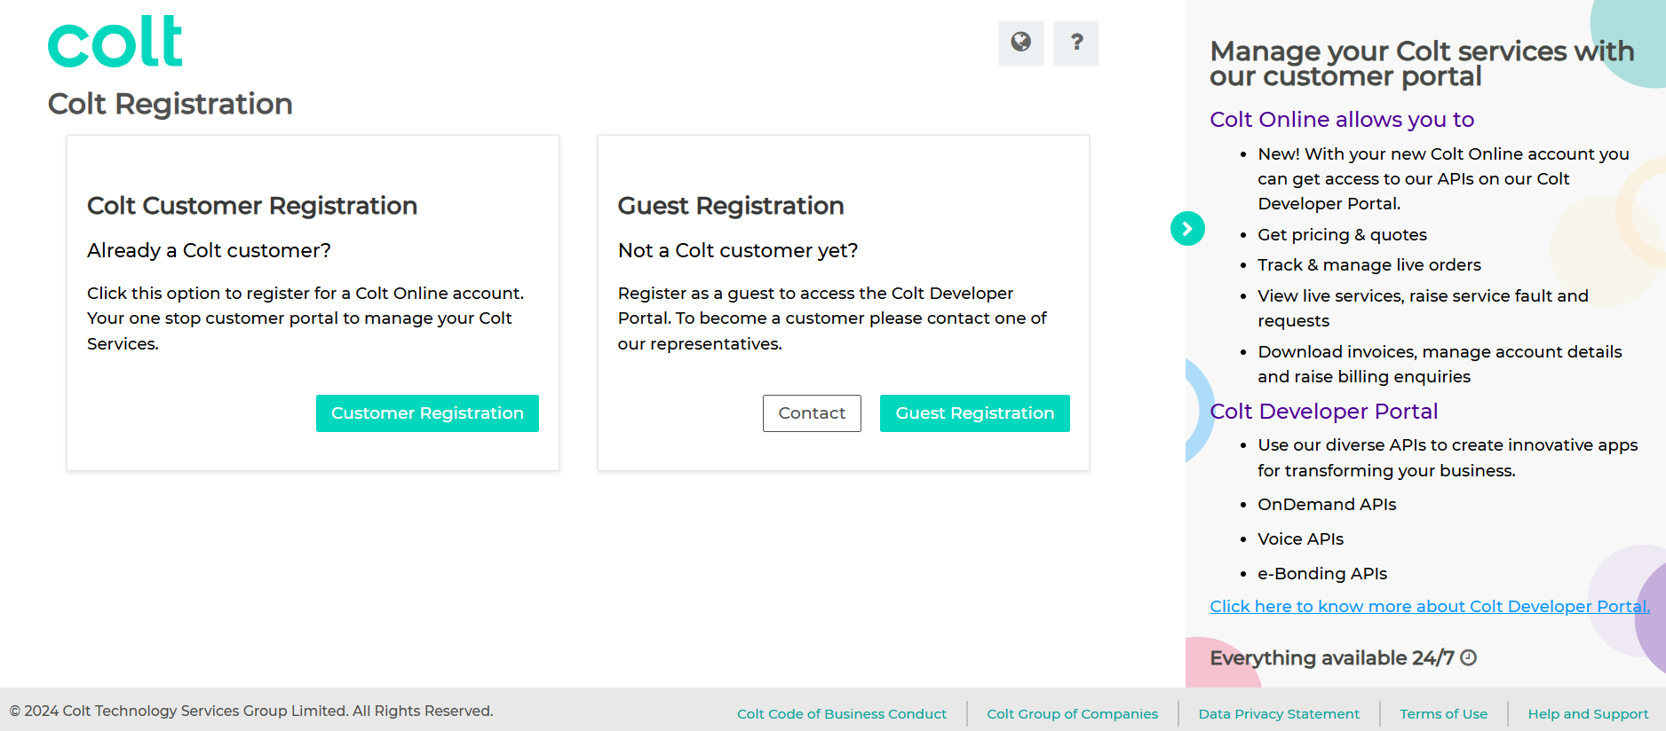

If you are an existing Colt Online User

If you already have Colt Online access, then login to Colt Online.
Under the ‘Tools’ menu, you’ll find the ‘Colt Developer Portal’ link.
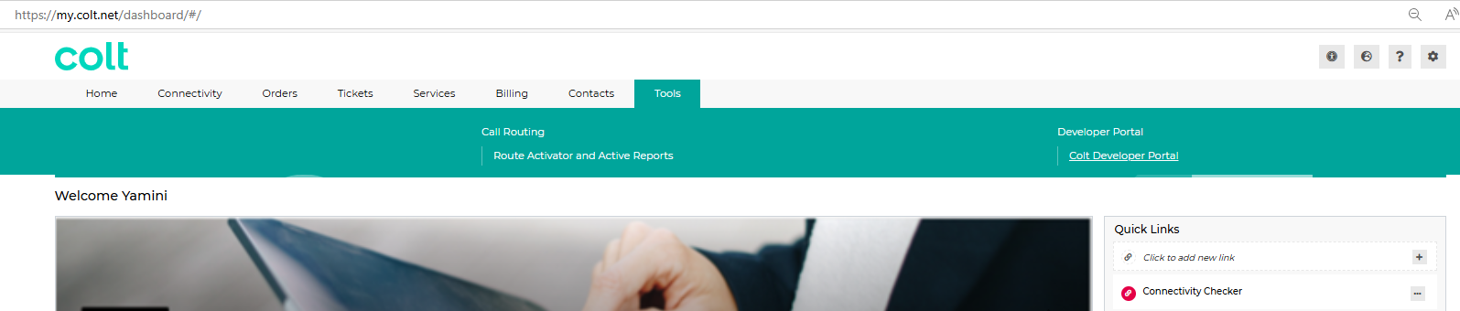
Click on this link and you will be redirected to the Colt Developer Portal. Click on ‘Log in’.
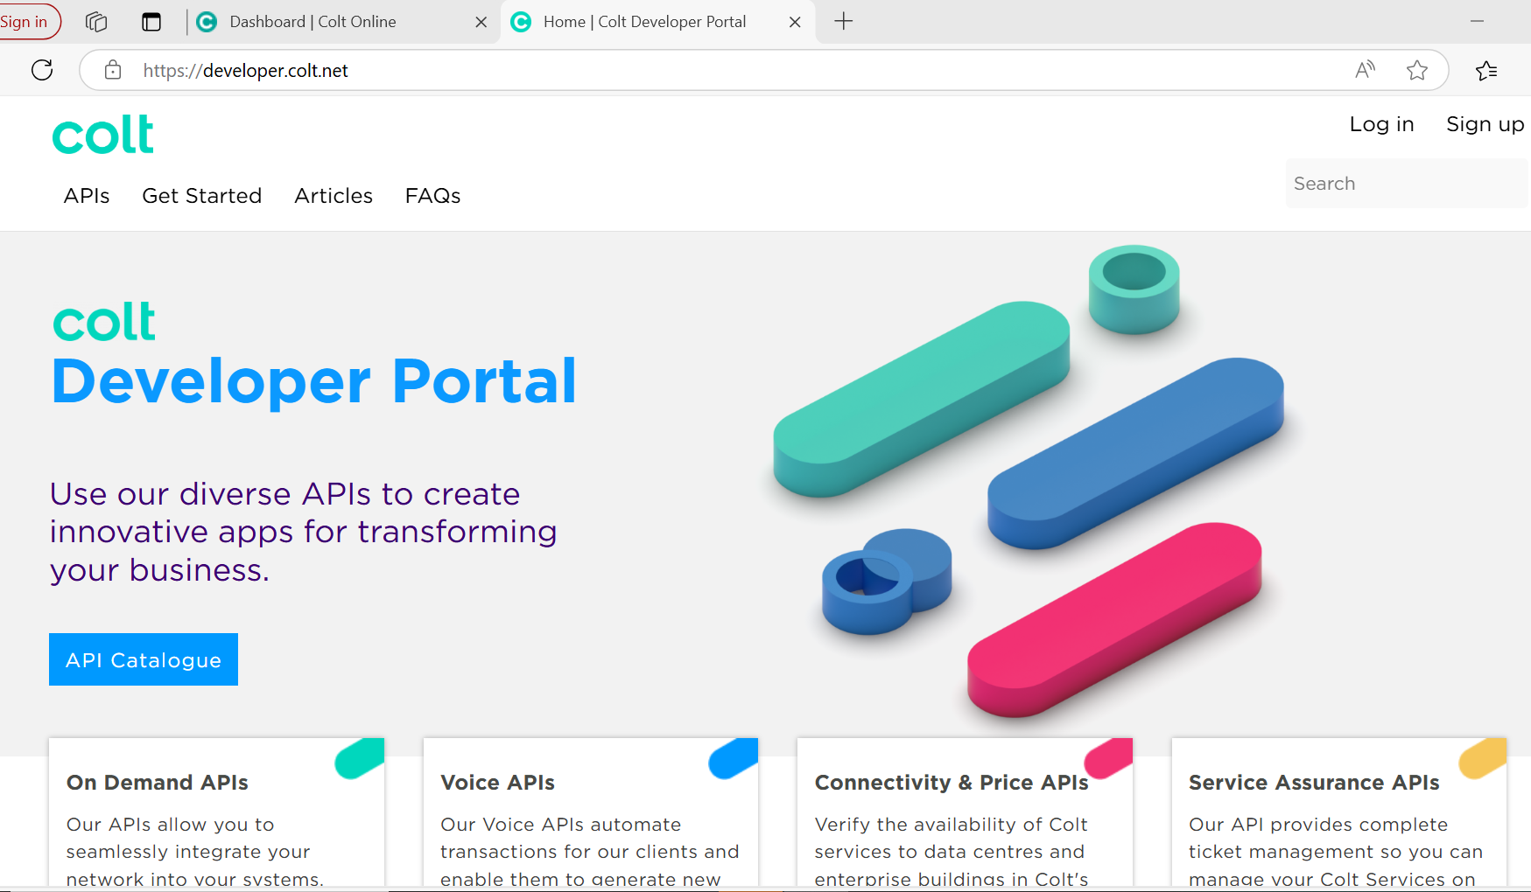

1.2 APP creation

In order to use the APIs, you need to request for an application using the ‘Apps’ option.
- First login to the Colt Developer Portal with your credentials.
- Click on the Apps icon in the Menu navigation in the top right corner
- Click on the Add APP button

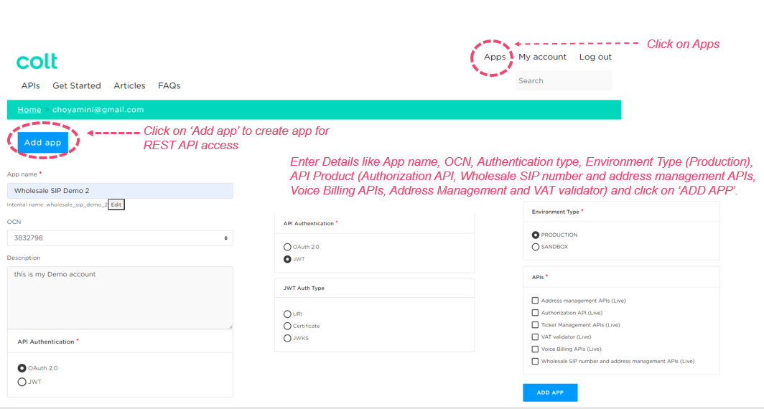

Your APP will be created and you can view it under the ‘Apps’ section. You’ll see your ‘Consumer Key’ and ‘Consumer Secret’ is created instantly.
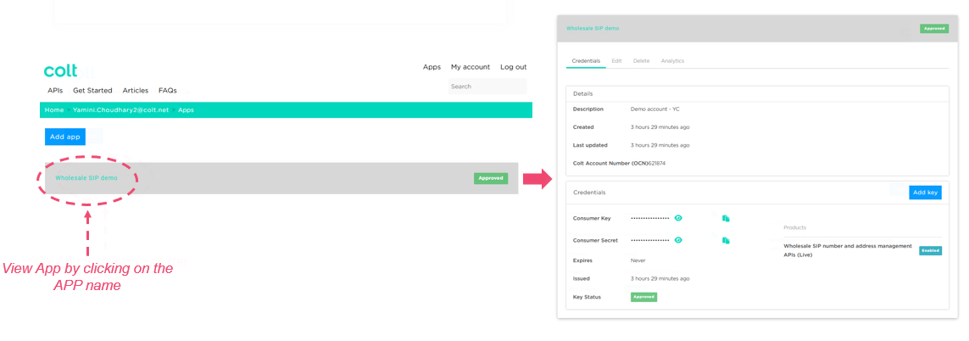
Please note:
- Your customer domain can have up to 5 Apps only.
- Your selected ‘Products’ will be visible as ‘Enabled’ – see example screenshot below.

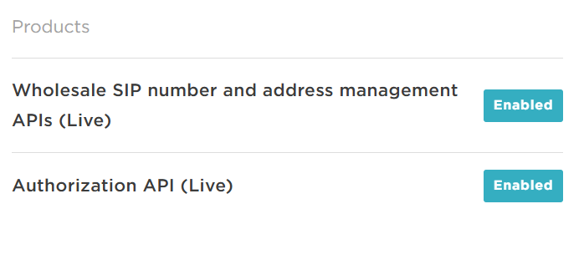
Go to the ‘APIs’ section to view the Wholesale SIP (Number Management), Address Management, VAT validation & Billing APIs and use the Voice Authorization API to generate the token and use this token to authenticate the API calls. You can download the OAS specification from the ‘API Document’ section.

1.3 Steps to generate OAuth 2.0 Access Token

- Navigate to the API Catalog to view the Voice Authorization- OAuth 2.0 API
- Click 'Access API' option to view the API and click on the Authorize button. A pop-up window appears to enter the authorisation credentials
- Enter your 'Consumer Key' in the Username field and your 'Consumer Secret' in the Password field
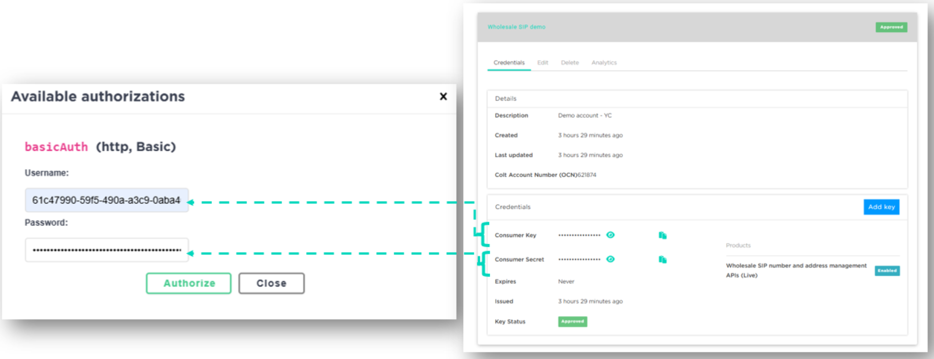
- Click the Authorize button
- Click the close button or close the popup window
- Click Try it out button against POST /token resource
- Enter the mandatory request parameters and click Execute button
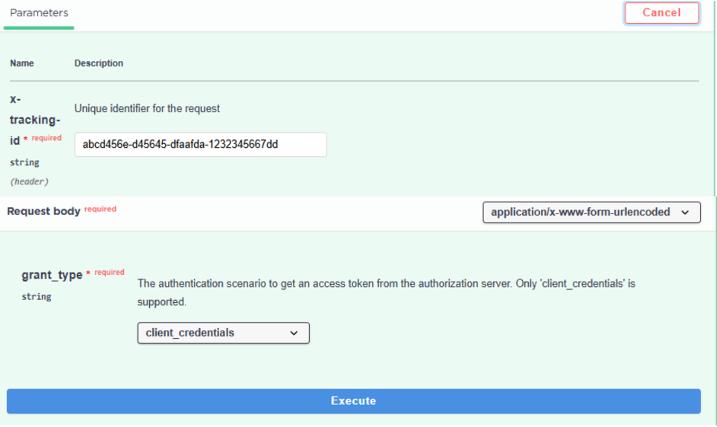
- The API response returns the JWT Access Token. Use the token to invoke subsequent functional APIs
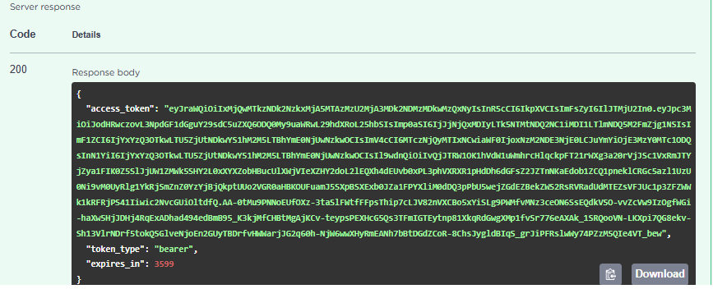

1.4 Steps to Invoke APIs using OAuth 2.0 Access Token

- Navigate to the API Catalog to view e.g. the Wholesale SIP Number Management API
- Click the 'Access API' option to view the API and click on the Authorize button. A pop-up window appears to enter the authorization credentials
- Enter the Access Token generated in the above step as the access token value and click the Authorize button

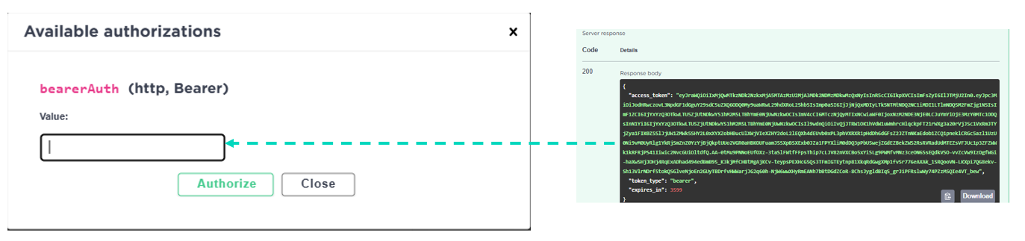

- Click close button or close popup window
- Click the Try it out button against the resource (for example: POST/v1/reservation/order resource)
- Enter the request parameters as per the API specification and click the Execute button
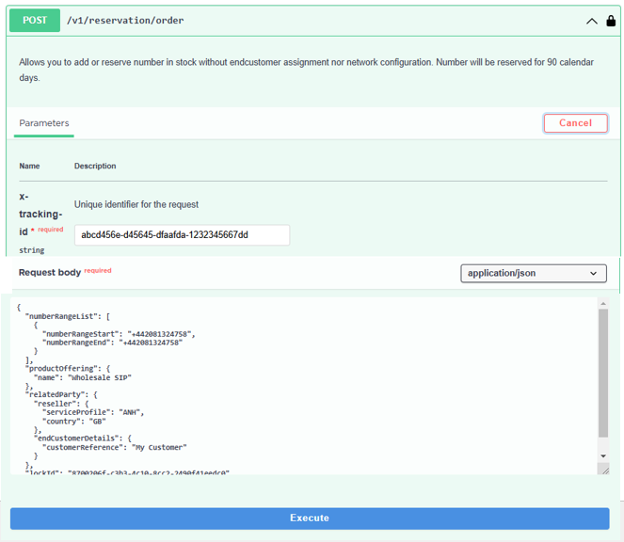

- The API is successfully invoked if the authorization credentials are valid and returns the response as per the API specification
- If you would like further help, under the API documents section you will find test requests & responses.

Glossary:
  - APP - Registered API developer account with unique Authentication credentials to access the subscribed APIs
  - API - Application Programming Interface

