Colt Number Hosting
19th Oct 2024 Release Notes

Introduction
This document describes the Colt Number Hosting 19th Oct 2024 release.
The release will focus on
- Address Management and Directory services update in Austria
- Spain Regulatory changes
- NOD & B2B API improvements including Port-In rejection code management (All countries exc NL)
These changes might imply development at your end, so please read this document carefully.
The changes in this release required your support during our test period. The Customer UAT ran from 9th Sept 2024 to 27th Sept 2024.

Document change control
Version | Change description
V1 | 19th Oct 2024 Release note
V2 | Updates in  - Sections Address Management & Directory Services in Austria and ES Regulatory changes - to show NOD UI changes.  - Section Numbers on Demand (NOD) and B2B API improvements for updated porting windows for Romania and NOD UI changes.  - Sections Appendix A: XSD (link 2) , Appendix B: API specifications (number management) and Appendix C: Rejection Codes with updated links (‘New Action’ column updates/clarifications).

Address Management & Directory Services in Austria

To ensure regulatory compliance in Austria, important changes relating to address management and validation, and directory services will be implemented as follows:
- New fields are added for AT are marked as ‘New’ in the table below. Some validation of existing fields will be updated. Fields which are changing are marked ‘Update’. Other fields are marked as ‘Remove’.
- Update EDB address and Directory Service Update are now clubbed together in an End-customer Address Update
- Final address verification and validation will be performed with Informatica Address Doctor v4

All changes are applicable in Austria (AT) for number Activation, new Port-In & Address Update operations. The fields are described in the table below:

Element | Description | Change | Current Type | Current Length | Updated Type | Updated Length | Customer Action
End customer Name and details
endCustomerName | It is the end customer name to whom numbers will be activated. | Update | M | L ≤ 80 | M | L ≤ 250 | Length increased to 250
buildingName | Name of the building | Remove | CM | L ≤ 50 | - | - | Field removed
premisesNumber | Number of the building | Update | CM | L ≤ 20 | M | L ≤ 20 | Field is mandatory
streetName | Name of the street | Update | M | L ≤ 50 | M | L ≤ 80 | Length increased to 80
cityTown | Name of the Town. | No change | M | L ≤ 50 | - | - | -
postalZipCode | postalCode | No change | M | L = 4 | - | - | Only Numeric characters allowed
block | (Building) block number or reference | New | - | - | O | L ≤ 3 | Only alphanumeric characters are allowed
stairs | Stairs number or reference | New | - | - | O | L ≤ 3 | Only alphanumeric characters are allowed
floorSuite | Floor number or reference | New | - | - | O | L ≤ 3 | Only alphanumeric characters are allowed
doorNumber | Door number | New | - | - | O | L ≤ 4 | Only alphanumeric characters are allowed
addressID | Either the complete address or addressID is required in the request | New | - | - | CM | L ≤ 20 | Either the complete address or addressID is required in the request
Directory services update (Optional Node)
orderType | Allowed values:  New  Cease  Amend | No change | M | LOV | - | - | Only ‘New’ value is applicable for Activation and Portin Activation Journeys and for Preactivated numbers activated in Modify with action ‘New’.  All 3 ‘New’, ‘Amend’ and ‘Cease’ values are applicable in Modify Operation when DSU changes required.
customerType | Type of Customer. Note we only support Business end-customers in AT | New | - | - | M | LOV | List of values:  Business  Residential  Mixed
endCustomerName | End customer name | New | - | - | CM | L ≤ 250 | Field added.  If customer Type is Business then ‘endCustomerName/Organization Name’ is Mandatory.  If customer Type is Mixed then either ‘end Customer Name’ or ‘First Name and Last name’ is Mandatory.
companyRegistrationNumber | Company Registration Number | New | - | - | CM | L ≤ 11 | Mandatory for customer type = Business
firstName | First Name of the residential customer | New | - | - | CM | L ≤ 50 | Field added.  If customer Type is Residential then ‘First Name’ and ‘Last name’ is Mandatory.  If customer Type is Mixed then either ‘end Customer Name’ or ‘First Name and Last name’ is Mandatory.
lastName | Last name of the residential customer | New | - | - | CM | L ≤ 250 | Field added.  If customer Type is Residential then ‘First Name’ and ‘Last name’ is Mandatory.  If customer Type is Mixed then either ‘end Customer Name’ or ‘First Name and Last name’ is Mandatory.
telephoneNumber | DSU Telephone number | Update | M | L ≤ 14 | M | L ≤20 | increase the length from 14 to 20.
isFaxNumber | Is the DSU Telephone number a Fax number? | New | - | - | O | LOV | List of values:  Yes  No(By Default)
businessSuffix | businessSuffix | New | - | - | CM | L ≤ 50 | Applicable only for Customer Type is either Residential / Mixed then Mandatory, otherwise empty
businessDescription | businessDescription | New | - | - | O | L ≤ 80 | New Optional field added
additionalInstructions | Additional notes/instruction | Update | O | L ≤ 250 | O | L ≤ 500 | Length increased to 500
notes |  | Remove | O | L ≤ 250 | - | - | Field removed
The Directory Services address (fields below) or the addressID is required in the request (New)
premisesNumber | Number of the building | New | - | - | M | L ≤ 20 | -
streetName | Name of the street | New | - | - | M | L ≤ 80 | -
cityTown | Name of the Town. | New | - | - | M | L ≤ 50 | -
postalZipCode | postalCode | New | - | - | M | L = 4 | Only Numeric characters allowed
block | (Building) block number or reference | New | - | - | O | L ≤ 3 | Only alphanumeric characters are allowed
stairs | Stairs number or reference | New | - | - | O | L ≤ 3 | Only alphanumeric characters are allowed
floorSuite | Floor number or reference | New | - | - | O | L ≤ 3 | Only alphanumeric characters are allowed
doorNumber | Door number | New | - | - | O | L ≤ 4 | Only alphanumeric characters are allowed
addressID | Either the complete address or addressID is required in the request | New | - | - | CM | L ≤ 20 | Either the complete address or addressID is required in the request

Numbers on Demand
Address fields (number activation, address update, portIn)
Current:
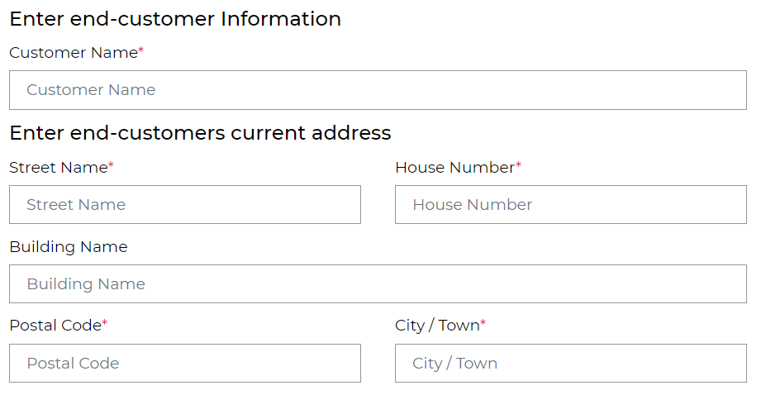

New:
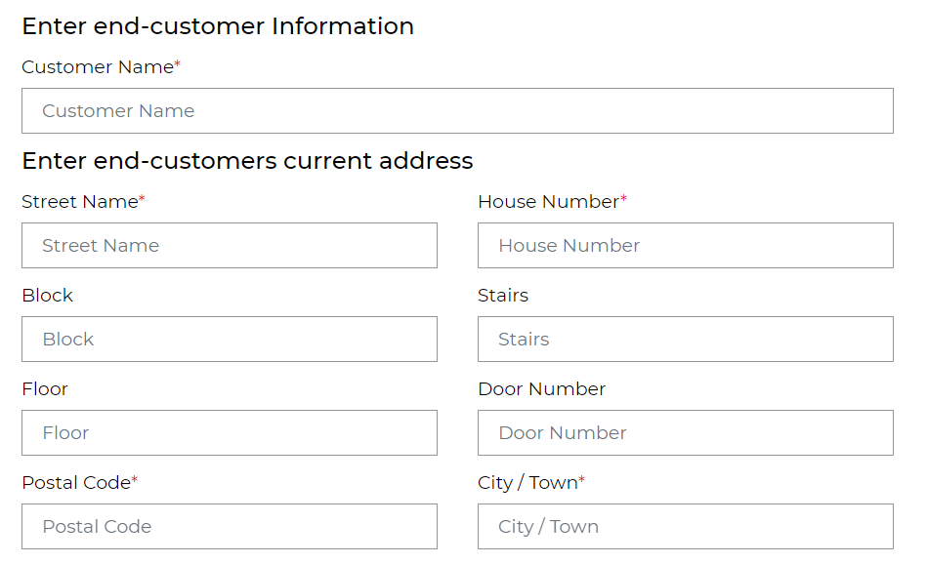
Directory Service Update
Today ‘My telephone number page offers ‘Directory Service Update’ action. This option will be removed.
Current:
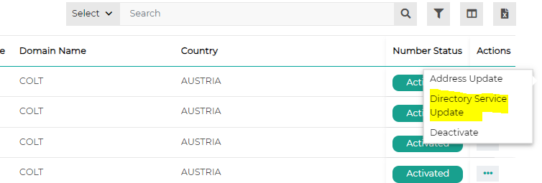
New:
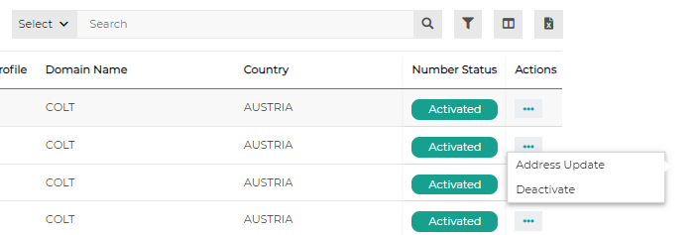
Directory service update fields (number activation, address update, portIn)
Current:
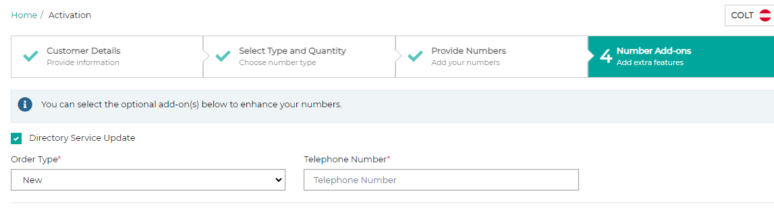
New:
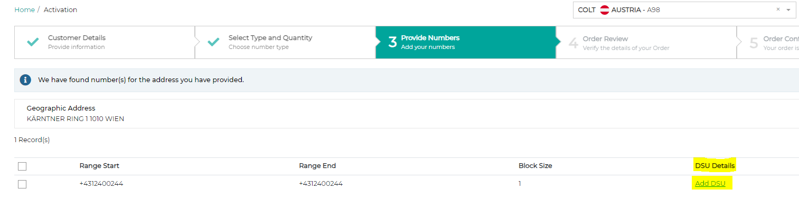
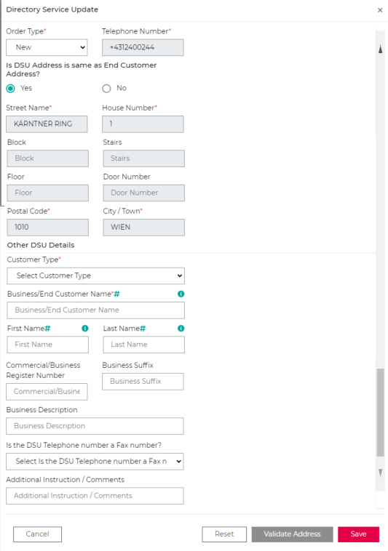

ES Regulatory changes

The consultation was approved earlier this year by the Regulator in Spain (CNMC) see here: (NUM/DTSA/3186/23 - SUBASIGNACIONES | CNMC), which simplifies the sub-allocation of numbers to resellers.
If you are not already notified or authorized in Spain by CNMC to provide electronic communication services, then you must do so by using this link:
https://sede.cnmc.gob.es/tramites/telecomunicaciones/registro-de-operadores-de-redes-y-servicios-de-comunicaciones
Once you are notified with CNMC, and if you have not already done so, please complete and sign the Spanish language version of the joint application form here.
An English version of the joint application form can be found here, for your guidance only.
This joint application form is signed by you & Colt and it permits you to sub-assign Colt’s numbers to your end-customers with no regulatory limit on the volume of numbers. You will be able to reserve and/or activate Colt numbers within minutes through our portal or using our APIs
In this release we are removing the old and now redundant Spain-specific system functionality from our NOD portal and our APIs to align with the latest regulatory changes.
Please note this is a code-breaking change - see details below:-
- You can reserve/activate numbers with blocksize =1, 10 or 100.
- ‘UsageType’ Field is removed from these flows:-
  - Number reservation
  - Number activation (direct)
  - Order Details will not return the ‘UsageType’ field in a response
- ‘SubAssignmentAgreement’ doc is no longer required for reservations and activations
- ‘Reservation Pending’ number status for Spain will be removed from
  - NOD- My Telephone Number Page
  - B2B APIs - numberEnquiry (SOAP/HTTPs), numberCollection (REST)

Numbers on Demand
Number reservation and Activation screens
Current:
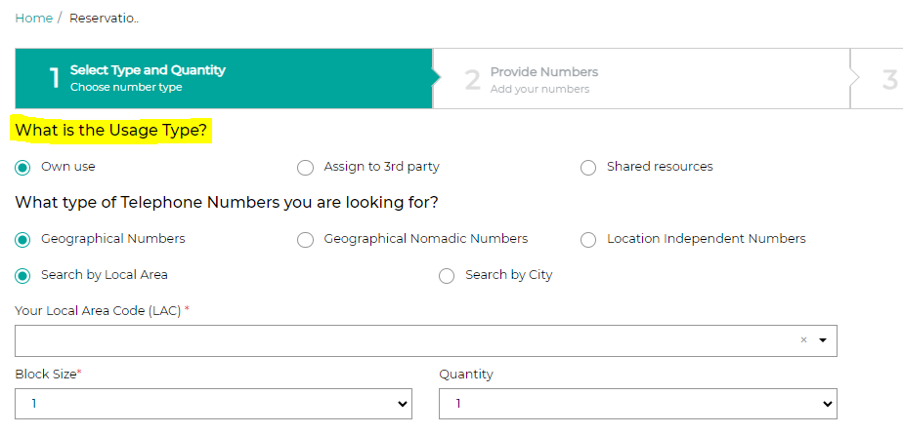
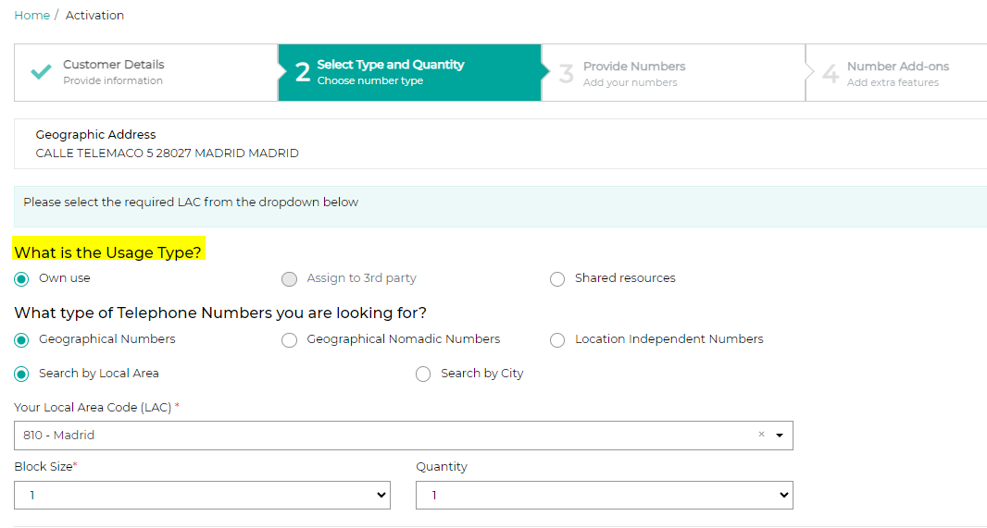
New:
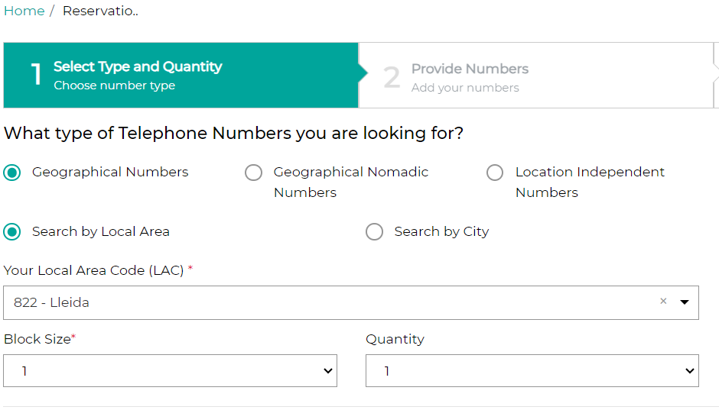
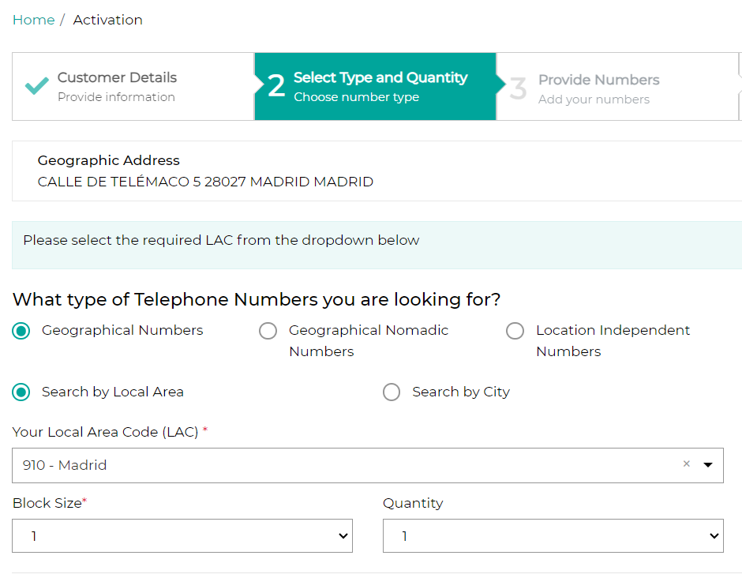

Numbers on Demand (NOD) and B2B API improvements

Below are 7 improvements targeted for release on 19th Oct 2024. Updated XSDs and API OAS specifications can be found in the Appendix A: XSD and Appendix B: API specifications.

Sr no | Functionality | Interface | Improvement Description | Country Scope | Code Breaking change for customer (Yes/No)
1 | Port-In Rejection Management | NOD and B2B APIs | Colt will send a New Rejection Code, a New Rejection Reason in the Order ID API response and in the callBack notifications.  The ‘Next Action’ will be added to the customer e-mail notification for port-in order updates and in order details screen (NOD only).  Please refer to Appendix C for a comprehensive list of updated port-in rejection codes & reasons. | All except NL | Yes
2 | Number Deactivation / reactivation | NOD and B2B APIs | When a deactivation is performed on a pre-activated number, the number should move from Activated to Quarantined.  When the number goes into quarantine, reactivation is also possible and the reactivated number will move to activated status. | IT, CH and Zone B countries | Yes
3 | Port-out orders  Accept/Reject  (DE Registered reseller) | NOD and B2B APIs | All DE port out orders raised by a registered DE reseller will move to ‘Customer Feedback Awaited’ status and will require confirmation/rejection from the registered DE reseller.  If no response received, an order will automatically move to Confirmed status after 5 working days | DE | No
4 | Activation  Deactivation  Address Update  Reactivation  Port-In  Port-Out | NOD and B2B APIs | If a failure occurs whilst updating the Emergency Database for the order types below, a message: “Your order is technically completed and pending for emergency database update" will be shared as a new Order Description. Order types are:-  - Activation  - Deactivation  - Address Update  - Reactivation  - Port-In  - Port-Out  Email notifications will be triggered for Port-In and Port-Out orders with the same message.  Post the successful completion of an order which reflects the successful update of the Emergency Database, the order description will be updated to: “Request has been processed successfully.” | All except DE, DK and Zone B | No
5 | View reseller data | COL | ‘Has Customer Owned Numbers’ = Yes/No field will be displayed in View Reseller Data screen. | FR | No
6 | Port-In  Update Port In order (Change date Modify Port) | NOD and B2B APIs | Porting windows are being refreshed for all Zone B countries.  Porting windows marked with * - there is no out-of-office hours’ support from the GSIP Voice Support.  Czech Republic  Current: 0900-1000, 1000-1100, 1100-1200, 1200-1300, 1300-1400, 1400-1500, 1500-1600 and 1600-1700  New: 0600-0700*, 0700-0800*, 0800-0900, 0900-1000, 1000-1100, 1100-1200, 1200-1300, 1300-1400, 1400-1500, 1500-1600,  1600-1700, 1700-1800*, 1800-1900*, 1900-2000*, 2000-2100* and 2100-2200*  Finland  Current: 1000-1100, 1100-1200, 1200-1300, 1300-1400, 1400-1500, 1500-1600 and 1600-1700  New: 0800-0900, 0900-1000, 1000-1100, 1100-1200, 1200-1300, 1300-1400, 1400-1500, 1500-1600, 1600-1700 and 1700-1800*  Luxembourg  Current: 0800-1100 and 1300-1600  New: 0000-0100, 0100-0200, 0200-0300, 0300-0400, 0400-0500, 0500-0600, 0600-0700, 0700-0800, 0800-0900, 0900-1000, 1000-1100, 1100-1200, 1200-1300, 1300-1400, 1400-1500, 1500-1600, 1600-1700, 1700-1800*, 1800-1900*, 1900-2000*, 2000-2100*, 2100-2200*, 2200-2300* and 2300-0000*  Norway  Current: 0900-1000, 1000-1100, 1100-1200, 1200-1300, 1300-1400, 1400-1500 and 1500-1600  New: 0800-0900, 0900-1000, 1000-1100, 1100-1200, 1200-1300, 1300-1400, 1400-1500 and 1500-1600  Poland  Current: 0900-1700  New: 0000-2359*  Romania  Current: 1000-1400  New: 0900-1300, 1300-1800 and 1400-1800  Slovakia  Current: 0900-1600  New: 0900-1200 and 1200-1800 | Zone B countries | Yes
7 | Address validation APIs | APIs and NOD | In Germany we have a very strict dependency between LAC and address. Also the emergency call routing is based on the address.  LAC and emergency Routing code must be identified via the coordinates of the address. Colt will get the coordinates internally via address doctor ADv4 and will allow to fetch the valid Local Area Code.  - validGeographicAddress API– no change in request and response structure. If coordinates are not fetched internally then the ‘validLAC’ will not be returned in the response.  - validateAddress REST API- returns geo coordinates (latitude/longitude) along with validated address in response. These coordinates can be used to fetch the validLAC using the fetchLACbyLocation API.  - fetchLACbyLocation REST API- Address is optional Germany but Geo Coordinates (will be returned in validateAddress API response) are required in the request to get the validLAC in response.  - AddressIDs returned in validGeographicAddress/validateAddress API response before 19th Oct release will be marked as Invalid. These addressIDs cannot be used post the release for activation/port-in/addressUpdate orders.  - If address is valid and LAC or coordinates are not retuned in response, please reach out to us with the valid address details. | DE | Yes (new REST APIs only)

Numbers on Demand UI changes:
Enhancement 1:
Order details page to reflect new field ‘New Action for Customer’ under Porting Details section.
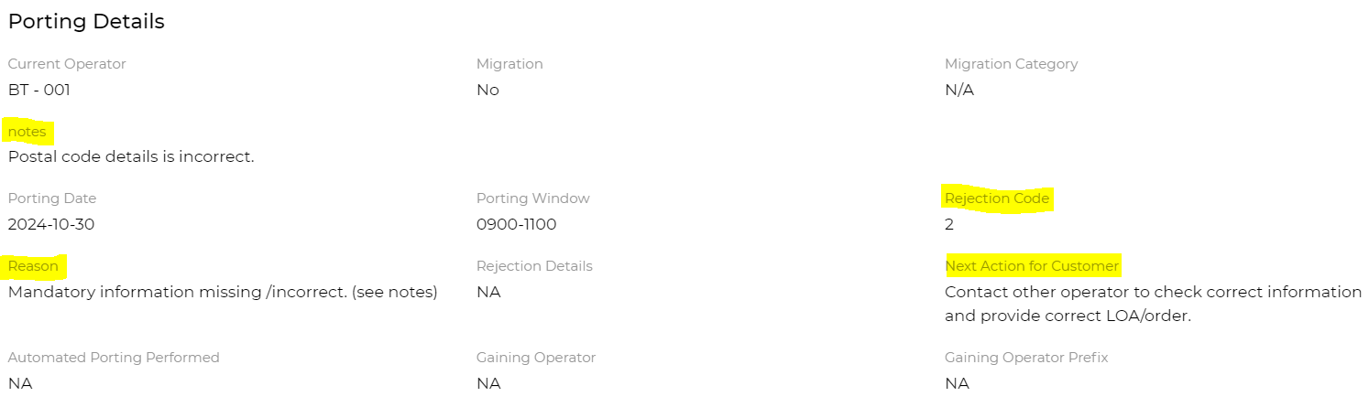

Appendix A: XSD

Please click link 1 and link 2 for updated XSDs

Appendix B: API specifications

OAS Specification for number management APIs

Please click here for the OAS Specification for Number Management APIs

OAS Specification for address management APIs

Please click here for the OAS Specification for Address Management APIs

Appendix C: Rejection Codes

Please click here for the new Rejection code and reason for all countries.

