Colt Wholesale SIP (Number Hosting) 9th August 2025 Release Notes

Introduction
This document describes the Colt Wholesale SIP (Number Hosting) 9th August 2025 release.
The release will focus on
- Introduction of Digital Letters Of Authorisation for porting in UK & France
- The ability for you to track requests for free numbers
- NOD and B2B API improvements
- Introduction of new fields for the VAT/Business ID check in Finland
These changes might imply development at your end, so please read this document carefully.
The changes in this release require your support during our test period. The Customer UAT is planned from 30th June 2025 to 4th July 2025. Please get in touch with NumberHostingUATSupportTeam@COLT.NET if you would like to participate in the UAT.

Document change control
Version | Change description
V1 | 9th Aug 2025 Release note
V2 | Updates made on 1st July to these release notes with more details of the following:-  - Change in the billing address node (UK)- updated in section Digital LOA (UK and France)  - Added more details of the external links which can be used to check for a valid Business/VAT ID - updated in section Introduction of new fields for Finland and VAT ID check  - Added NOD screenshots in sections Digital LOA (UK and France), Track requests for free numbers in NOD, Introduction of new fields for Finland and VAT ID check and Appendix C: Numbers on Demand UI changes  - Added sample API request and response in sections Digital LOA (UK and France) and Introduction of new fields for Finland and VAT ID check  - Updated OAS specifications- Appendix B: API specifications

Digital LOA (UK and France)
We are introducing a new optional Digital Letter of Authorization (DLOA) in this release. The DLOA is an electronic version of the traditional Letter of Authorization for port in requests and will allow your end customers to electronically sign the LOA using Docusign.
The DLOA is generated based on the information provided by you in the port-in order raised in our Numbers on Demand portal or over API. We will then generate the DLOA with the information you have populated in the order and send it to your end customer who must then sign it digitally. The signed DLOA will then be stored against the port in order for future reference.
This functionality is optional. If you have your own DLOA functionality then you can opt not to use this feature and to manually upload your end-customer’s LOA in our port-in order.
The DLOA is being rolled out in phases – it will be available for the UK and France in Aug’25, followed by Belgium, Spain and Italy in the target release of Nov’25.
The benefits of using the DLOA are:
1. Increased Efficiency
- Faster Processing: DLOAs can be created, sent, and signed instantly, cutting down the delays associated with manual workflows
- Automated solution: Easily integrates into digital workflows and systems
2. Improved Accuracy
- Template Standardization: Reduces errors by using a standardized digital form
- Quick Validation: the required fields are validated in real time
3. Enhanced Security
- Digital Signatures: Ensures authenticity and integrity of the document using DocuSign secure digital envelopes
4. Convenience
- Remote Access: End customers can authorise from anywhere, without the need to print, sign, and scan documents
- Device Compatibility: Can be signed on computers, tablets, or smartphones
5. Cost Savings
- Reduced Paper and Printing Costs: Eliminates the need for physical documents
- Lower Administrative Overhead: Less time spent on document management and mailing logistics

Current Port-In process / manual journey – no change
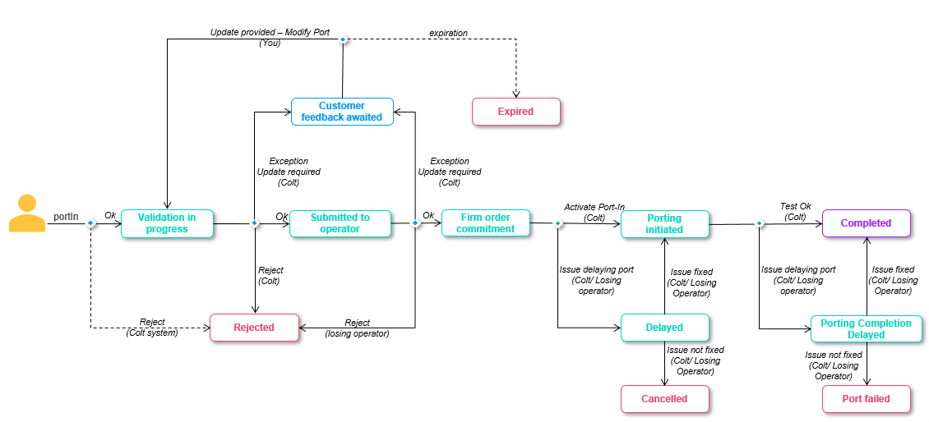

New DLOA Port-In process
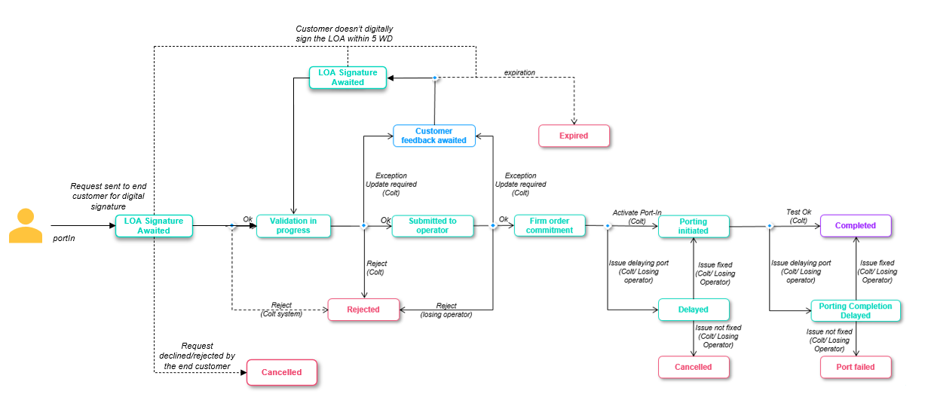
When you submit the portIn request using NOD/API with DLOA as ‘True’ or tick the flag in NOD, then
  - The request will move to ‘LOA Signature Awaited’ status
    - callBack API notifications, order details screen/API will be enabled with this new status
  - Your end customer will receive the port-in request for digital signature, using the end-customer’s email ID you provide in the port-in order.
The DLOA must be signed within 5 working days otherwise it will expire
  - If signed successfully, Colt will move the order to ‘Validation In progress’ status and our porting desk will receive the order for validation.
    - You will be notified by email (and by callBack if in use) regarding this
    - We will automatically update the porting date if we see that the porting date no longer adheres to the porting lead time (e.g. if the end customer is taking time to sign the DLOA) and you’ll find the details in the email notification and order details.
  - If the DLOA is not signed by the end customer and the link expires after 5 days, then the port-in order will move to ‘Expired’ status.
    - You will be notified by email (and by callBack if in use) regarding this
  - An end customer can also decline/reject the DLOA signature request from their end. In this case the port-in order will move to ‘Cancelled’ status.
    - You will be notified by email (and by callBack if in use) regarding this
  - The Porting Desk can put the order into ‘Customer Feedback Awaited’ status like today to get more details from you. If you update the telephone number (Add new numbers, modify/remove existing numbers) in the ‘Modify Port’ request, the request will again go to your end customer for DLOA signature and the order status will be ‘LOA Signature Awaited’.

Sample emails
DLOA Signature:
- Email to reseller-
Subject line: Porting Letter of Authorization - Order ID : {orderId}
Email content:
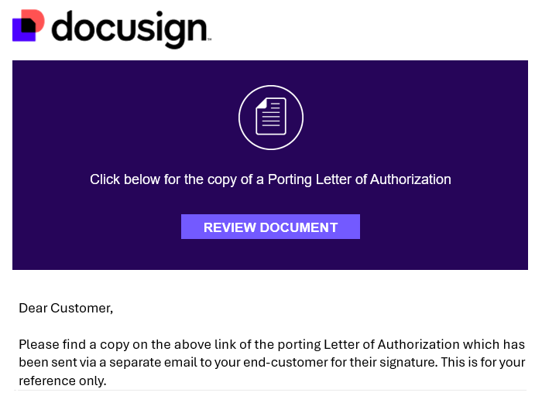
- Email to end customer-
Subject line: Porting Letter of Authorization - Order ID : {orderId}
Email content:
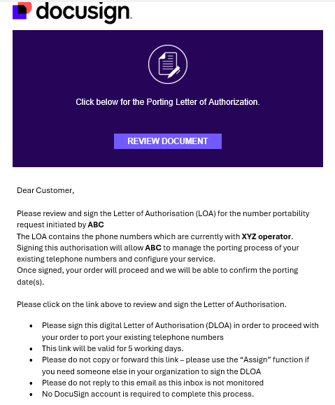

DLOA successfully signed by the end customer
- Email to reseller and end customer-
Subject line: Completed: Porting Letter of Authorization - Order ID : {orderId}
Email content:
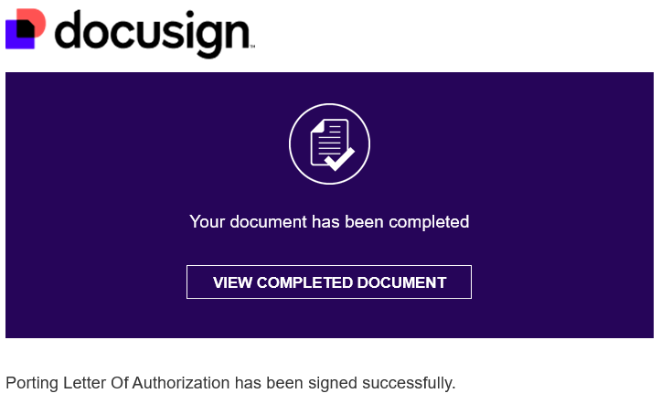

DLOA declined by the end customer
- Email to reseller and end customer-
Subject line: Declined: Porting Letter of Authorization - Order ID : {orderId}
Email content:
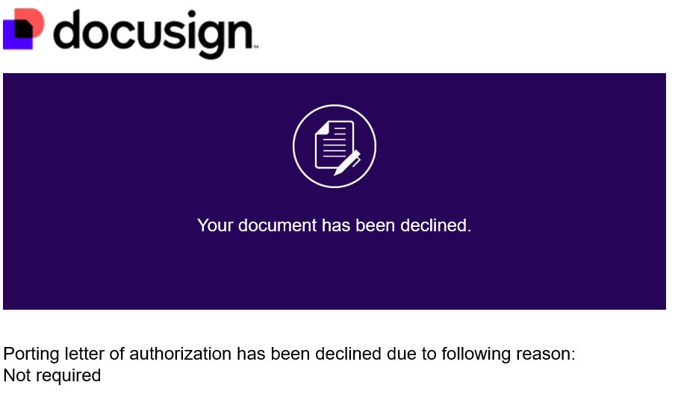

DLOA link expired after 5WD
- Email to reseller and end customer-
Subject line: Voided: Porting Letter of Authorization - Order ID : {orderId}
Email content:
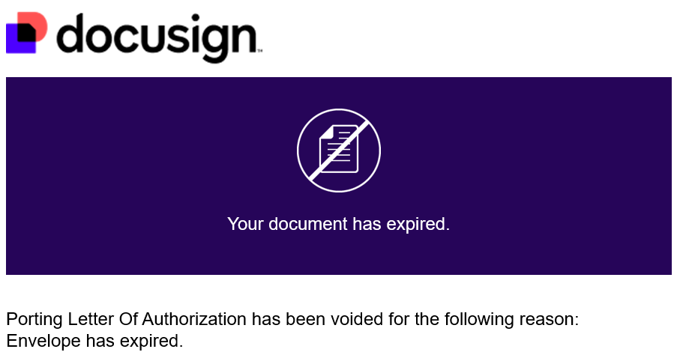

DLOA email and link
Email Link Expiry: Links in the email notifications will expire after 48 hours or after more than 5 consecutive clicks
If a link expires, the end customer/signee gets an option to ‘Send New Link’. The end customer/signee will receive a new email with the new link
DLOA expiry: The DLOA will expire 5 working days after it is sent to the end customer/signee. If the DLOA is not actioned by the end customer within 5 working days, the port-in order will be ‘Expired’ and the DLOA will also expire. An expired DLOA cannot be viewed or signed.
How the DLOA works is shown below:-
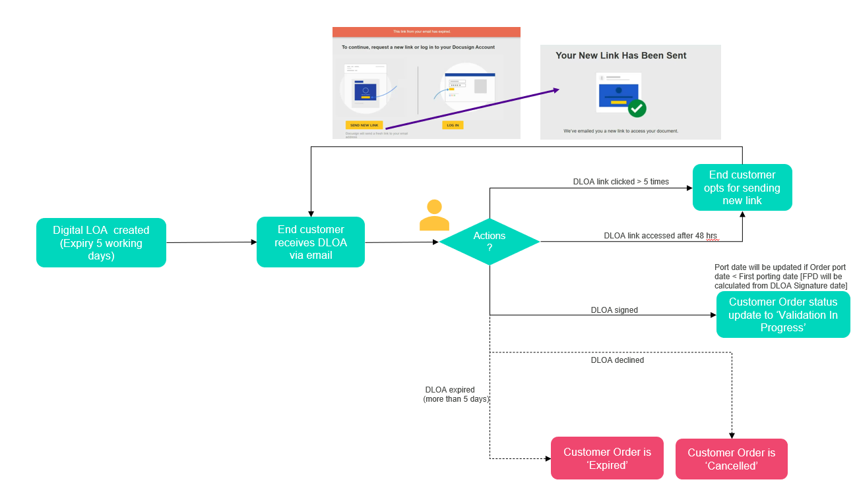

NOD and API impacts:

The DLOA is an optional feature and you have an option to continue with the manual process or opt for the new DLOA journey.
Impacted Functionality:
- NOD: Port -in, Modify Port and Bulk Port In
- new Apigee APIs: POST/v1/portIn/order and POST/v1/portUpdate/order
Please note that DLOA feature will not be available for existing SOAP/HTTPS and REST portIn APIs. There are no mandatory changes which impact you if you’re using existing SOAP/HTTPS and REST portIn APIs.

GB (United Kingdom)

Field level details
Fields/sections | Impact | Manual Journey | DLOA Journey
Digital LOA / digitalLetterOfAuthorityFlag | New Optional field  NOD: Digital LOA  Tick box  (Default: Unticked/ Manual)  Apigee API: digitalLetterOfAuthorityFlag  Allowed values: True, False (Default) | If the flag is not ticked on NOD or no value/ ‘False’ is sent in the API request, then the existing manual process will continue. | If the flag is ticked or the value is sent as ‘True’ in the API request, the DLOA journey will be initiated.
Customer Name / endCustomerName | No Change | Mandatory | Mandatory
Company Registration Number / companyRegistrationNumber | New optional field for DLOA journey only | Not applicable | Optional
End Customer current address | No Change | Mandatory | Mandatory
End Customer new address | No Change | Optional | Optional
End Customer billing address  (can be same as the current address or any country address can be entered) | New Optional field/node  NOD: House Number, Billing Street, City/ Town, Post Code, Country  Apigee API: billingHouseNumber, billingStreet, billingCity, billingPostCode, billingCounty | Not applicable | Optional
Telephone Numbers | No Change  max 20 single numbers/ ranges | Mandatory | Mandatory
Telephone Numbers | Update  Current behavior: both Geo and Non Geo numbers are accepted within the same request  New behavior: either Geo or Non Geo will be accepted in the request. A combination of geo/non-geo will not be allowed | New Mandatory change | New Mandatory change
Main Billing Number (MBN) | Update  NOD: Main Billing Number  Apigee API: rangeMainBillingNumber  Current behavior: Main Billing Number is mandatory for both Geo/Non Geo numbers  New behavior: Main Billing Number is now mandatory for Geo numbers only. | Main Billing Number is now mandatory for Geo numbers only. | Mandatory for Geo numbers only
Billing Account Number | New conditional mandatory field  NOD: Billing Account Number  Apigee API: rangeMainBillingNumber | Mandatory for Non-Geo numbers only | Mandatory for Non-Geo numbers only
Single or Multi Line | No Change | Optional | Optional
Directory Service Update (DSU) | No Change | Optional | Optional
Letter of Authorization | No Change for manual journey  Not required for DLOA journey | Mandatory | Not applicable
Invoice Document/ Supplementary Form | No Change | Optional | Optional
Porting Date | No Change | Mandatory | Mandatory
Porting Window | No Change | Mandatory | Mandatory
Current Operator | No Change  NOD: Current Operator  Apigee API: currentOperator | Mandatory | Mandatory
Operator Email ID | New mandatory field for DLOA journey only | Not applicable | Mandatory
Operator Name | New conditional mandatory field for DLOA journey  If Current Operator is ‘Others’ then you need to provide ‘Operator Name’ in the request  NOD: Operator Name  Apigee API: digitalLetterOfAuthorityDetails currentOperatorName | Not applicable | Conditional Mandatory
Notes | No Change | Optional | Optional
Porting Contact details (port update notifications are sent to the email address present in this section) | No Change | Optional | Optional
Digital LOA details / signatoryDetails  (your end customer will receive the DLOA for signature via DocuSign- the email ID must be of the customer’s signatory because the docusign email cannot be forwarded on by the end-customer) | Mandatory for DLOA journey  Sender details (you will be the sender of the email triggered to the end customer and the details provided below are what your end customer will see. This is an optional node- if not provided, it will automatically fetch sender details from Colt’s database)  NOD: Your Company Name (M) and Your Email Address (M)  Apigee API: senderCompanyName (M), senderEmail (M)  Recipient/Signing Authority details (your end customer who will receive the LOA for digital signature)  NOD: First Name (M), Last Name (M), Title (M) and Email ID (M)  Apigee API: signingAuthorityFirstName (M), signingAuthorityLastName (M), signingAuthorityTitle (M) and signingAuthorityEmail (M) | Not applicable | Mandatory
Customer Reference | No Change | Optional | Optional

NOD screen changes:
A new checkbox for the ‘Digital LOA’
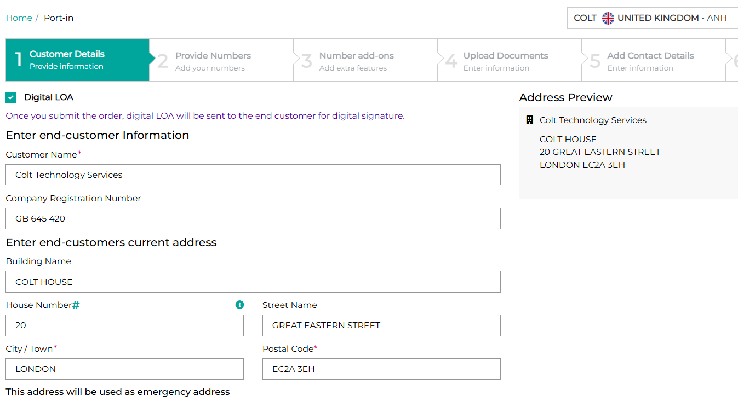
You can select if the Billing address is the same as the end customer current address or not:
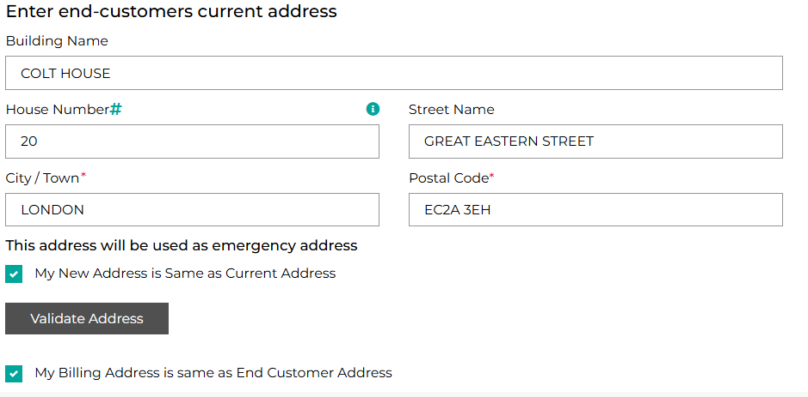
You can select if the Billing address is different from the end customer’s current address:
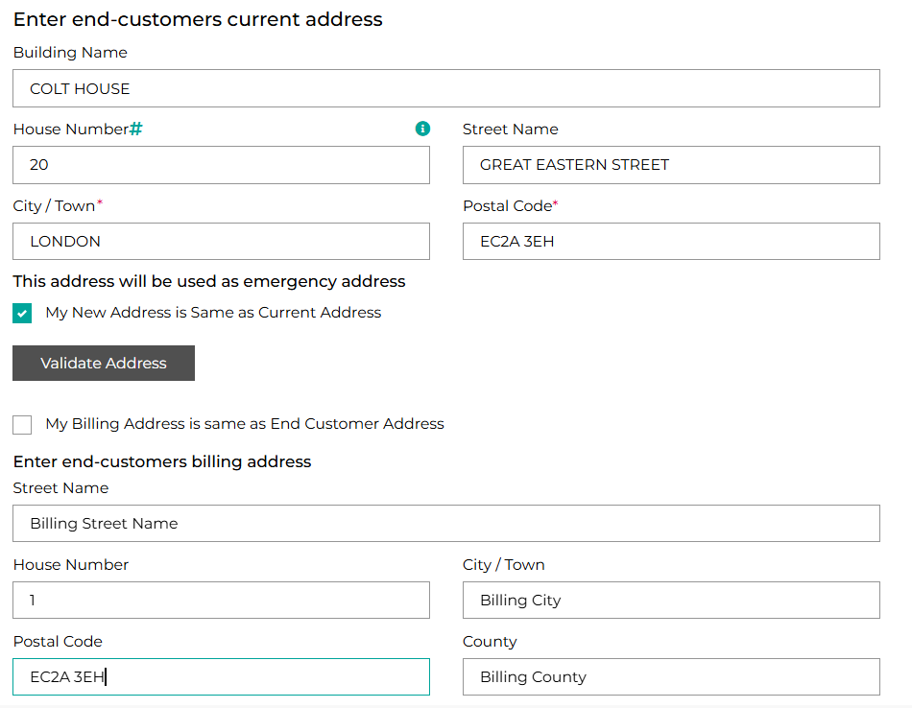
Note a combination of Geo and Non Geo numbers are not allowed in the same request:
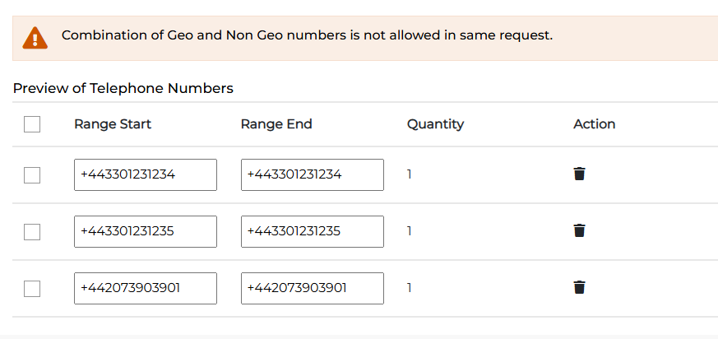

For Geo numbers, the Main Billing Number is required:
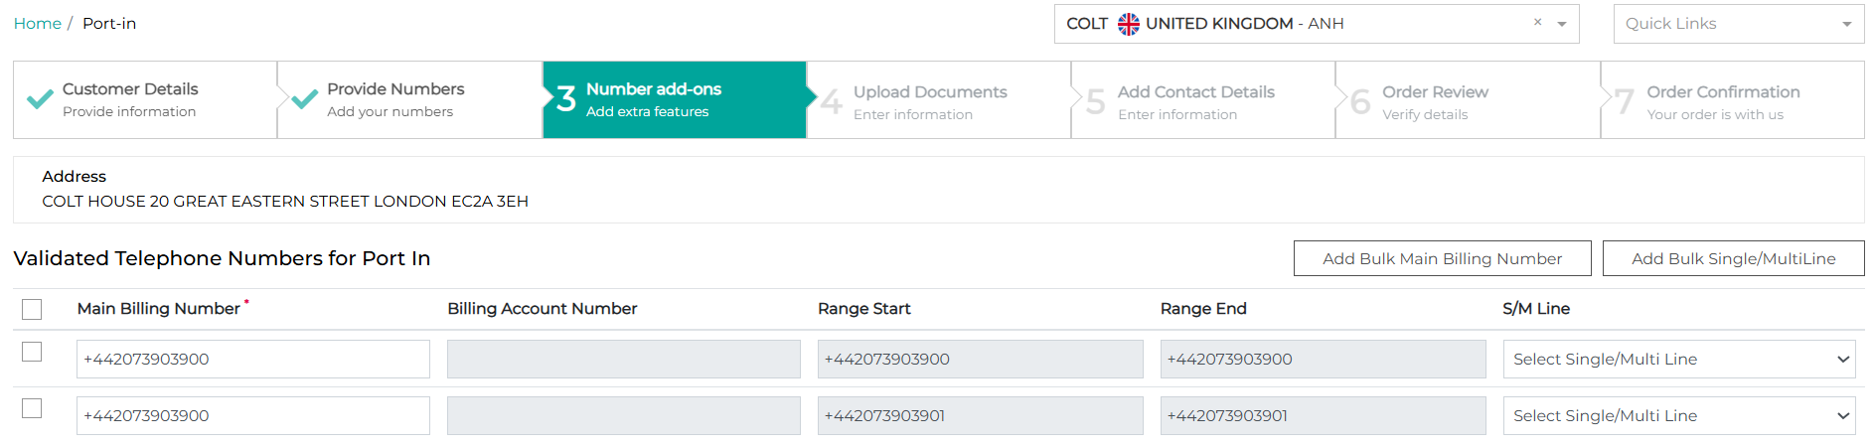
For Non Geo numbers, the Billing Account Number is required:
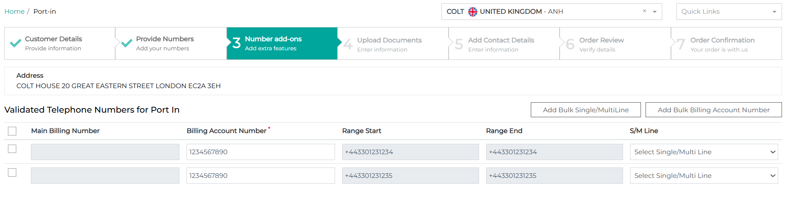
A new field of ‘Operator Email Address’ is required:
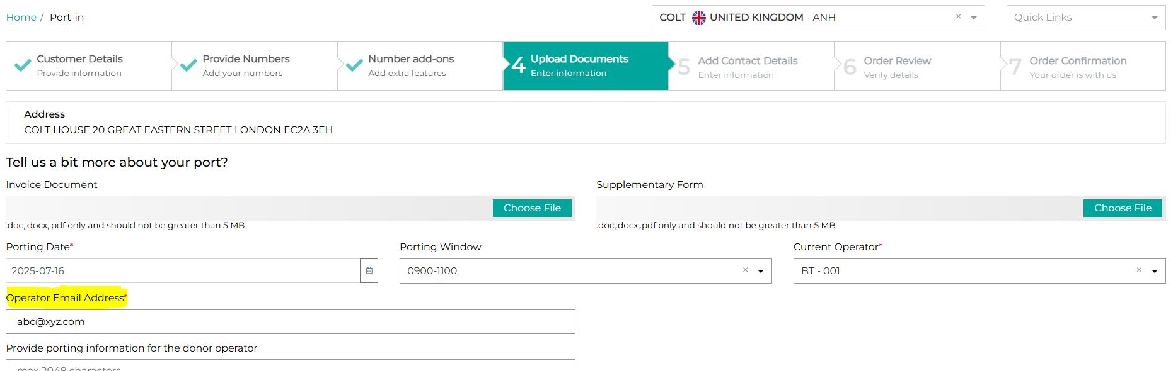
You will need to provide your details as the sender (which your end-customer will see) and also the details of your end-customer who is the recipient & signs the Digital LOA:
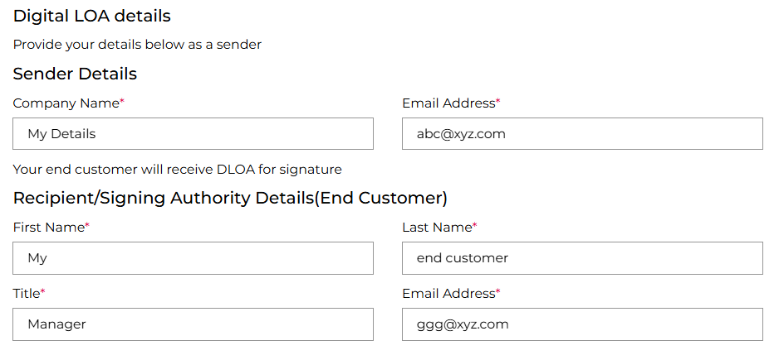
Your end customer will receive the Digital LOA and you’ll receive a copy of it. Your end customer then needs to open the link to review and sign the LOA.

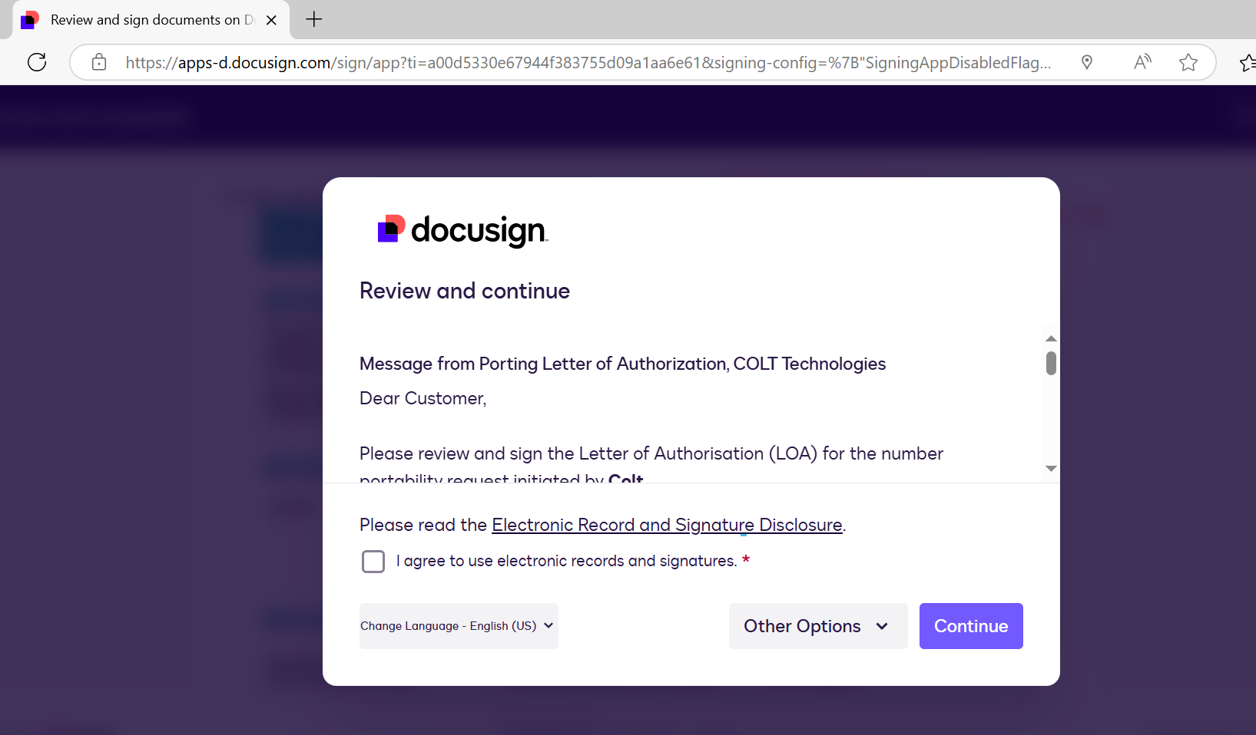

Sample API request and response

Request | Response
{  "numberRangeList": [  {  "numberRangeStart": "+442076333020",  "numberRangeEnd": "+442076333029",  "rangeMainBillingNumber": "+442076333020"  },  {  "numberRangeStart": "+442076333030",  "numberRangeEnd": "+442076333030",  "rangeMainBillingNumber": "+442076333030"  }  ],  "portDetails": {  "portingDate": "2025-07-02",  "portingWindow": "0900-1100",  "portingContact": {  "firstName": "My",  "lastName": "Customer",  "phoneNumber": "+447394472749",  "email": "MyCustomer@abc.com",  "mobileNumber": "+447394472749",  "fax": "+447394472749"  },  "currentOperator": "BT - 001",  "digitalLetterOfAuthorityFlag": true,  "digitalLetterOfAuthorityDetails": {  "currentOperatorName": "test operator",  "currentOperatorEmail": "abc@xyz.net",  "senderEmail": "ggg@abc.com",  "senderCompanyName": "Reseller Company Name",  "signatoryDetails": {  "signingAuthorityTitle": "PO",  "signingAuthorityFirstName": "My",  "signingAuthorityLastName": "End Customer",  "signingAuthorityEmail": "xyz@abc.com"  },  "endCustomerBillingAddress": {  "billingHouseNumber": "20",  "billingStreetName": "GREAT EASTERN STREET",  "billingCity": "LONDON",  "billingPostalCode": "EC2A 3EH",  "billingCountry": "GB"  }  }  },  "relatedParty": {  "reseller": {  "serviceProfile": "ANH",  "country": "GB"  },  "endCustomerDetails": {  "endCustomerName": "Colt Technologies",  "endCustomerAddress": {  "houseNumber": "20",  "buildingName": "COLT HOUSE",  "streetName": "GREAT EASTERN STREET",  "city": "LONDON",  "postalCode": "EC2A 3EH"  },  "companyRegistrationNumber": "123232323",  "customerReference": "My Customer 1"  }  },  "productOffering": {  "name": "Wholesale SIP"  }  } | {  "order": {  "id": "deb90391-756f-4abd-a99c-cfaecb5fb94c"  }  }

FR (France)

Field level details:
Fields/sections | Impact | Manual Journey | DLOA Journey
Digital LOA / digitalLetterOfAuthorityFlag | New Optional field  NOD: Digital LOA  Tick box  (Default: Unticked/ Manual)  Apigee API: digitalLetterOfAuthorityFlag  Allowed values: True, False (Default) | If the flag is not ticked on NOD or no value/ ‘False’ is sent in the API request, then the existing manual process will continue. | If the flag is ticked or the value is sent as ‘True’ in the API request, the DLOA journey will be initiated.
Customer Name/ endCustomerName or  First Name + Last Name / (firstName + lastName) | No Change | Mandatory | Mandatory
Company Registration Number / companyRegistrationNumber | No Change  Required if end customer name is entered in the request. | Conditional Mandatory | Conditional Mandatory
End Customer current address | No Change | Mandatory | Mandatory
End Customer new address | No Change | Optional | Optional
Telephone Numbers | No Change  max 20 single numbers/ ranges | Mandatory | Mandatory
Portability Type | No Change for manual journey  New Mandatory field (for DLOA journey only)  NOD: Portability Type  Apigee API: portType  Allowed values:  Total - All numbers of an installation to be ported (Main number + all associated DDIs)  Partial - Partial numbers of an installation to be ported -(Main number + some associated DDIs ) or (only few DDIs ) or (all DDIs excluding the Main number) | Not applicable | Mandatory
Porting Prefix | No Change | Optional | Optional
Main Billing Number (MBN) | Update  NOD: Main Billing Number  Apigee API: rangeMainBillingNumber  Current behavior: Main Billing Number is required at the order level (i.e. 1 MBN per order)  New behavior: Main Billing Number is now required at the range level.  For DLOA journey- MBN is required only if Portability Type is ‘Total’. | Mandatory at range level | Mandatory at range level if Portability Type/ PortType is ‘Total’  Optional if Portability Type/ PortType is ‘Partial’
Single or Multi Line | No Change | Optional | Optional
RIO Code | New Optional field  NOD: RIO Code  Apigee API: rangeRIOCode  A RIO code is a unique identifier associated to a telephone number, which is created when a consumer or small business request a new telephone number in France and its purpose is to facilitate the portability process. | Optional | Optional
Letter of Authorization | No Change for manual journey  No upload of the LOA is required in the case where the DLOA is being auto-generated based on your port-in order | Mandatory | Not applicable
Invoice Document/ Supplementary Form | No Change | Optional | Optional
Porting Date | No Change | Mandatory | Mandatory
Porting Window | No Change | Mandatory | Mandatory
Current Operator | No Change  NOD: Current Operator  Apigee API: currentOperator | Mandatory | Mandatory
Porting Contact details (port update notifications are sent to the email address present in this section) | No Change | Optional | Optional
Digital LOA details / signatoryDetails  (your end customer will receive the DLOA for signature via DocuSign - the email ID must be of the customer’s signatory because the docusign email cannot be forwarded on by the end-customer) | Mandatory for DLOA journey  Sender details (you will be the sender of the email triggered to the end customer and the details provided below are what your end-customer will see. This is an optional node- if not provided, it will automatically fetch sender details from Colt’s database)  NOD: Your Company Name (M) and Your Email Address (M)  Apigee API: senderCompanyName (M), senderEmail (M)  Recipient/Signing Authority details (your end customer who will receive the LOA for digital signature)  NOD: First Name (M), Last Name (M), Email Address (M)  Apigee API: signingAuthorityFirstName (M), signingAuthorityLastName (M), signingAuthorityEmail (M)  For the tri-party LOA, an email will be sent to you and to your end customer for signature.  NOD nodes/sections: Recipient (Reseller/you) and Recipient (Your end customer)  Signing Authority Details (Reseller-you)  NOD: First Name (M), Last Name (M), Email address (M)  Apigee API: resellerFirstName (M), resellerLastName (M) and resellerEmail (M)  Signing Authority Details (End customer)  NOD: First Name (M), Last Name (M), Email address (M), Landline (M), Mobile, Fax  Apigee API: signingAuthorityFirstName (M), signingAuthorityLastName (M), signingAuthorityEmail (M), signingAuthorityLandline, signingAuthorityEmail and signingAuthorityFax | Not applicable | Mandatory
Customer Reference | No Change | Optional | Optional

NOD screen changes:

New checkbox for the ‘Digital LOA’:
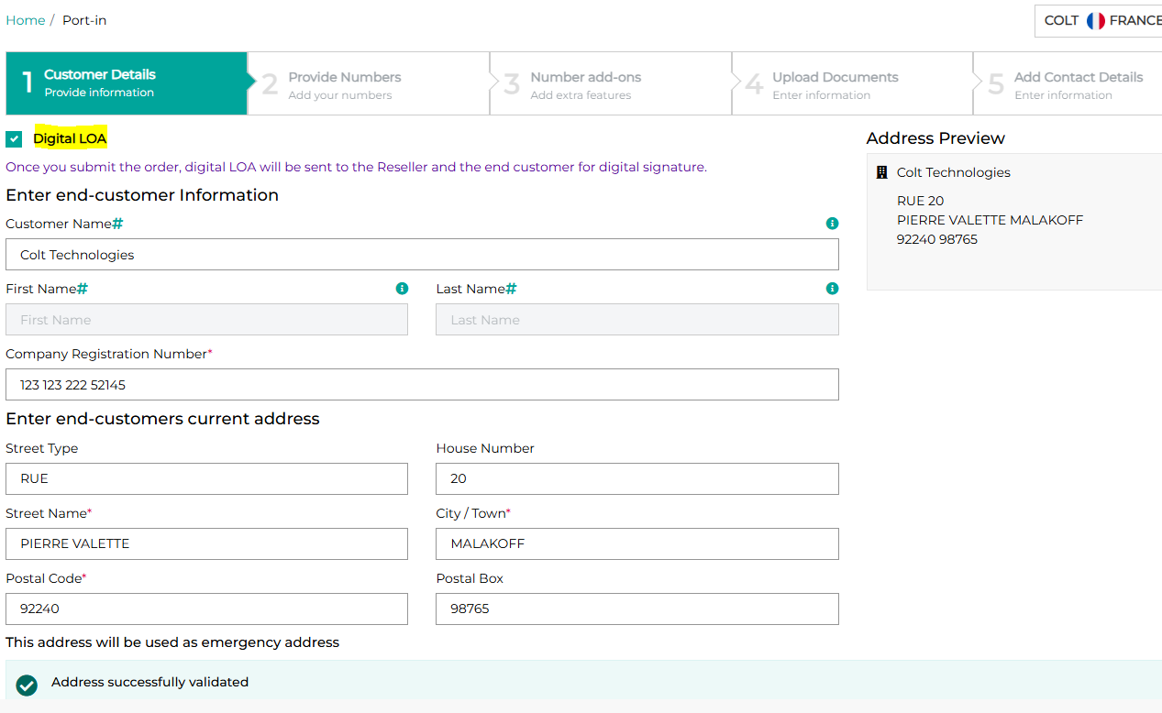
There are new fields in the Number add-ons screen: Portability Type + RIO Code. The Main Billing Number will also be required at range level:
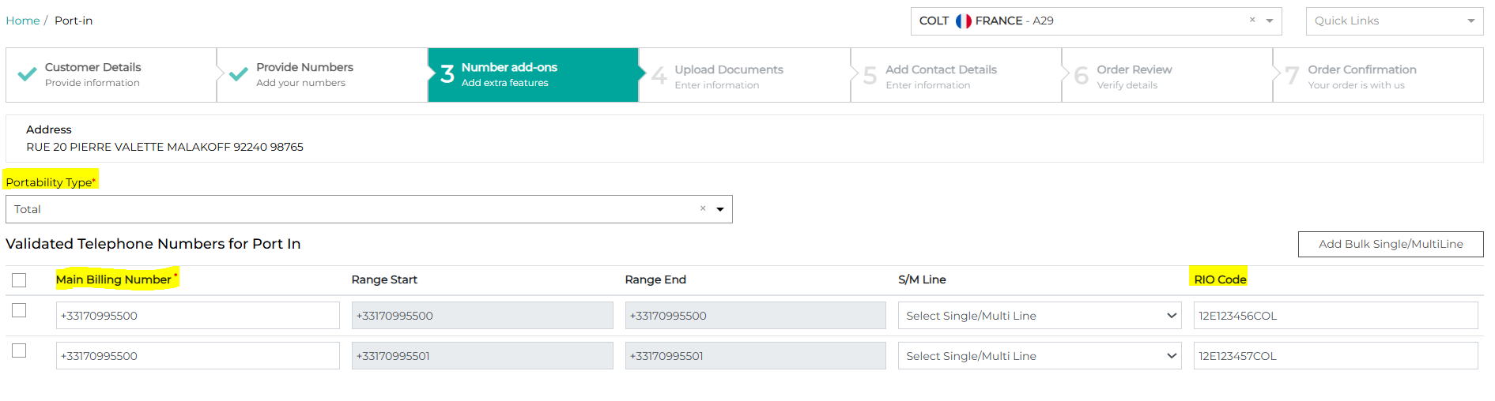
You will need to provide your details as the sender (which your end-customer will see) and also the details of your end-customer who is the recipient & signs the Digital LOA:

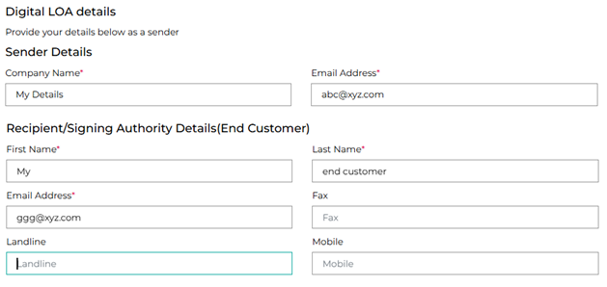
If you use the tri-party LOA in France, then an email will be sent to you and to your end-customer for signature.
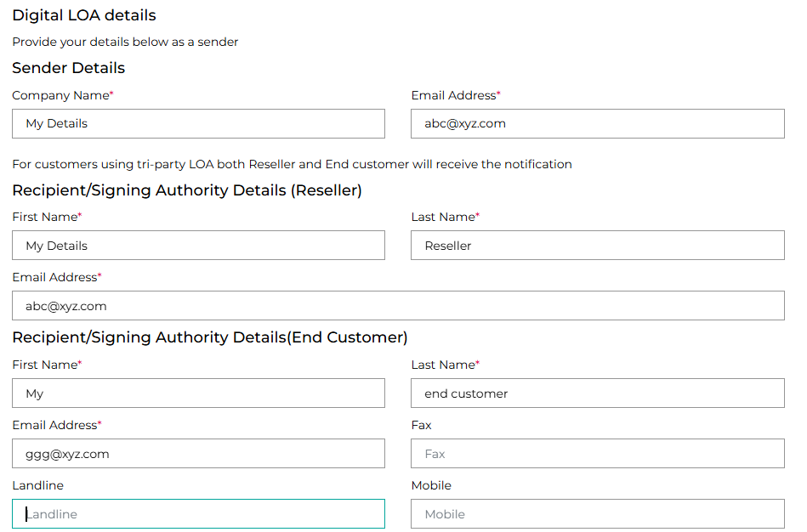
Your end customer will receive the Digital LOA and you’ll receive a copy of it. Your end customer then needs to open the link to review and sign the LOA.

Sample API request and response

Request | Response
{  "numberRangeList": [  {  "numberRangeStart": "+33171827300",  "numberRangeEnd": "+33171827300",  "rangeMainBillingNumber": "+33171827300",  "rangeRIOCode": "12E123456COL"  }  ],  "portDetails": {  "portingDate": "2025-07-24",  "portingWindow": "0900-1200",  "portingContact": {  "firstName": "My",  "lastName": "Customer",  "phoneNumber": "+447394472749",  "email": "MyCustomer@abc.com",  "mobileNumber": "+447394472749",  "fax": "+447394472749"  },  "currentOperator": "Adenis",  "portType": "Total",  "digitalLetterOfAuthorityFlag": true,  "digitalLetterOfAuthorityDetails": {  "senderEmail": "abc@xyz.net",  "senderCompanyName": "Colt",  "signatoryDetails": {  "signingAuthorityFirstName": "My End",  "signingAuthorityLastName": "Customer",  "signingAuthorityEmail": "ggg@abc.com"  }  }  },  "relatedParty": {  "reseller": {  "serviceProfile": "A29",  "country": "FR"  },  "endCustomerDetails": {  "endCustomerName": "Colt Technologies",  "endCustomerAddress": {  "houseNumber": "20",  "streetType": "RUE",  "streetName": "PIERRE VALETTE",  "city": "MALAKOFF",  "postalCode": "92240"  },  "companyRegistrationNumber": "12345676543212",  "customerReference": "My Customer"  }  },  "productOffering": {  "name": "Wholesale SIP"  }  } | {  "order": {  "id": "7d571a02-d6d8-4473-8856-74779cc46f1a"  }  }

For the tri-party LOA
Request | Response
{  "numberRangeList": [  {  "numberRangeStart": "+33171827300",  "numberRangeEnd": "+33171827300",  "rangeMainBillingNumber": "+33171827300",  "rangeRIOCode": "12E123456COL"  }  ],  "portDetails": {  "portingDate": "2025-07-24",  "portingWindow": "0900-1200",  "portingContact": {  "firstName": "My",  "lastName": "Customer",  "phoneNumber": "+447394472749",  "email": "MyCustomer@abc.com",  "mobileNumber": "+447394472749",  "fax": "+447394472749"  },  "currentOperator": "Adenis",  "portType": "Total",  "digitalLetterOfAuthorityFlag": true,  "digitalLetterOfAuthorityDetails": {  "senderEmail": "abc@xyz.net",  "senderCompanyName": "Colt",  "signatoryDetails": {  "resellerFirstName": "My",  "resellerLastName": "Reseller",  "resellerEmail": "abc@xzy.com",  "signingAuthorityFirstName": "My End",  "signingAuthorityLastName": "Customer",  "signingAuthorityEmail": "ggg@abc.com"  }  }  },  "relatedParty": {  "reseller": {  "serviceProfile": "A29",  "country": "FR"  },  "endCustomerDetails": {  "endCustomerName": "Colt Technologies",  "endCustomerAddress": {  "houseNumber": "20",  "streetType": "RUE",  "streetName": "PIERRE VALETTE",  "city": "MALAKOFF",  "postalCode": "92240"  },  "companyRegistrationNumber": "12345676543212",  "customerReference": "My Customer"  }  },  "productOffering": {  "name": "Wholesale SIP"  }  } | {  "order": {  "id": "7d571a02-d6d8-4473-8856-74779cc46f1a"  }  }

Track requests for free numbers in NOD
Current behaviour: Today when you try to reserve or activate numbers in the Numbers on Demand portal and either no numbers are returned at all or the exact quantity of free numbers are not returned, then today you can use the ‘request numbers’ feature. When you request free numbers, an email is triggered to Colt’s local country number manager and you will hear back from the Reseller Support Voice team in due course. There is no order ID created and tracking is manual.
New behaviour: We are introducing a new automated order flow to capture these requests and you will receive updates directly from Colt’s local country number manager.
For France (FR)- this feature will not be available if you’re using your own numbers.
For Germany (DE)- it is mandatory that you attach a document with your order (the BnetzA Approval Form) if the block size is bigger than 100. This document is available from your Colt Account Manager.
For Denmark (DK)- In Denmark there is no concept of geographic numbers – effectively all numbers are location independent/nomadic numbers . Please check for free numbers in all LACs before placing an order for free numbers.
For Netherlands (NL), the following additional fields are mandatory
- End Customer Name
- Request reason (E.g.: Existing end customer is expanding their operations and needs XXX numbers for new sites, and provide the company size (e.g. number of staff) as proof)
- The end customer’s installation address for these additional numbers (all address fields to be provided for NL). LAC/address validation will not be done as it will be manually verified by Colt’s local country number manager.
New order type- ‘Free Number Request’ will be introduced for this new flow. This will be visible in the ‘My Orders’ page on NOD and in the Order reports as well.
- Colt’s local country number manager will receive the ‘Free Number Request’ and they will either Accept (and provide a lead time) or Reject (with a rejection reason) this request. You will be notified via email and via callBack API notification (if in use) regarding the status of your request.
- You can cancel the request if the order is in ‘Validation In Progress’ or ‘Accepted’ status.
- Once numbers are ready, Colt’s local country number manager will ‘Complete’ the request and you will be notified via email and via callBack API notification (if in use) regarding the status of your request. You can then search for the free numbers like today and reserve/activate them.
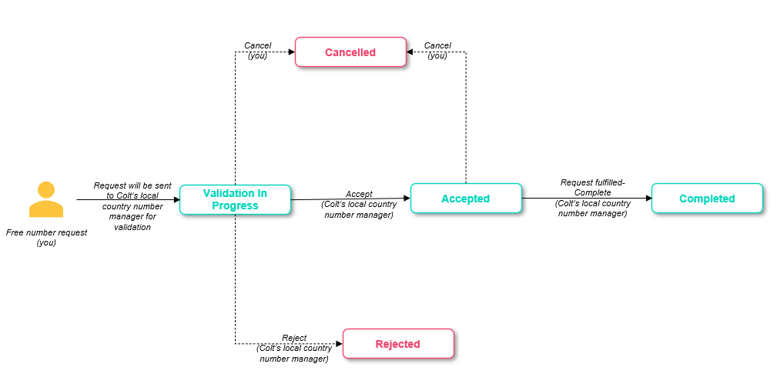

Numbers on Demand portal changes:
If no numbers or no exact quantity can be returned in the response then you will see a ‘Request Numbers’ option. Please click on this option to provide details of your request and submit the order. An Order ID will be returned to you for tracking purposes.
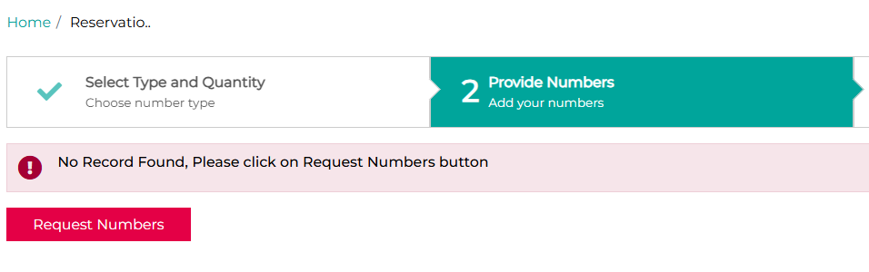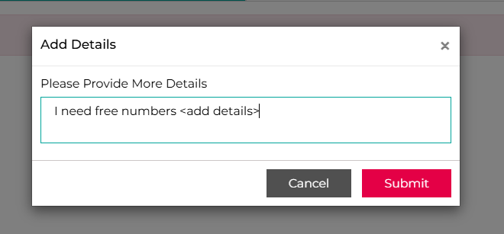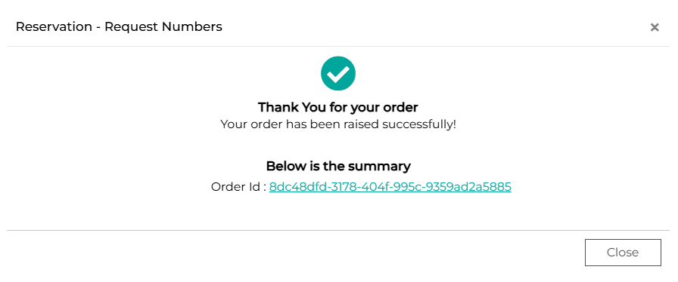
You can track this order ID and see the details of your order as shown below: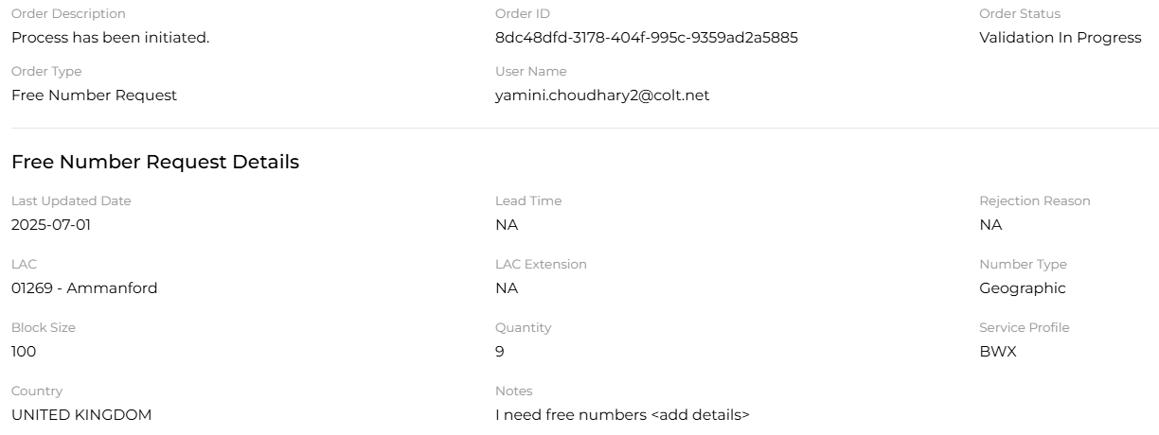

Numbers on Demand (NOD) and B2B API improvements
Below are 9 improvements targeted for this release. Updated XSDs and API OAS specifications can be found in the Appendix A: XSD and Appendix B: API specifications.
Please note: Screenshots showing the NOD portal changes will be shared 10 days before the release.
Sr no | Functionality | Interface | Improvement Description | Country Scope | Code Breaking change for customer (Yes/No)
1 | Activation  PortIn  Address Update | APIs | Customer type: Business and Residential  Only the End customer name is required for the ‘Business’ Customer type. An error will be thrown if the first & last name or Date of Birth is also provided in the request.  Only the first & last name and Date of Birth is required for the ‘Residential’ Customer type. An error will be thrown if the ‘End customer name’ is provided in the request. | DE | Yes/No:  Depends on how you’ve structured the request.
2 | PortIn  Modify port In | NOD | The Main Billing Number will be captured at range level (like the UK) at the time of port-in / modify port-in request submission.  There is no impact on existing SOAP and REST APIs.  The new Apigee API only accepts MBN at range level. | All except GB, NL, DE and Zone B | No
3 | PortIn/Out update notifications | Colt Online | Today you can provide only one single email id to receive port-in/out update email notifications.  Following the release, you will be able to provide different email ids (up to 5) to receive port-in and port-out update notifications.  You can either update this information on your own using ‘View Reseller Data’ functionality or please reach out to ResellerSupport.Voice@colt.net to modify the details for your service profile. | All | No
4 | Activation  PortIn  Address Update | NOD | The position of the ‘Orientation Number’ field in CZ is changed. It needs to be entered after you have entered the ‘House Number’. | CZ | No
5 | My Orders | NOD | You are able to select any or multiple order types and statuses using the ‘filter’ on the ‘My Order’ page | All | No
6 | Order Details | NOD  APIs | The addressID is displayed in the order details response, if a new address is provided in the NewPortIn request | All except DE | No
7 | Reminder notifications for port-expiry | NOD  Apis | When a portin date is a future date and if the end customer doesn’t port within 10 working days (inclusive of the Porting Date), then orders in Firmed Order Committed (FOC) status will move into ‘Expired’ status. We’ll send reminder notifications to you regarding the expiry of a port order. | BE | No
8 | Block duplicate requests | NOD and B2B APIs | When a deactivation request is in progress then no further action is allowed for the same full/partial range (e.g. actions like address update/ port-out/ duplicate deactivation will fail)  There is a new error message "There is already an order in progress for the number xxxxxxxxxxxxx" (The number/s which are duplicate in the new request will be displayed)  A new number status 'Deactivation in progress' will be available on 'My Telephone Number' Page under the 'Number Status' column.  No action can be taken via My Telephone Number Page if the number is in 'Deactivation in progress' status.  This new status 'Deactivation in progress' will be also be available in the Number Hosting Report Number Report in NOD.  These APIs will support the new number status 'Deactivation in progress' for all 3 APIs-  1. SOAP - numberEnquiry  2. REST - GET/numberCollection  3. REST Apigee - GET/number  Only for NL- If a port-out request comes in for the same partial/ full range for which a deactivation/ port-in deactivation request is in progress, the port-out request goes on hold and resumes (i.e. goes to Customer Feedback Awaited (CFA) status) immediately after the port-in deactivation is completed (i.e. the number status becomes port-in quarantine). | All except DE | No
9 | Address Management APIs  Number Management APIs | New Apigee APIs | Other OAS specification updates for the new REST Apigee APIs:  Address Management:  - Renamed addressID to addressId  Number Management:  - Renamed addressID to addressId  - Renamed custom data type: addressIDTypeV1 to addressIdTypeV1  - Renamed invoicedocumentFileContent to invoiceDocumentFileContent | All | No

Introduction of new fields for Finland and VAT ID check

In this release we are introducing:-
- 1 optional and 2 new mandatory fields for Finland – Company Number registered indicator and then ‘LegitimateSignee’ and ‘VAT/Business ID/‘customerRegistrationNumber’ for number activation, address update and portIn functionality.
- We are also introducing an external check on the VAT ID in Finland against the European Commission’s VAT Information Exchange System (VIES). – see: https://europa.eu/youreurope/business/taxation/vat/check-vat-number-vies/index_en.htm. This is to improve the accuracy and validity of orders for new numbers and ports.

Legitimate Signee
Field type: Mandatory
Allowed pattern="([^×Þ÷þ])[A-Za-z0-9À-ÖØ-öø-ÿ:,!`'/\-\.\(\)'@=~+&amp;&quot;&lt;&gt; \w]*"
Maximum allowed length: 255
customerRegistrationNumber/Business ID/VAT number
Field type: Mandatory
Allowed pattern= Alphanumeric characters and hyphen
Maximum allowed length: 20
companyNumberRegistered (APIs)
Field type: Optional
Allowed values: True (default), False
- If ‘true’, VAT number will be validated
- If ‘false’, VAT number validation step will be skipped
These fields will be returned in the order and number details response.
For Numbers on Demand portal users:
In the Numbers on Demand portal you will see the extra validation step of the VAT/business ID in Finland when activating a number, porting-in a number and updating an end-customer address, including bulk orders (just like Portugal & Spain).
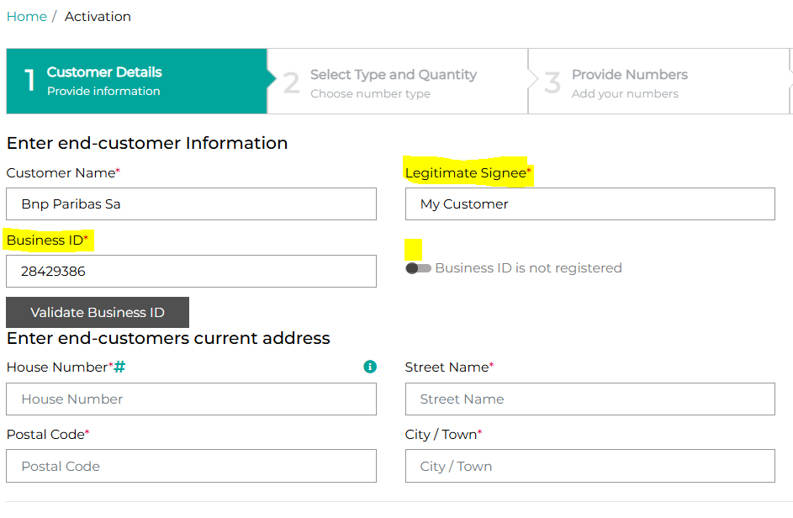
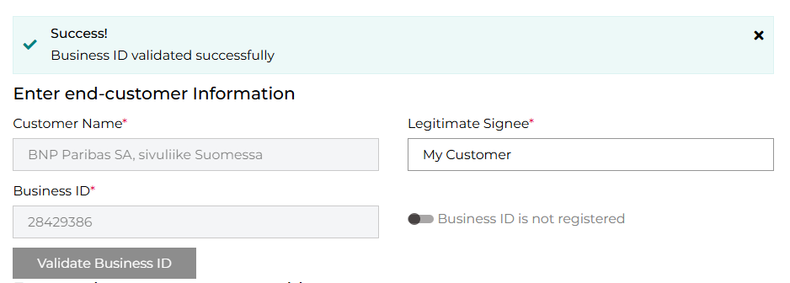
If a business/VAT ID is incorrect or not found, you will receive an error message:
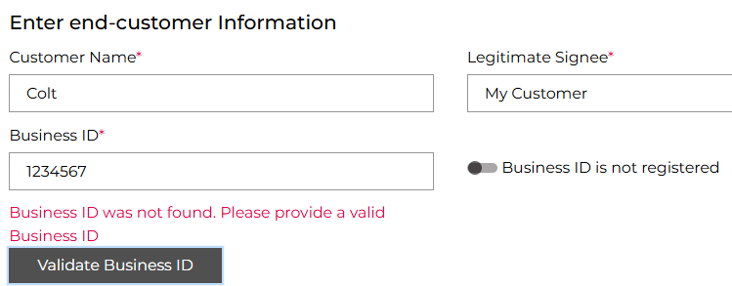
If your end-customer has only recently registered for VAT and their details are not yet in VIES, then you can enter their Business/VAT ID by selecting “Business ID is not registered” and your order will proceed as normal.
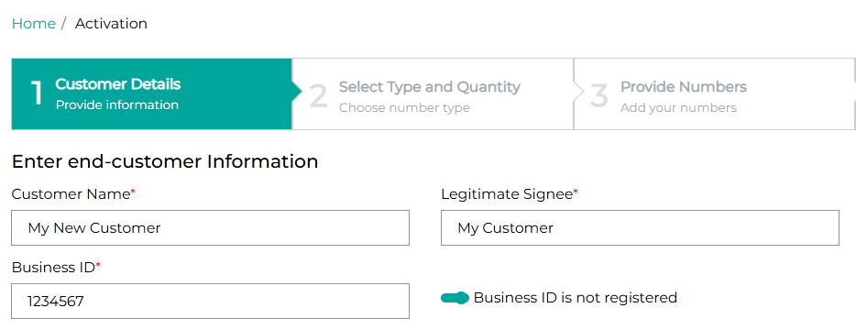
For API users:
The REST API will be available for VAT validation based on the VIES API (check-vat-number),
- VAT/business ID is mandatory parameter
- Please refer to the Appendix B for updated OAS Specification for VAT validation APIs
Sample API request and responses
Request | Response
{  "country": "FI",  "companyRegistrationNumber": "28429386",  "endCustomerName": "Bnp Paribas Sa"  } | {  "country": "FI",  "companyRegistrationNumber": "28429386",  "requestDate": "2025-06-24T07:28:02.252Z",  "valid": true,  "endCustomerName": "BNP Paribas SA, sivuliike Suomessa",  "endCustomerNameMatch": false  }
{  "country": "FI",  "companyRegistrationNumber": "28429386",  "endCustomerName": "Colt"  } | {  "country": "FI",  "companyRegistrationNumber": "28429386",  "requestDate": "2025-06-24T07:28:48.796Z",  "valid": true,  "endCustomerName": "BNP Paribas SA, sivuliike Suomessa",  "endCustomerNameMatch": false  }
{  "country": "FI",  "companyRegistrationNumber": "1234567",  "endCustomerName": "Colt"  } | {  "country": "FI",  "companyRegistrationNumber": "1234567",  "requestDate": "2025-06-24T07:29:24.952Z",  "valid": false,  "endCustomerName": "---",  "endCustomerNameMatch": false  }

Please note: you can also use these external links to check the end-customer has a valid VAT/business ID & signee in Finland to ensure accuracy:
- www.ytj.fi
- www.finder.fi

Appendix A: XSD
Please click here for the updated XSDs

Appendix B: API specifications

OAS Specification for number management APIs

SAG REST API: https://apimgd01.colt.net/numberManagement/v2 | Please click here for updated OAS specification.
New Apigee REST API:  https://apis.colt.net/numberManagement | Please click here for updated OAS specification.

OAS Specification for address management APIs

New Apigee REST API:  https://apis.colt.net/addressManagement | Please click here for updated OAS specification.

OAS Specification for VAT validation APIs

SAG REST API:  https://apimgd01.colt.net/common-services/v1 | Please click here for updated OAS specification.
New Apigee REST API:  https://apis.colt.net/common-services | Please click here for updated OAS specification.

Appendix C: Numbers on Demand UI changes
Main Billing Number at range level
Applicable for port-in, modify port-in (including bulk) & order details in all countries except UK, NL, DE and Zone B:
Current behaviour | New behaviour
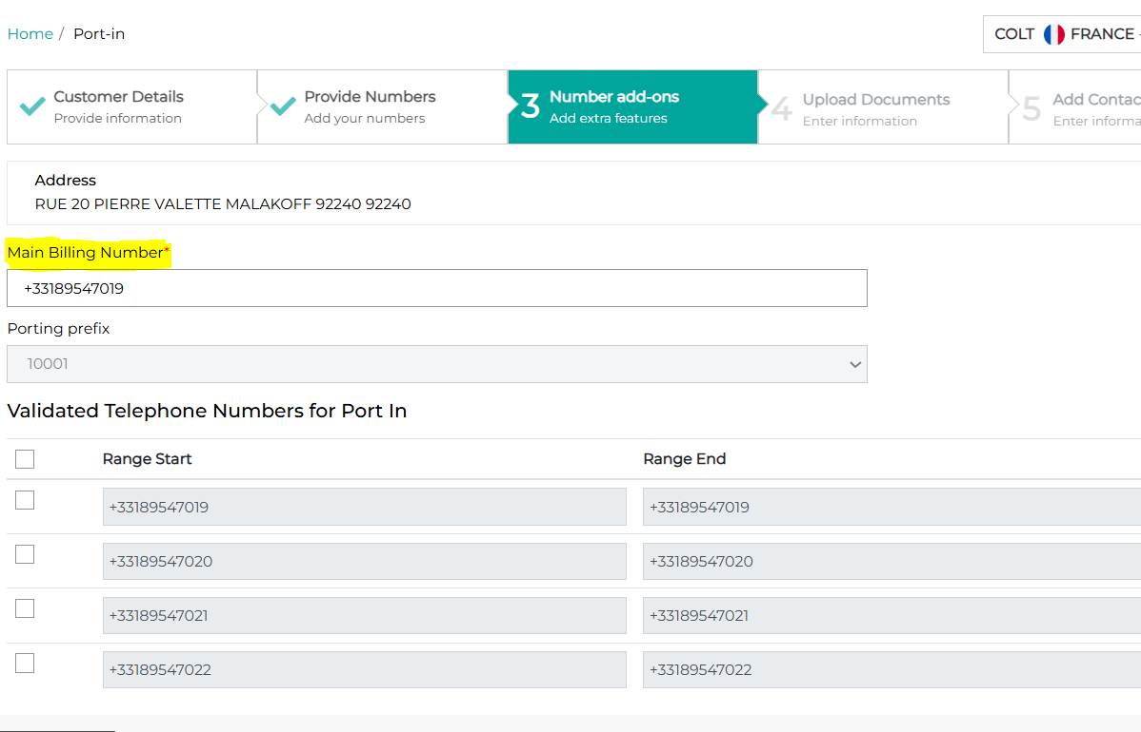 | 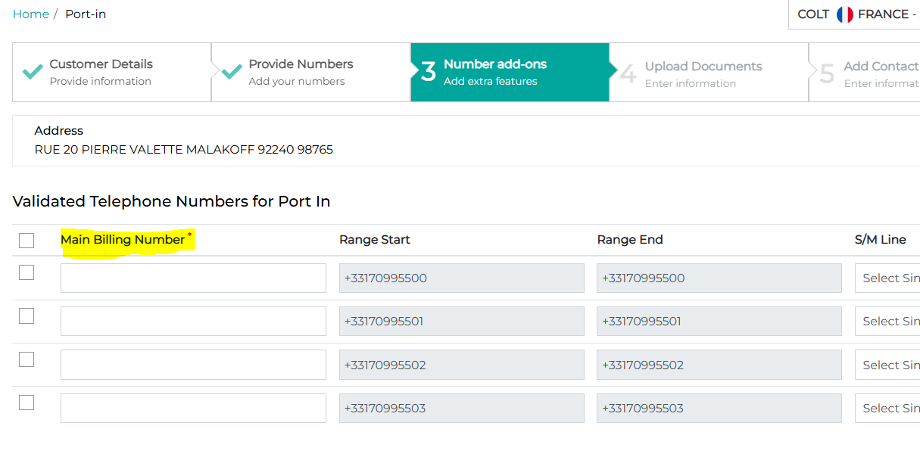

PortIn/Out update notifications- update email ids via ‘View Reseller Data’ and add multiple email ids.
You can provide different email ids (up to 5) to receive port-in and port-out update notifications by searching for your Wholesale SIP (Geographic Number Hosting) profile using the ‘View Reseller Data’ page and clicking on the service profile hyperlink.
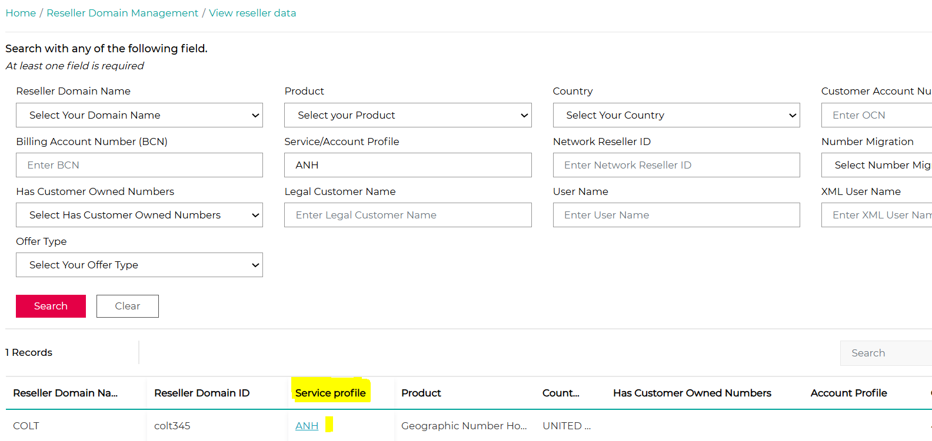
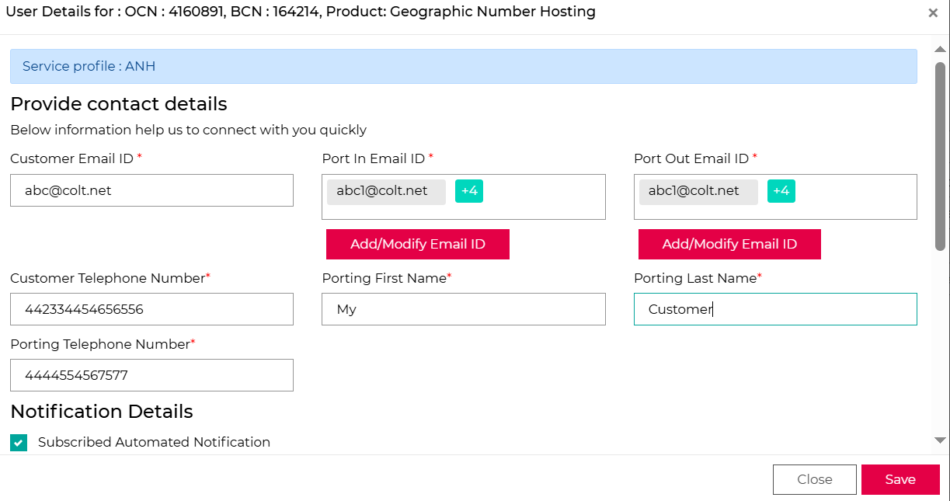
Then click on the Add/Modify Email ID to add multiple email IDs (up to 5) for port-in and port-out email updates:
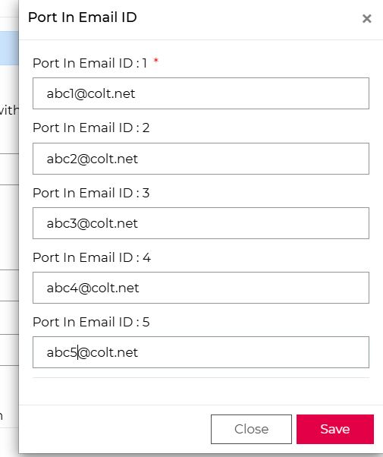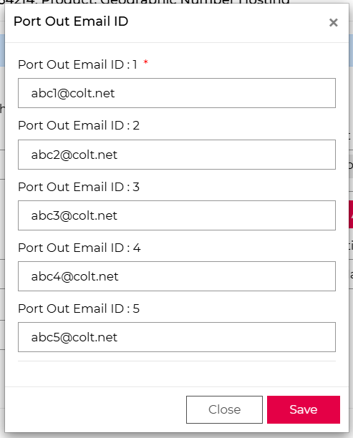
Scroll further and add/update ‘Subscribed Automated Notification’ details and save the changes.
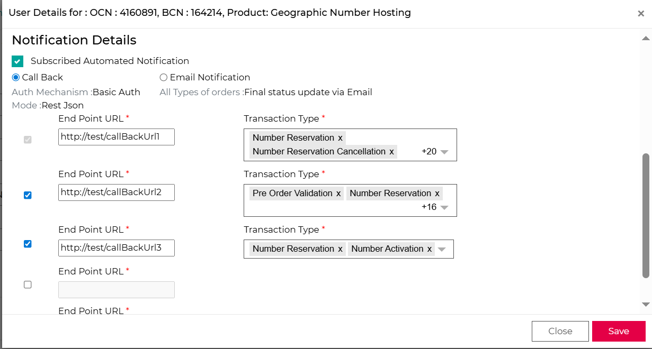

Czech Republic: Orientation Number field
The position of the ‘Orientation Number’ field in CZ is changed. It needs to be entered after you have entered the ‘House Number’:
Current behaviour | New behaviour
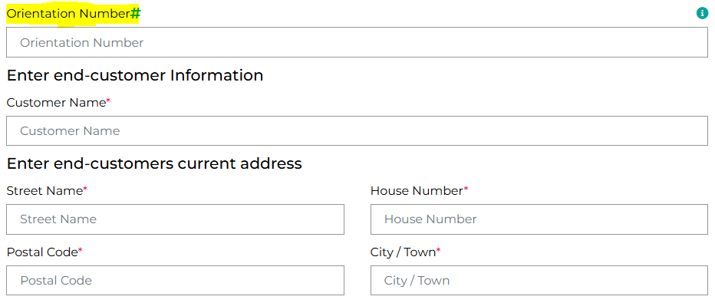 | 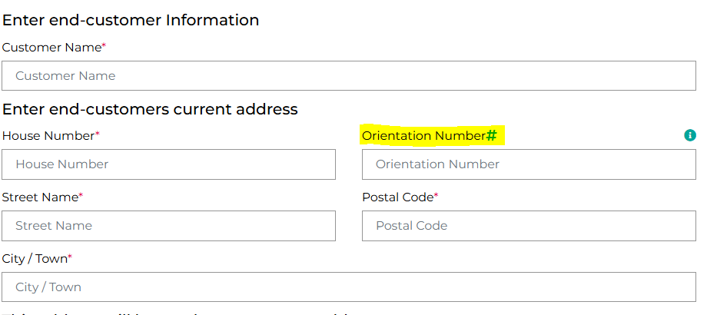

My Orders page
You are able to select one or more order types and statuses using the ‘filter’ on the ‘My Order’ page
Current behaviour | New behaviour
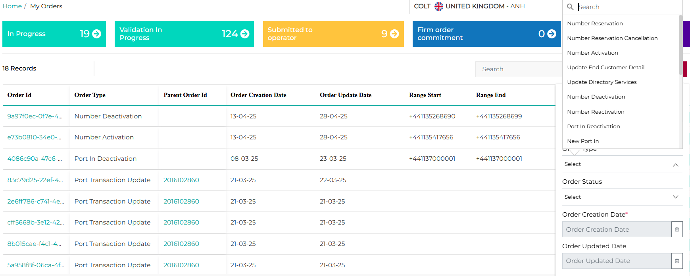 | 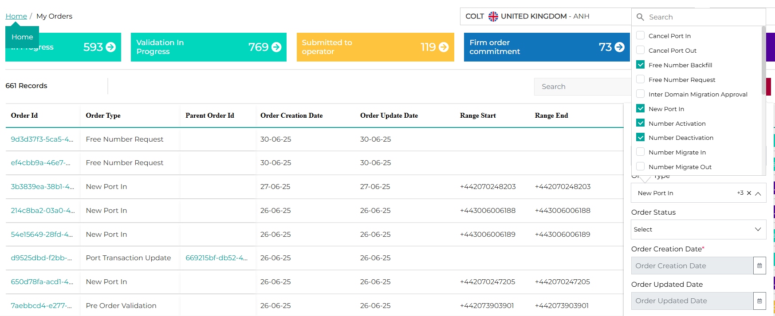
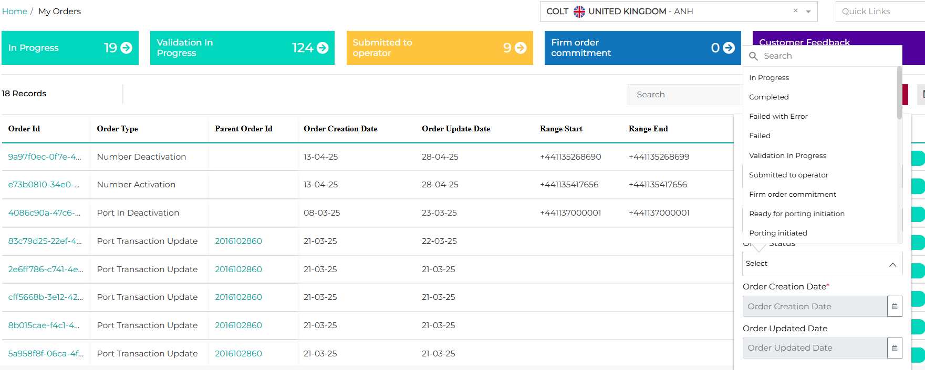 | 