Colt Wholesale sip network guide

Abstract
This document provides you with further guidance and support for Colt’s Wholesale SIP Trunking service (previously known as Number Hosting) with on demand number management.

Document Version 1.2
Release Date 20/07/2026

Disclosure / Confidentiality
Highly Confidential, not for distribution ☐
Distribution within Architecture & Design ☐
Distribution within Colt ☐
Distribution permitted external to Colt ☒
Copyright ©
No part of this document may be reproduced or adapted in any form, including photocopying or storing it by electronic means, except as is necessary for the purpose of the recipient's dealings with Colt, without the written permission of Colt. Any copies made of any part of this document shall include the notice:
© 2026 Colt Technology Services. The Colt name and logos are trademarks. All rights reserved.
No information contained in this document shall be disclosed to any third party without the written permission of Colt.

Table of Contents
Document Information 4
Version History 4
1. Document scope 5
2. Numbering & CLI features 6
2.1. Number formats 6
2.2. SIP URI Format 7
2.3. CLI policy and origin surcharging for outbound calls (You to Colt) 7
2.3.1. Impacts of the CLI policy on how Colt bills origin surcharges 8
2.3.2. Direct Call Scenario 9
2.3.3. Call Forwarding Scenario 9
2.3.4. Invalid Origin (invalid CLI) 9
2.4. CLI screening 9
2.5. Calling Line Identification Restriction (CLIR) 9
2.6. Calling Line Identification Presentation (CLIP) No Screening 10
2.7. Country specific CLI requirements (Regulatory) 10
2.7.1. Austria 10
2.7.2. Belgium and The Netherlands 10
2.7.3. Czech Republic, Finland, Luxembourg, Norway & Romania 11
2.7.4. France 11
2.7.5. Germany 19
2.7.6. Ireland & UK 19
2.7.7. Italy 19
2.7.8. Poland 20
2.7.9. Spain 20
2.7.10. Sweden 20
2.7.11. Switzerland 21
3. Signalling 22
3.1. Standard Compliance 22
3.2. Transport Types 23
3.3. SIP Trunking Modes 24
3.4. SIP Timers 24
3.5. Session Timers 24
3.6. DNS resolution Support 24
3.7. SIP Response Codes 25
3.7.1. SIP Response Codes for unsupported destinations 25
3.7.2. SIP to ISUP CPC Mapping 25
4. Bearer Services 28
4.1. Codecs 28
4.2. Media Path 29
4.3. Transcoding 29
4.4. Fax 30
4.5. Modem 30
4.6. DTMF 30
4.7. Clear Channel 31
4.8. Call Admission Control (CAC) 31
4.9. Tones & Announcements 32
4.10. Echo Cancellation 32
4.11. Circular routing 32
4.12. Call barring 32
5. Access technologies 33
5.1. Overview 33
5.2. Internet 34
5.3. IP VPN 34
5.4. Quality of Service 35
6. Resiliency options 37
6.1. Overview 37
6.2. Access Options 39
6.2.1. Primary is Dedicated, Secondary is Internet 39
6.2.2. Primary Dedicated, Secondary Dedicated 40
6.2.3. Primary Internet, Secondary Internet 43
6.3. Trunk Resiliency 45
6.3.1. Call Routing 45
6.3.2. Trunk Out of Service and Recovery Methods 45
7. Emergency Service Numbers & Short Number calls 47
7.1. List of supported numbers 47
7.2. Emergency Call Routing (ECR) 47
8. VoIP Performance Reporting 50
9. Glossary 51
Appendix A: Germany: user-provided geolocation header 53
A.1 Geographic coordinates: 54
A.2: Postal address / civic location 56
A.3 References (as of July 2026) 59

Document Information

Location:
Click here: https://developer.colt.net/wholesale-sip-documentation

Version History

Version | Issue Date | Reason for Change
1.1 | 06.07.2026 | Updates:-  2.1 CLI length update for Belgium  2.2 SIP URI format clarification  2.7.4 Updated France CLI specific requirements  2.7.7 Added new Italy section  2.7.9 Updated Spain  2.7.11 Updated Switzerland  7.1 & 7.2 Clarification on the numbers on which we support Emergency call routing
1.2 | 20.07.2026 | Updates:-  Colt CLI screening enabled in Belgium, Germany & Italy which enhances customers’ own CLI screening measures in accordance with local regulation

Document scope
This document provides you with further technical guidance and support for Colt’s Wholesale SIP service (previously known as Number Hosting) with on demand number management.

Numbering & CLI features

Number formats
Supported format
All Numbers, e.g. Calling, Called and Redirecting Number, should be sent in E.164 international format +<CC>NSN, with:
- CC = Country Code,
- NSN = National Significant Number.
Please note there are exceptions for France as described in this section.
CLI length
The table below provides an overview of the CLI length e.g. Austria has a minimum CLI length of 7 digits and a max CLI length of 15 digits. Calls which fail CLI length check will be blocked.
Zone A Countries:
Country (Country Code) | CLI length (CCNSN) for National & EEA profiles | CLI length (CCNSN) for Global profile
Austria (43) | 7-15 | 7–15
Belgium (32) | 10-13 | 10–15
Denmark (45) | 10 | 10-14
France (33) | 11 | 11-15
Germany (49) | 7-17 | 7–17
Ireland (353) | 10-12 | 10–15
Italy (39) | 8-13 | 8–15
Netherlands (31) | 11 | 9-13
Portugal (351) | 12 | 12
Spain (34) | 11 | 11-15
Sweden (46) | 9-11 | 8-15
Switzerland (41) | 11 | 11
United Kingdom (44) | 11-12 | 9–12

Zone B Countries:
Country (Country Code) | CLI length (CCNSN)
Czech Republic (420) | 12
Finland (358) | 8-15
Luxembourg (352) | 8-13
Norway (47) | 10
Poland (48) | 11
Romania (40) | 11
Slovakia (421) | 12

SIP URI Format
SIP URI format shall comply with [RFC3261]/19.1 and TEL URI with [RFC3966] with:
- SIP URI:
  - globalnumber@domainname with optional user=phone OR globalnumber@IP_address with optional user=phone where globalnumber is a valid E.164 number.
- Tel URI: valid E.164 number.
A valid number is a number that belongs to the national numbering plan of the country identified by the Country Code in the E.164 number.

CLI policy and origin surcharging for outbound calls (You to Colt)
In the Colt footprint the number displayed to the called party is the one contained in the SIP From header.
For basic calls (i.e. normal outbound calls) a valid CLI populated with the customer number is expected in the PAI header. If the PAI header is not supported, a customer CLI can also be signalled in the FROM header.
For forwarded calls the Diversion header should be populated with the customer number, the FROM Header should contain the number of the original caller (Original Calling Number).
For France specific details, please go to the France section below.
For all SIP Headers the format defined in 2.1 should be used.
This is important as it defines the origin Colt will allow with the service and defines the level of risk for origin surcharges.
- Colt CLI screening (default for Belgium, Germany & Italy*): Only allows calls originating from in-country Colt Fixed Line CLIs which are activated/ported-in on the Trunk group
- National Profile (default): only allows calls originating from all in-country Fixed Line CLIs of the Trunk Group (TG) country.
- National+Mobile Profile: only allows calls originating from all in-country Fixed and mobile CLIs of the Trunk Group (TG) country
- EEA Profile: only allows calls originating from the 13 Colt countries (zone A) Fixed Line CLIs
- EEA+Mobile Profile: only allows calls originating from all in-country Fixed Line CLIs of the 13 Colt countries (zone A) and mobile CLIs of the TG country
- Global Profile: allows traffic originating from any origin excluding calls from +1 to +1. Measures to address misuse/spoofing of national CLIs may result in some in-country calls being restricted/blocked.
- Global Profile RMD US: allows traffic originating from any origin including calls from +1 to +1 (US traffic which requires customers to register in the US FCC’s RMD database and provide Colt with their FRN/registration number). Measures to address misuse/spoofing of national CLIs may result in some in-country calls being restricted/blocked.
* Italy: the Colt CLI screening profile applies if the customer has a reseller licence. If the customer has a voice licence then any profile can apply.

In zone B countries, the National profile is the only possible profile applicable to zone B trunk groups:
- Only allows calls originating from in-country Fixed Line CLIs which are activated/ported-in on the Trunk group in Finland & Slovakia
- Allows calls originating from all in-country Fixed Line CLIs of the TG country in Czechia, Luxembourg, Norway, Poland & Romania (note Regulatory conditions apply in these countries – see below)

For all profiles, the below traffic is blocked, where:
- No CLI is presented
- CLI length is invalid (i.e. not within defined number length of the country)
- The CLI contains alphanumeric (a-z, A-Z) or special characters (#, @ etc.)
- CLIs are in an invalid format, e.g. a country code is followed by ‘0’ in all zone A countries (except Italy because +390 is valid)
- CLIs are not assigned to any operator by a national Regulator
The SIP response code for calls blocked due to an invalid CLI is 403 (Forbidden) without announcement which gives you the benefit that you can crank back the call.

Impacts of the CLI policy on how Colt bills origin surcharges

CLI policy | Impact on how Colt bills origin surcharges
Colt CLI screening profile, National profile & National+Mobile Profile | These profiles are setup to avoid origin surcharges being applied, however this cannot be guaranteed as market/regulatory conditions may change. Advance notice of changes to pricing is given in accordance with the Wholesale SIP / Number Hosting service specific terms. Please refer to your Wholesale SIP / Number Hosting rate card.
EEA profile & EEA+Mobile Profile | This reduces the risk of surcharges but does not remove it completely as there are few low surcharge scenarios in the zone A countries.
Global & Global Profile RMD US | Includes call scenarios where origin surcharges may apply.

Direct Call Scenario
CLI Policy, blocking rules & origin surcharges are applied on the ‘trusted CLI’:
- If ‘PAI’ is available, the ‘trusted CLI’ will be the value received in the ‘PAI’ header.
- If ‘PAI’ is not available, the value received in ‘FROM’ will be treated as the ‘trusted CLI’.

Call Forwarding Scenario
CLI Policy, blocking rules & origin surcharges are applied on the ‘received RDN’ (ReDirecting Number), i.e. calls will be blocked if the Diversion Header does not match the CLI Policy.

Invalid Origin (invalid CLI)
It is common industry practice for higher surcharges (group D) to apply to calls where the calling line identifier (CLI) is invalid.
Although Colt blocks calls as described in the above CLI policy, we cannot guarantee that calls will not incur a surcharge due to an invalid CLI as a point of origin, which will incur the higher surcharge (group D). Examples include (please note this is not an exhaustive list):-
- If the trusted CLI length does not comply with the length in the national numbering plan
- If the trusted CLI has a prefix which is not allowed from a regulatory perspective in the national numbering plan e.g. the CLI is a Premium Rate or Shared Cost number

CLI screening
End-user provided CLI must be screened and validated by you. Colt will pass only those calls which fulfil the following requirements:
- SIP protocol: CLI signalled within PAI header.
If you do not support PAI you may also signal ‘trusted CLI’ in the FROM header if you guarantee a correct CLI. If FROM = anonymous then a valid CLI must be signalled in the PAI header (or alternate method of transmitting CLI compatible with the RFC).
When Colt screens forwarded calls, the diversion header will be used as the trusted CLI.

Calling Line Identification Restriction (CLIR)
You are responsible for providing the correct ‘CLIR’ information to Colt.
- SIP protocol: Colt support the following options to signal a CLI as restricted in a SIP INVITE:
- ‘Anonymous’ or ‘unknown’ or ‘restricted’ or ‘unavailable’ is set in one of the following fields: FROM Header, P-Preferred ID, P-Asserted ID or Remote Party ID and
- By inserting P-Asserted-Identity header and Privacy: Id header (RFC3323/3325)
- Valid CLI is set in another signalling field
Colt still need a CLI when you set any of the fields FROM Header, P-Preferred ID, P-Asserted ID and Remote Party ID to anonymous’ or ‘unknown’ or ‘restricted’ or ‘unavailable’.
For France specific details, please go to the France section below.

Calling Line Identification Presentation (CLIP) No Screening
You must configure your own services to comply with the regulatory conditions on how a presented CLI must be managed and shown to a called party – see here: 2503_CLI Presentation - regulatory requirements per country_v10.0. You are responsible for providing the correct ‘CLIP No Screening’ information to Colt. However Colt cannot guarantee the functionality across other carriers’ networks.

Country specific CLI requirements (Regulatory)
Colt scan both the ‘PAI’ and ‘FROM’ fields in relation to the regulation regarding domestic/national calls. If either of the two fields signal a domestic origin of a call delivered over an international trunk, we apply the rules accordingly. For more details, please see the country information below.

Austria
In Austria the regulatory conditions have been tightened and calls originating from Austria CLIs (+43) to Austrian national numbers (national calls) must be sent to Colt on your Austria SIP Trunk.
If Austrian national calls (CLI and Called Number = +43) are sent from a non-Austrian SIP trunk, then they will be deemed to be as international origin and the CLI will be marked as international origin (‘P-Austria-Origin’ SIP Header) by Colt. On receipt of P-Austria-Origin SIP Header from Colt the PTT & OLOs may choose to take no action or anonymize the CLI or they may even block the call.
Colt will anonymize the CLI for national calls received with P-Austria-Origin from PTT&OLO or national calls from international origin which are terminated on Colt network (routed to customers). The same applies also for calls from Austrian national mobile numbers as well as forwarded / redirected calls, i.e. Colt will send P-Austria-Origin towards PTT&OLO and anonymize CLI for calls terminated on Colt network.

Belgium and The Netherlands
As a result of misuse/spoofing of CLI’s telecom operators including Colt have implemented more measures in the network to prevent this.
Blocking of calls from blacklisted CLIs received from an international origin in the Netherlands
On request of NL authorities, operators, including Colt, have implemented blocking of calls from abroad for a specific list of numbers, where the owner of the number has indicated that their number(s) will never be used as a CLI from abroad.
Calls from a CLI in this list sent on a non-NL trunk group will be deemed to be of international origin and will be blocked.
Blocking of national/domestic calls originating internationally (Belgium)
The regulatory conditions have been tightened in Belgium and calls originating from Belgium CLIs (+32) to Belgian national numbers (national/domestic calls) must be sent to Colt on your Belgium SIP Trunk.
If you see calls from national/domestic Belgium CLIs which you can identify as originating from outside Belgium, then you must block these calls, in accordance with regulation.
If Belgian national fixed line calls are sent to Colt from a non-Belgian SIP trunk, then they will be deemed to be of international origin and will be blocked. Calls from Belgian national mobile numbers as well as forwarded / redirected calls will have the CLI restricted / anonymized if they are received from an international origin.
Colt CLI screening
Colt CLI screening is enabled in Belgium which enhances customers’ own CLI screening measures. Colt will only allow calls from Colt Belgium numbers or from Belgium numbers ported into Colt on the Belgium SIP trunk. Calls from any other origin will be blocked with Q.850 release cause 34 or SIP 503 service unavailable error response.

Czech Republic, Finland, Luxembourg, Norway & Romania
The regulatory conditions have been tightened in the Czech Republic and calls originating from Czech CLIs (+420) to Czech national numbers (national/domestic calls) must be sent to Colt on your Czech SIP Trunk.
If Czech national calls (CLI and Called Number = +420) are sent from a non-Czech SIP trunk, then they will be deemed to be of international origin and will be blocked. Redirected/forwarded calls are an exception.
The same rules and logic apply in Finland, Luxembourg, Norway & Romania.

France

Implementation of the CLI policy in France
This section complements the above CLI related sections with specific French requirements.
 | French requirement | Related section above
Basic Call to Colt  P-Asserted-Identity header (PAI) | On Colt France trunks, P-Asserted-Identity header is mandatory. It is a “trusted” CLI that is network checked by the call originating operator network. PAI is allocated to the calling party originating the call by the originating operator.  If the PAI header contains a valid French “polyvalent” E.164 number (+33ZABPQMCDU with Z=1, 2, 3, 4, 5 or 9), it must be assigned to a fixed telephony line by the originating network of the call, i.e. your network if the caller is one of your end-customers.  If PAI is not a valid number, the call is rejected by Colt. | CLI policy and origin surcharging for outbound calls (You to Colt)
Basic Call to Colt  From header | On Colt France trunks, From header must be sent. If not set to ‘Anonymous’ or ‘unknown’ or ‘unavailable’, it must contain a valid E.164 number that can be:  - same as the PAI header  - a number allocated or not to the calling party allocated by the originating network of the call  - a Freephone number  If From is not a valid number, the call is rejected by Colt. | CLI policy and origin surcharging for outbound calls (You to Colt)
Forwarded Call to Colt | On Colt France trunks, the Diversion header must contain a valid French E.164 number officially operated by your redirecting network and allocated to the called party redirecting the call. | CLI policy and origin surcharging for outbound calls (You to Colt)
CLIR | On Colt France trunks, P-Asserted-Identity header (PAI) cannot be set to ‘Anonymous’ or ‘unknown’ or ‘restricted’ or ‘unavailable’.  The Displayed Number contained in the From header can be restricted with Privacy: user. | Calling Line Identification Restriction (CLIR)
CLIP | The number displayed to the called party is always the number contained in the From header. | Calling Line Identification Presentation (CLIP) No Screening

Resale of Numbers in France
Since January 2023 the resale of numbers is forbidden, and all Operators are expected to source their own numbers and a porting/routing prefix from the regulator in France (ARCEP) to provide services to their end customers. For more information on how Colt can host your own numbers and porting/routing prefix in France or use of an alternative tri-partite agreement, please contact your Colt Account Manager.
Please note that reselling of numbers will no longer be allowed from July 2028, so Colt numbers will be transferred to you as an operator with a minimum of 6 months’ notice.

France CLI Authentication
The regulator (ARCEP) defines a French Operator as an operator having its own French numbers and/or porting prefixes attributed by ARCEP. Please refer to: ARCEP Decision n° 2025-2215
Naegelen law was issued in July 2020 aiming to strengthen the protection of users against number spoofing and to consolidate the chain of trust between French Operators.
The law requires that all calls transiting the French network must be signed by the French originating operator and verified by the French terminating operator. Calls that do not pass the verification shall be blocked and reported.
The France CLI Number Authentication Mechanism (MAN) based on STIR/SHAKEN was introduced by APNF in H2 2024 to comply with regulation.
The term French number refers to French number resources (number, routing/porting prefix) as defined in the French Numbering Plan issued by ARCEP, including the Short National Codes and French overseas territories.
Signing a call consists of: an Originating/Signing French Operator adding its signature in the SIP INVITE; adding an Identity header built with the Originating French operator’s certificate assigned by APNF; adding the number to the SIP INVITE From and To headers, and adding the level of attestation of the call, along with other parameters.
CLI Authentication requires that:
- French operators are onboarded on APNF’s MAN platform
- The calling party number contained in the SIP From header is authenticated by the operator originating the call. The French originating operator is responsible for the call
- The French operators originating outbound calls to French numbers must sign calls with their certificate and indicate a level of attestation (A, B or C)
- The French operators terminating inbound calls to French numbers must verify the signature received in the call. When the verification fails, the call must be blocked and reported
- Attestation Level or verstat value cannot be shared with the called party or end-user
- The French operators must comply with the APNF reporting requirements for monitoring

Attestation Levels define the level of trust of the origin of the call:
- A – Full attestation: The originating operator signing the call is responsible for the call and has:
  - a direct authenticated relationship with the end customer making the call (that is not an operator) and can identify this end customer, and
  - can establish a verified association between the end customer’s telephone access and the calling number (contained in the From header) displayed to the called party
- B – Partial attestation: The originating operator signing the call is responsible for the call and has:
  - a direct authenticated relationship with the end customer making the call (that is not an operator) and can identify this end customer, and
  - cannot establish a verified association between the end customer’s telephone access and the calling number (contained in the From header) displayed to the called party
- C – Gateway attestation: The originating operator signing the call has no relationship with the end-customer making the call (i.e. calls forwarded, international origin calls, …).

If you are a French operator who needs to be onboarded on MAN, you are required to:
- register with APNF and subscribe to APNF’s MAN service.
- Request a MAN certificate
You can choose one of two options:
- Self-signing/verification: signing, verification and reporting capabilities implemented by you
- TSO/TVO Technical Signing Operator (TSO) / Technical Verification Operator: you mandate Colt to sign, verify and comply with MAN reporting requirements on your behalf
All French operators are required to:
- sign all calls to French destinations routed to Colt
- verify all calls routed by Colt to your French end-customers/destinations
- comply with MAN reporting requirements
- send French national traffic* on your Colt French trunk
*French National call= both calling and called numbers are French

Signing
Options | Country trunk | Operator Role | Regulatory Requirements
Self-signing | FR | You= signing operator  (responsible for the call)  Colt=transit operator | You sign the calls to a destination in the French territories  Colt block unsigned calls
Self-signing | Non-FR
TSO | FR | You= signing operator  (responsible for the call)  Colt= Technical Signing Operator (calls are signed by Colt using your certificate) | You signal Attestation level using P-Attestation-Indicator and optionally P-Origination-id in your SIP INVITE to Colt.  Colt uses the received values or default trunk values if any of the above P-Headers is not received.
TSO | Non-FR |  | Colt blocks the calls with FR fixed From AND/OR PAI.

Verification
Options | Country trunk | Operator Role | Regulatory Requirements
Self-verification | FR only | You=verification operator  Colt=transit operator | You verify the calls and report unsigned and non-compliant calls.  Colt block and report unsigned calls.
TVO | FR only | You= terminating operator  Colt=Technical Verification Operator | Colt verify calls on your behalf, block and report non-compliant calls to MAN.

For calls with destination France originating outside of France, please refer to the section International Origin below.
Please make sure you read the Colt Q&A in English or French for more detailed information of the requirements depending on the setup you choose. In addition, you can visit APNF extranet (access is provided with your MAN subscription).

Number format for National Short codes and French Overseas Territories numbers
In addition to the Number format defined in chapter 2.1, French Wholesale SIP customers must comply with the following format requirements:
Local number format must be used for national short codes (French specific non-E.164 numbers: 1X, 1XY, 10YT, 118XYZ, 116XYZ, 3BPQ)
Number Category | SIP & RFC References | SIP Signaling Examples
French Short Number codes defined in the French Numbering Plan. | • E.164 non-compliant  - SIP URI format shall comply with RCF3261 phone-context parameter SHALL be set to +33  • tel URI with local-number format (RFC 3966). Applies to Request-URI, To, and From header fields | French Short Number (3610)  Request-URI:  <tel:3610; phone-context=+33>  To:  <tel:3610; phone-context=+33>  From:  <sip:3610; phone-context=+33@IP_address; user=phone>

French Overseas Territories or DROM (Départements-Régions d'Outre-Mer) numbers
French overseas territories numbers are regulated by ARCEP and follow the same rules as per the French mainland numbers. Calls from/to DROM numbers shall be sent to Colt with the correct DROM country code and using global-number format (E.164).
DROM Countries
+590 Guadeloupe, Saint-Martin et Saint-Barthélemy
+594 Guyane
+596 Martinique
+262 La Réunion, Mayotte and other French territories of the Indian Ocean
+508 Saint-Pierre-et-Miquelon
Number Category | SIP & RFC References | SIP Signaling Examples
French Overseas Numbers  (aka DROM).  Geographic numbers assigned to French overseas territories with territory-specific country codes defined in the French Numbering Plan. | • E.164-compliant numbering (RFC3966)  • Consistently apply the territory-specific country code in the Request-URI, To, and From header fields | Request-URI:  tel:+590591123456  To:  tel:+590591123456  From: <sip:+590591123456@IP_address;user=phone>

International origin
Please contact your Colt Account Manager to order a French trunk for your French traffic if you don’t have one – please note that:-
- International blocking is applied on French National calls* with fixed CLI in From and/or PAI routed to Colt over non-French trunks (this includes diverted calls)
- Anonymization is applied on French National calls* with French mobile CLI in From and PAI routed to Colt over non-French trunks
*French National call= both calling and called numbers are French
Please note that Colt does not apply the above blocking/anonymization rules in the instance where you self-sign your outbound calls or if you mandated Colt to sign with your certificate because it is your responsibility to adhere to the regulation (see: Authentification des numéros de téléphone fixe ou mobile : que dois-je faire en tant qu’opérateur téléphonique ? | Arcep)

Mobile Origin
Please contact your Colt Account Manager to order a French trunk for your French traffic if you don’t have one – please note that:-
- Anonymization is applied on French National calls* with French mobile CLI in From and French fixed number in PAI calls originated over French trunks
- No anonymization/blocking applies to diverted calls with French mobile CLI on French trunks
*French National call= both calling and called numbers are French
Please note that Colt does not apply the above anonymization rules in the instance where you self-sign your outbound calls or if you mandated Colt to sign with your certificate because it is your responsibility to adhere to the regulation (see: Authentification des numéros de téléphone fixe ou mobile : que dois-je faire en tant qu’opérateur téléphonique ? | Arcep)
If you collect traffic to French destination originating outside of France (i.e. the end-customer making the call is located outside of France/the French territories), please see below.

Requirements per scenario

If you operate Colt French numbers:
Call origin | Country Trunk between you and Colt | Calling  Number  (SIP From or PAI) | Called Number  (SIP Request-URI) | Regulatory Requirements | Operator Role and Responsibilities
French Territories | FR | FR fixed | FR any (except emergency) | Colt sign the call | Colt – Signing Operator
French Territories | FR | FR mobile | FR any (except emergency) | Not allowed: Colt anonymize the CLI | Colt – Signing Operator

If you are self-signing calls:
Call origin | Country Trunk between you and Colt | Calling  Number  (SIP From or PAI) | Called Number  (SIP Request-URI) | Regulatory Requirements | Operator Role and Responsibilities
Outside of French Territories | FR and/or non-FR | FR fixed | FR any (except emergency) | You block the call | You – International gateway responsible to block the call
Outside of French Territories | FR and/or non-FR | FR mobile | FR any (except emergency) | You sign the call with Attestation Level C and add in your SIP INVITE to Colt  • Privacy id; user  • PANI 999999900 | You – International gateway and Signing Operator  Colt – Transit Operator

If Colt is your nominated TSO:
Call origin | Country Trunk between you and Colt | Calling  Number | Called Number | Regulatory Requirements | Operator Role and Responsibilities
Outside of French Territories | FR and non-FR | From or PAI= FR fixed | FR any (except emergency) | You block the call  French national traffic are not allowed on non-FR trunks It must be sent over FR trunks | You – International gateway responsible to block the call
Outside of French Territories | FR and non-FR | From or PAI= FR mobile | FR any (except emergency) | You add in SIP INVITE  • Privacy id; user AND  • PANI 999999900 | You – International gateway operator, responsible for signing the call  Colt – Technical Signing Operator (TSO) and transit operator

Display delegation
Article L44 V of the CPCE by Law No. 2020-901 known as the "Naegelen" law states that: "Operators are required to ensure that, when their end-user customers use a number from the numbering plan established by the authority as a caller identifier for the calls and messages they send, these end-users are indeed the assignee of the said number or that the assignee of the said number has given its prior agreement to such use.”
Display Delegation is a solution designed by APNF that provides to the French operators the capability to manage their end customers’ Display Delegation request via the MAN BND (Delegated Number Database) portal or APIs.
Display delegation is an add-on to the FR CLI Authentication to allow French operators onboarded on the APNF MAN platform to sign with attestation A (instead of B), calls issued by their French end-customers with a French Calling Number provided to their French end-customers by another French operator
Calls with Attestation Level B will no longer be permitted post APNF’s target of 31 December 2027.
Display delegation is allowed for all French numbers defined in the French Numbering Plan except:
- French Mobile numbers
- French resold numbers (e.g. Colt owned numbers and used by you)
The Display Delegation solution requires that end-customers request the delegation of their calling numbers to:
- the provider of their numbers they want to use as Calling numbers and
- the originating operator that will route their outgoing calls with those calling numbers.
Therefore, Colt CANNOT manage Display Delegation on your behalf. If you anticipate that you will need to provide Display Delegation to your French end-customers, you must handle delegation requests directly with your French end-customers and APNF.
Please refer to APNF technical specifications available on APNF extranet.
If your French end-customers only make calls from your own or ported-in numbers, Display Delegation is not required.
If you opted for TSO/TVO configuration and you implement display delegation, you will be authorized to signal attestation A in the P-attestation-Indicator sent to Colt for calling numbers delegated to you by your end-customers.
Display Delegation is an additional module of France CLI Authentication and it does not impact on your existing France CLI authentication setup.

Calls from automated systems in France
The numbering plan update from ARCEP here:- www.arcep.fr/uploads/tx_gsavis/22-1583.pdf states that 10-digit geographic, nomadic and mobile numbers must NOT be used as CLI presentation when the call originates from an automated system, effective from 1 January 2023.
Calls originating from an automated system can only originate from verified nomadic numbers, i.e. in mainland France from these new defined ranges: 0162, 0163, 0270, 0271, 0377, 0378, 0424, 0425, 0568, 0569, 0948 to 0949.
ARCEP sets out the conditions regarding the usage of such numbers:-
- You must be able to verify and guarantee to the authorities and any Voice operator in France that the use of the number has received the prior explicit agreement of the assignee of that number (e.g. a call centre’s client’s explicit agreement) in order for that number to be used as CLI presentation in each call or message in which it appears
- Otherwise you must prevent or block the call or message from originating from that number as CLI presentation (in the FROM field of the SIP header), even if CLI presentation masking is applied to that call or message
If you wish to support end-customers who make calls from automated systems then:
- As a reseller in France, you should apply to ARCEP for your own nomadic number blocks out of the following ranges: 0162, 0163, 0270, 0271, 0377, 0378, 0424, 0425, 0568, 0569, 0948 to 0949 and request Colt host these number blocks on your behalf and then assign these numbers to your end-customers for this specific use
- If you are a direct call centre and not a reseller, you should contact your Account Manager to review your requirements and eligibility to acquire Colt verified nomadic numbers. Considering ARCEP’s usage conditions applicable to those numbers, Colt’s provision of those are subject to specific contractual, operational & technical conditions

Germany
Anonymisation of national/domestic calls originating internationally
In Germany the regulatory conditions have been tightened and calls originating from Germany CLIs (+49) to German national numbers (national calls) must be sent to Colt on your Germany SIP Trunk.
If German national calls (CLI and Called Number = +49) are sent from a non-German SIP trunk, then they will be deemed to be of international origin and CLI will be restricted.
Colt CLI screening
Colt CLI screening is enabled in Germany which enhances customers’ own CLI screening measures. Colt will only allow calls from Colt German numbers or from German numbers ported into Colt on the Germany SIP trunk. Calls from any other origin will be blocked with Q.850 release cause 34 or SIP 503 service unavailable error response

Ireland & UK
As a result of misuse/spoofing of CLI’s telecom operators including Colt have implemented more measures in the network to prevent this.
Blocking of calls from blacklisted CLIs (DNO = Do Not Originate)
On request of the Irish and UK authorities, operators including Colt, have implemented blocking of calls from abroad for a specific list of numbers, where the owner of the number has indicated that their number(s) will never be used as a CLI from abroad.
Calls from a CLI in this list will be blocked.
Blocking of national/domestic calls originating internationally
The regulatory conditions have been tightened in Ireland and the UK and calls originating from Ireland CLIs (+353) to Irish national numbers (national/domestic calls) must be sent to Colt on your Ireland SIP Trunk and calls originating from UK CLIs (+44) to UK mainland national numbers (national/domestic calls) must be sent to Colt on your UK SIP Trunk.
If Ireland national calls (CLI and Called Number = +353) are sent from a non-Irish SIP trunk and UK national calls (CLI and Called Number = +44) are sent from a non-UK SIP trunk, then they will be deemed to be of international origin and will be blocked including redirected/forwarded calls.
Calls with Irish national mobile CLIs sent on a non-Irish Trunk will be blocked.
Calls with UK national mobile CLIs sent on a non-UK Trunk will not be impacted (no regulation yet).

Italy
Blocking of national/domestic calls originating internationally
Calls originating from Italian CLIs (+39) to Italian national numbers (national/domestic calls) must be sent to Colt on your Italian SIP Trunk.
If Italian national fixed line calls are sent from a non-Italian SIP trunk, then they will be deemed to be of international origin and will be blocked. Forwarded / redirected calls will have the CLI restricted / anonymized if they are received from an international origin.
Calls originating from Italian national mobile numbers sent from a non-Italian SIP trunk will be blocked.

Colt CLI screening
Colt CLI screening is enabled in Italy which enhances customers’ own CLI screening measures. If you have a reseller licence, then Colt will only allow calls from Colt Italian numbers or from Italian numbers ported into Colt on the Italy SIP trunk. Calls from any other origin will be blocked with Q.850 release cause 34 or SIP 503 service unavailable error response.
If you have Voice licence, then Colt CLI screening will not apply – please note under 2.4 that you are responsible for screening CLIs.

Poland
Blocking of calls from blacklisted CLIs received from an international origin
At the request of Polish authorities, operators in Poland have implemented blocking of calls from abroad for a specific list of numbers, where the owner of the number has indicated that their number(s) will never be used as a CLI from abroad.
Calls from a CLI in this list sent on a non-PL trunk group will be deemed to be of international origin and will be blocked.
CLI restriction of national/domestic calls originating internationally
The regulatory conditions have been tightened in Poland and calls originating from Poland CLIs (+48) to Polish national numbers (national/domestic calls) must be sent to Colt on your Polish SIP Trunk.
If Polish national calls (CLI and Called Number = +48) are sent from a non-Polish SIP trunk, then they will be deemed to be of international origin and will be restricted / anonymized. An exception is redirected/forwarded calls.

Spain
Blocking of national/domestic calls originating internationally
Calls originating from Spanish CLIs (+34) to Spanish national numbers (national/domestic calls) must be sent to Colt on your Spanish SIP Trunk.
If Spanish national fixed line calls are sent from a non-Spanish SIP trunk, then they will be deemed to be of international origin and will be blocked. Calls from Spanish national mobile numbers as well as forwarded / redirected calls will have the CLI restricted / anonymized if they are received from an international origin.

Sweden
Blocking of national/domestic calls originating internationally
The regulatory conditions have been tightened in Sweden and calls originating from Sweden CLIs (+46) to Swedish national numbers (national/domestic calls) must be sent to Colt on your Sweden SIP Trunk.
If Swedish national fixed line calls are sent from a non-Swedish SIP trunk, then they will be deemed to be of international origin and will be blocked. Forwarded / redirected calls will have the CLI restricted / anonymized if they are received from an international origin. Calls from Swedish national mobile numbers will be blocked.

Switzerland
Wholesale SIP customers must ensure they indicate in their order for a Swiss SIP trunk that it was must be ordered & provisioned in-country if they plan to offer numbers/services to Swiss financial institutions in accordance with the Finma guidelines.
CLI restriction of national/domestic calls originating internationally
Calls originating from Switzerland CLIs (+41) to Swiss national numbers (national calls) must be sent to Colt on your Switzerland SIP Trunk.
If Swiss national fixed line calls as well as forwarded / redirected calls are sent from a non-Swiss SIP trunk, then they will be deemed to be of international origin and the CLI will be marked as international origin (‘P-Swiss-Origin’ SIP Header) by Colt. On receipt of P-Swiss-Origin SIP Header from Colt the PTT & OLOs may choose to take no action or anonymize the CLI, or they may even block the call.
Calls from Swiss national mobile numbers from international origin will also be marked with P-Swiss-Origin Header towards PTT&OLO from July 2026.

Signalling

Standard Compliance

The service is compliant with the following standards for basic SIP interoperability:
RFC | Description
RFC 3261 | SIP
RFC 3264 | Offer/Answer
RFC 3311 | UPDATE
RFC 3262 | 100rel / PRACK (configurable per trunk)
RFC 4028 | SIP Session Timers (configurable per trunk, INVITE or UPDATE method)
RFC 3323/3325 | SIP Privacy extensions (Privacy/P-Asserted-Id)
RFC 5806 | Diversion Header
RFC 4244 | History-Info*
RFC 3515 | SIP REFER*
RFC 3892 | Referred-By Header*
RFC 3326 | SIP Reason Header
RFC 2327 | Session Description Protocol (SDP)
RFC 2782 | Describes a DNS RR which specifies the location of the server(s) for a specific protocol and domain.*
RFC 2806 | URLs for Telephone Calls*
RFC 2976 | SIP INFO Method
RFC 3311 | SIP UPDATE Method
RFC 3362 | Real-time Facsimile (T.38) - image/t38 MIME Sub-type Registration
RFC 4028 | Session Timers in SIP
RFC 4474 | Authenticated Identity Management
RFC 7433 | Call control UUI data

*Restrictions apply

Other Specifications
SIP-ISUP interworking according to ITU-T Q.1912.5 and RFC 3398
SIP Connect 1.0 – Compliant
SIP Connect 1.1 – Partially Compliant
- Registration mode is not supported.
- TLS is optional (not mandatory).
The following RFCs are not supported:
- RFC 4967 (Dial string URI parameter),
- RFC 5031 (Emergency services URN),
- RFC 5280 (X.509 PKI CRLs),
- RFC 6140 ("Registration for Multiple Phone Numbers),
- RFC 5876 (Updates to Asserted Identity in the SIP protocol),
- RFC4566 (RFC2327 SDP is supported)

Supported SIP Methods
Method | Supported?
INVITE | YES
ACK | YES
BYE | YES
CANCEL | YES
UPDATE | YES
PRACK | YES
OPTIONS | YES
REGISTER | NO
SUBSCRIBE | YES*
NOTIFY | YES *
INFO | YES *
REFER | YES *
*Supported but normally not used and not used as part of standard product feature set

Transport Types

The following SIP transport types are supported:
- SIP-TCP (Port 5060)*
- SIP-UDP (Port 5060)*
- SIP-TLS (Port 5061)
The TCP/UDP port is fixed on the SBC but can be customized for requests sent towards the customer
The maximum SIP PDU size is 6 K bytes .
*Colt can support other than 5060 as signalling port for receiving SIP signalling, however this will be bespoke configuration.
Note: Colt can support any signalling port towards customer SIP equipment

SIP Trunking Modes

Wholesale SIP supports Static Mode SIP trunking whereby a SIP trunk is established between a fixed source and destination IP address on the Colt SBC and Customer VoIP platform.
Registration Mode, where the VoIP platform registers to the network and does not require fixed source IP address, is currently not supported.

SIP Timers

SIP Timers protocol retransmission timers are set to the default values recommended in RFC3261 – T1=500ms, T2=4000ms.
The INVITE retransmission, Timer B, applicable for SIP-UDP, is set to T1*64 by default. For resilient services it is reduced to T1*3=1.5s (1 retransmission).
An answer supervision timer is set to 300s on Colt gateways (timeout for interval between first 18x and the call being answered). Note that it is possible that calls may be released earlier by an answer timeout elsewhere in the network.
The Long Duration Call timer is set to 2880mins (48hrs).

Session Timers

By default, SIP Session Timers (RFC4028) are supported using the Re-INVITE method and Session-Expires 1800s (30mins) and MinSE=90s. If the session refresh causes issues e.g. call dropped or muted it can be disabled on request.
Note that the customer VoIP platform does not need to support Session Timers (Colt SBC will act as Refresher in this scenario).

DNS resolution Support

In general, sending or receiving Fully Qualified Domain Names (FQDN) in SIP messages is not supported - FQDNs will not be resolved to an IP address or vice versa.
The host portion of SIP URIs contained in SIP headers used for routing of SIP messages (e.g. Request-URI, Contact, Record-Route, via, and Route headers) MUST contain numeric IPv4 addresses. FQDNs in other URIs of a SIP message will be ignored.
DNS support for resolving FQDNs based on RFC 3263 (Locating SIP Servers) may be possible as part of a bespoke design.

SIP Response Codes

SIP Response Codes for unsupported destinations
Destination codes not supported by Colt due to regulatory or commercial reasons will be blocked with SIP Response 503 ‘Service Unavailable’.

SIP to ISUP CPC Mapping

SIP | Definition | ISUP | Crank back
400 | Bad Request | 41 | YES
401 | Unauthorized | 21
400 | Bad Number Format | n.a.
402 | Payment Required | 21
403 | Forbidden | 21
403 | Stale Date | n.a.
404 | Not Found | 1
405 | Method Not Allowed | 63
406 | Not Acceptable | 79
407 | Proxy Authentication Required | 21
408 | Request Timeout | 102
409 | Conflict | 41 | YES
410 | Gone | 22
411 | Length Required | 127
413 | Request Entity Too Large | 127
414 | Requested URL Too Large | 127
415 | Unsupported Media Type | 79
416 | Unsupported URI1 Scheme | 127
420 | Bad Extension | 127
421 | Extension Required | 127
423 | Interval Too Brief | 127
428 | Use Identity Header | n.a.
436 | Bad Identity Info | n.a.
437 | Unsupported Credential | n.a. | 2
438 | Invalid Identity Header | n.a. | 2
480 | Temporarily Not Available | 18
481 | Call Leg or Transaction Does Not Exist | 41 | YES
482 | Loop Detected | 25
483 | Too Many Hops | 25
484 | Address Incomplete | 28
485 | Ambiguous | 1
486 | Busy Here | 17
487 | Request Terminated | 31
488 | Not Acceptable Here | 31
500 | Internal Server Error | 41 | YES
501 | Not Implemented | 79
502 | Bad Gateway | 38 | YES
503 | Service Unavailable | 41 | YES
504 | Server Timeout | 102
505 | SIP Version Not Supported | 127
513 | Message Too Large | 127
600 | Busy Everywhere | 17
603 | Decline | 21
604 | Does Not Exist Anywhere | 1
606 | Not Acceptable | 31
N/A | Internal: No Route to Specified Network | 2 | YES
N/A | Internal: No Route to Destination | 3 | YES
N/A | Internal: No Circuit Available | 34 | YES
N/A | Internal: Switching Equipment Congestion | 42 | YES
N/A | Internal: INVITE Request timeout/IP Address unreachable | 151 | YES

SIP reject code | SIP reject sub-code
400 | Bad Number format
403 | Stale Date
428 | Use Identity Header
436 | Bad Identity Info
437 | Unsupported Credential
438 | Invalid Identity Header

Call will be re-routed to an alternate SIP trunk if available
2 Specific to STIR/SHAKEN (CLI Authentication France)

Bearer Services

Codecs

The following audio codecs are supported. Please note that not all codecs are enabled by default.
The far right column describes whether it’s possible to transcode to other codecs e.g. G.729a to G.711 if there is a codec mismatch.
 | Codec | Sample Size | Enabled by Default? | Transcode Support?
1 | G.729A | 20ms | YES | YES
2 | G.711alaw | 20ms | YES | YES
3 | G.726 (32Kbps) | 20ms | YES | YES
4 | G.722 | 20ms | NO | YES
6 | G.711ulaw | 20ms | NO | YES
7 | iLBC (15.2Kbps)* | 20ms* | NO | YES
* iLBC can fallback to lower bit rate 13.33Kbps/30ms depending on mode parameter in offer/answer

 | Transcoding is an optional and chargeable feature, disabled by default, allowing customer to connect equipment that supports only a limited set of codecs.

Silence suppression and comfort noise based on RFC3389 (for codecs that do not support discontinuous transmission) are not enabled by default.

Video codecs are currently not supported.

In order to ensure 100% successful IP to IP calls, customer must support G711Alaw 20ms codec as a fall-back. If customer cannot support the G711Alaw codec then Colt can provide a transcoding capability, this is a chargeable feature. If neither of above requirements are met, customer takes the risk of having IP to IP call failures.

RTCP
RTCP is disabled by default. RTCP-XR is not supported.

Media Path

RTP ports used on the Colt SBC are dynamically allocated from UDP port range 1024 to 65534 excluding ports 5060/5061 which are reserved for signalling. This is a global setting and cannot be adapted per trunk. There is no restriction on peer RTP port range.

The media path for IP-IP calls between trunks is always anchored at the SBC. Media bypass (also known as media optimization or direct media) where the media path is established directly between customer endpoints, is not supported.

For security, by default, if the source IP address of incoming RTP packets differs from the outbound RTP IP address (negotiated in the SDP Offer/Answer), the traffic will be discarded by the Colt SBC (resulting in one-way audio). This feature can be disabled on request.
- Media IP addresses are negotiated during call setup
- On the SBC, one or more IP addresses are allocated for media. Media addresses are separate from signaling addresses but are in the same subnet and VLAN.

Transcoding
Transcoding is an optional and chargeable feature, disabled by default, allowing customer to connect equipment that supports only a limited set of codecs.
Transcoding involves translating the media stream from one encoding format on ingress, to another encoding format on egress and vice versa. Transcoding ensures that calls can be established even when there is no common end-to-end codec.
- Transcoding will only be required where the customer has endpoints that do not support G.711alaw (either 1st choice codec or as a fall back).
- It only applies to IP-to-IP call flows (see exceptions below).
- When transcoding is enabled, it is applied selectively, on a call-by-call basis.
- Transcoding only occurs as a last resort when the network and endpoints cannot agree a common codec end- to-end. Usually, this occurs regardless of codec priorities configured in the network and on the endpoints (see exceptions below).
- Transcoding consumes additional DSP resources on the SBC and is only configured when explicitly required
When the codec list on a trunk is customized (codecs removed or added) selective transcoding is enabled by default for all codecs apart from G.711alaw.This is done to ensure interoperability with other endpoints in the Colt network.

Transcoding for Fax
Transcoding for fax will not be configured since in most cases fall back from T.38 to G.711 will work.

Transcoding for DTMF and sample size
In some cases, a mismatch of DTMF or sample size encoding may cause a less preferred codec to be selected or a call to fail. In this case, manually configure ‘Different DTMF Relay’ or ‘Different Packet Size’.

Fax
Group 3 Fax (V.27 ter, V.29, and V.17) is supported using the T.38 protocol. Typically, the answer side will detect the Fax tone (2100Hz CED answer tone) and initiate a Re-INVITE for T.38. Fallback to G.711 is also supported for endpoints that do not support T.38.
Super Group 3 (V.34) is detected as modem call and will use G.711 pass-through.
Fax ECM (Error Correction Mode) is disabled by default (requires additional DSP resources) but can be enabled on request.
For VoIP platform that only support G.711 Fax pass-through, fax transcoding (G.711 óT.38) can be enabled to ensure interoperability.

T.38 protocol is supported on a best effort basis. In order to insure 100% successful Fax transmission, customer must support G711 codec as a fallback.

Modem
Modem Pass-through (V.34) is supported with codec up-speed to G.711 using Re-INVITE.
Echo cancellers and Non-linear processing are disabled on detection of a 2100Hz phase reversing modem tone.

DTMF
Out-of-band DTMF is supported using RFC4733 (updates RFC2833) which defines the RTP Payload for DTMF Digits, Telephony Tones and Telephony Signals. The default payload type is 101.
Colt does not modify payload type sent from other carriers. If customer requires a particular payload type for all calls, transcoding will be applicable. Transcoding is a chargeable service.
Use of RFC4733 avoids distortion that may be caused by compressed audio codecs and avoids signalling path delay associated other out-of-band DTMF techniques such as SIP INFO.

DTMF using SIP INFO is not recommended and supported only on a best effort basis.

Clear Channel
64k unrestricted data channel over RTP can be supported using RFC4040 (Clear mode). The default payload type is 125 Caveats.
Customer endpoints need an accurate clock source to prevent bit errors.
Clear Channel does not work with applications that require channel bonding e.g. ISDN video.

Call Admission Control (CAC)
Call Admission Control (CAC) defines the maximum call rate and maximum number of concurrent calls that can be supported on a trunk.
The call-limit is applied based on the information specified by the customer in the EOF.
There are configurable options as illustrated here:-
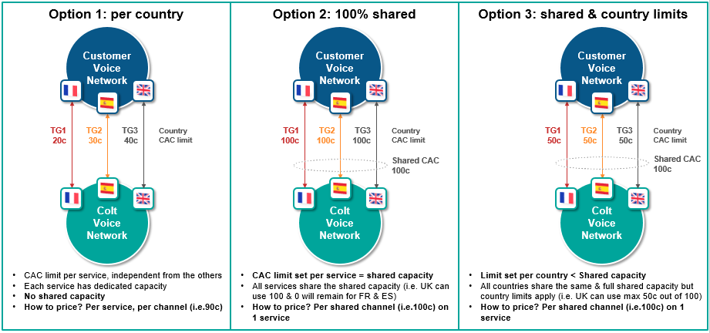

There is also a default call rate limit (CRL) of 10 call attempts per sec (CAPS), 5 in France.
When the call limit or CRL is exceeded on a trunk, the Colt SBC returns a Q.850 release cause 34 or SIP 503 service unavailable error response.
When the call limit is exceeded and resilient trunks are available, calls may overflow onto the other trunks, i.e. shared CAC is only supported for trunks hosted on the same Colt SBC (no POP resiliency).
The call rate limiting uses a token bucket policer which allows the call rate to temporarily burst above the defined limit. Only the calls that exceed the limit are dropped and there is no temporary lockout.
Please note that national/domestic calls which overflow to other country SIP trunks may be blocked as a result of national regulation. National/domestic calls should only be routed to the specific national/in-country SIP trunk(s) – see section 2.7.
Please note the zone B countries are out of scope of the pricing offer for options 2 & 3.

Concurrent Call Pool (CCP) – Shared CAC
Apart from call admission control, this feature will allow to configure combined CAC limit among the two or more Trunks configured in the same SBC. Shared pool CAC limit and individual CAC limit together will decides number of call allowed through the trunk. E.g Shared pool limit is assigned as 15, between two trunks and individual call limit is 10, then concurrent calls between two trunk will not exceed 15 and for single trunk there will not be more than 10 calls are permitted.

Tones & Announcements
Local Ring-Back tone
It is customer responsibility to provide local ring-back tone.
Colt is acting as a transit provider and consequently for calls towards the customer local ring-back tones to calling party has to be provided by the customer (or end-customer PBX) upon receipt of an alert indication without a media stream or without an indication of in-band tones e.g. 18x with no SDP.

SIP Response code for failed calls
Please refer to 3.7 SIP Response Codes .

Echo Cancellation
VoIP Gateways are equipped with ITU G.165 compliant echo cancellers. These are configured globally (cannot be adjusted per trunk) with an echo tail of 128ms.

Circular routing
All traffic, being sent from Colt to you, must be terminated within your network and not send back to Colt, unless it is call forwarding.

Call barring
Colt does not offer any call barring services per your end-customer individual request. There will be no CLI (per end-customer) related (un)blocking possible.

Access technologies

Overview
The figure below describes the high level network setup and IP addressing between the Colt VoIP POP and customer equipment.

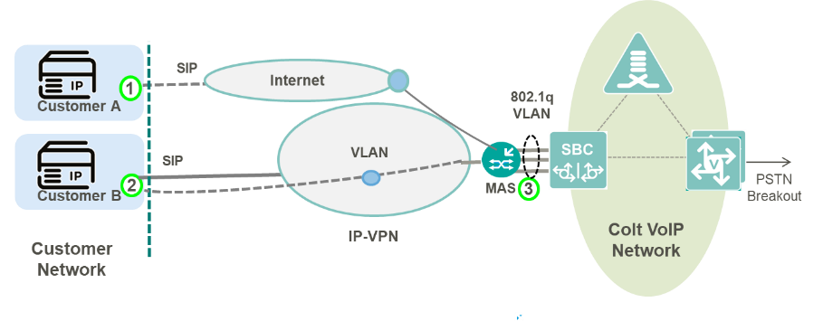

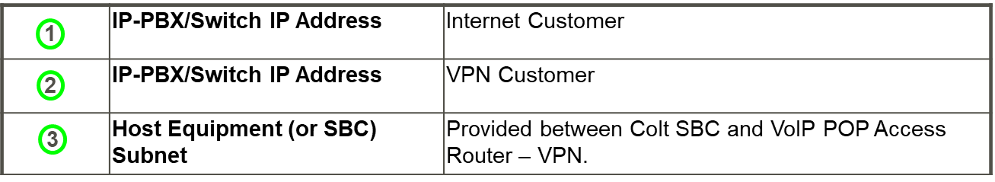
Wholesale SIP IP Addressing

For all types of access technology, the following IP address information is required to setup a Wholesale SIP trunk:
- IP-PBX/Switch IP Address - The host IP address that initial SIP Requests are sent to.
- IP-PBX/Switch IP Range - The host or subnet from which SIP requests/responses may originate in the customer network (often the same as IP-PBX IP Address).
Both of these addresses must be reachable from the Colt SBC i.e. routable over the Internet, IP-VPN.
Any subnets used to terminate RTP media e.g. phones, music-on-hold server, conference servers etc. must also be reachable from the Colt SBC. Additional IP addressing may be required depending on the access type used. These are described below.

Internet
Colt VoIP POPs are connected to the Colt Internet backbone and allows trunks to be established over the public Internet. A set of shared signalling and media public IP addresses are configured on each SBC and are reachable from the Internet.
Colt SBC IP Addressing
Each VoIP POP is configured with Public IPv4 subnet used for Internet connected trunks. Each SBC is configured one or more public SIP signalling and media IP addresses which are shared by all customers and trunks.
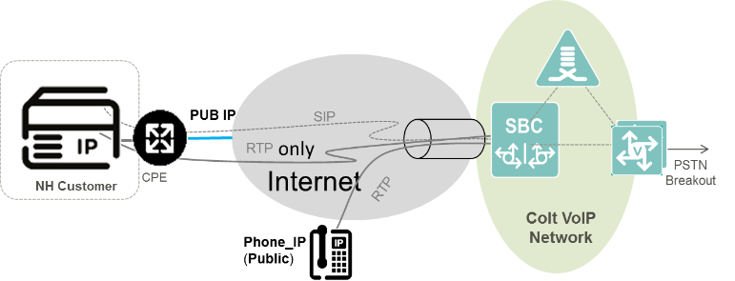
NAT Traversal
NH = Number Hosting/now known as Wholesale SIP

IP VPN
Connectivity to customers with IP VPN makes use of the MPLS enabled access switches in Colt VoIP POPs. The Customer IP VPN is terminated on the access switch and presented on a dedicated VLAN interface towards the SBC.
A Host Equipment Subnet is configured between the SBC and the access switch which hosts the SIP signalling and media addresses that the customer uses to connect to the VoIP POP from their VPN.

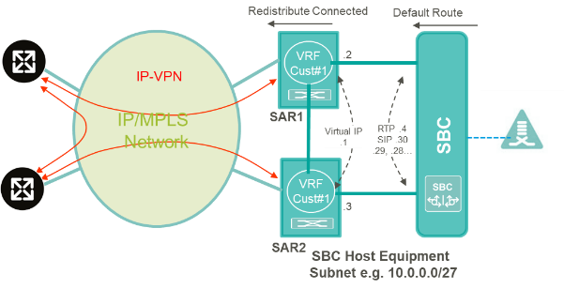
VoIP POP Configuration for IP-VPN
The Host Equipment Subnet is allocated a /27 IP Address range from the customer’s address space. This is typically an RFC1918 private address range that is routable from the customer a network. The subnet should be a /27 due to a design constraint on the Colt SBC.
- The one exception is where public IP addresses are used in which case there are no restrictions on the subnet mask.
- The design constraint requires that all (potentially) overlapping subnets (across different customers on the SBC) must use the same subnet mask. The subnet size has been standardized to /27 for this purpose.

If multiple trunks are required on the same SBC e.g. for resiliency or multi-country support, up to 26 trunks can be setup with separate SIP signalling IP addresses on the SBC sharing the same customer signalling IP address.
For each additional POP, or if more than 26 signalling IP addresses are required on the same POP, a separate /27 subnet is required.
SBC Host Equipment Subnet IP Address Allocation e.g. 10.0.0.0/27.
First Useable IP | SBC NEXT HOP | .1
Second Useable IP | RESERVED | .2
Third Useable IP | RESERVED | .3
Fourth Useable IP | SBC MEDIA / INTERFACE ADDRESS | .4
Last Non Broadcast IP N | 1st SBC SIP SIGNALLING ADDRESS | .30
N-n | nth SBC SIP SIGNALLING ADDRESS (1 ≤ n ≤ 26) | . (31-n)

Quality of Service
The Colt VoIP network supports Diffserv QoS marking for VoIP traffic. Voice payload is marked with DSCP 46 (EF) and signalling with DSCP 26 (AF31). This allows voice payload and signalling traffic priority over other kinds of traffic across the Colt IP backbone and customer access circuit. The DSCP markings correspond to the Premium and Business-1 Class of Service used with the existing COLT IP VPN product.

DSCP Markings
Class of Service | DSCP Marking (code point name) | IP VPN CoS Mapping
Premium (Voice) | 46 (EF) | Premium
Business-1 (Signaling) | 26 (AF31) | Business-1

Within the COLT IP network only markings from QoS enabled customers are trusted. All other traffic (Internet, Web, and Mail) is re-marked to DSCP 0 on ingress to the COLT IP network. Therefore, all Diffserv markings are trusted on ingress to the IMS PoP
For customers with Colt managed Internet Access, end-to-end QoS is provided across the Colt IP backbone using Diffserv markings applied by the Colt SBC and managed CPE. For Internet customers connected outside of the Colt IP backbone (via peering) traffic (e.g. VoIP over public Internet) is re-marked to DSCP 0 on ingress to the COLT IP network and no QoS is provided
For IP-VPN customers QoS is applied differently depending on whether the IP-VPN is dedicated for voice or used for both voice and data. For a dedicated service, the bandwidth delivered to each VPN site is dedicated to VoIP and there is no QoS applied on the access link. QoS marking is still applied and is used to prioritize traffic across the Colt IP backbone. If the IP-VPN is shared for data and voice, the bandwidth delivered to each site must be dimensioned according to the overall voice and data traffic. Class of Service must be applied on IP VPN sites to ensure voice traffic is prioritized and the appropriate bandwidth assigned to each QoS class.

Resiliency options

Overview
The options below describe how multiple SIP trunks can be connected to the same service e.g. for resiliency or multiple country trunks.
The resiliency options are mainly based on the type of Access Technology and load sharing type. For Dedicated access, IP-VPN is offered.
Below are the different resiliency options offered for Wholesale SIP:
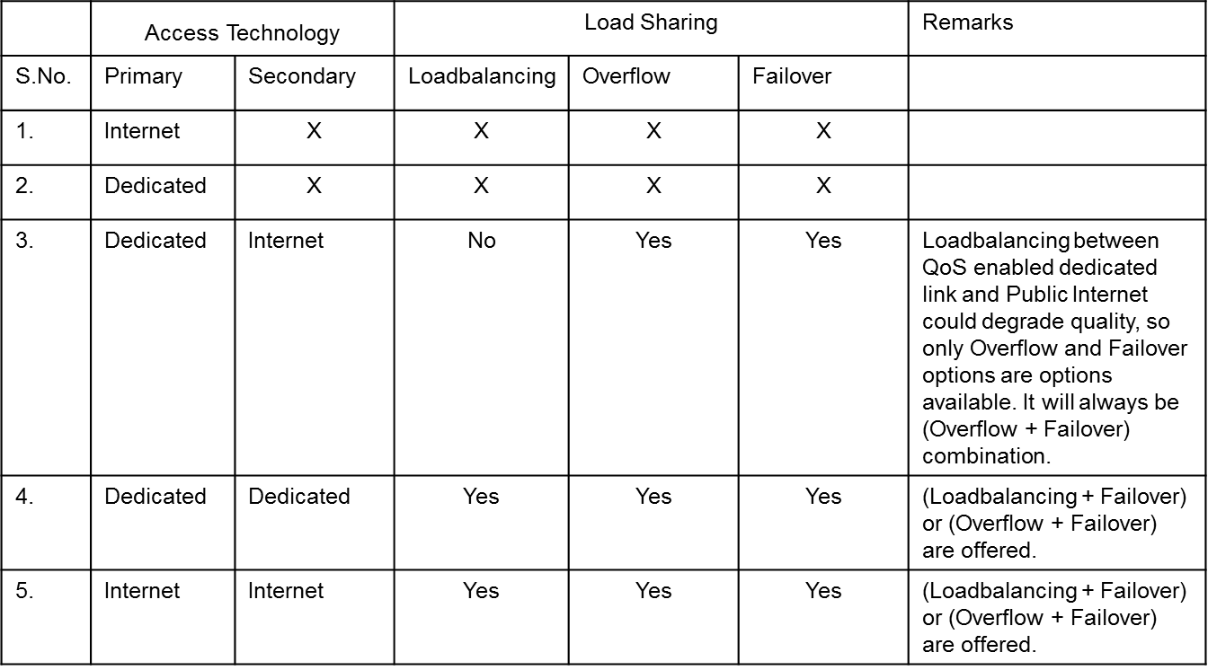
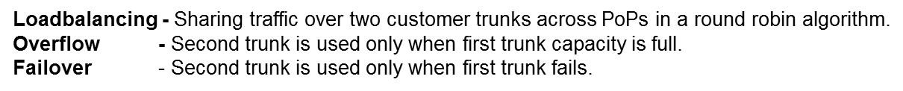
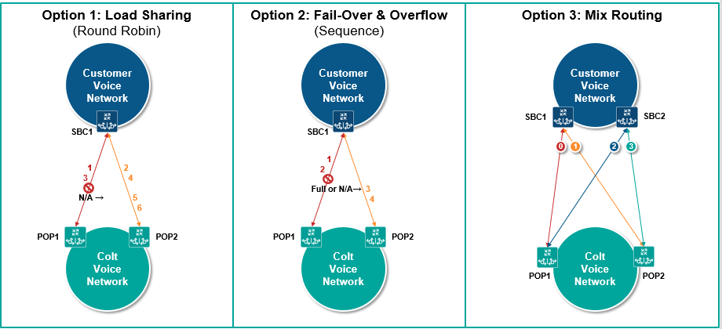

Access Options

Primary is Dedicated, Secondary is Internet
In this combination of connection type (primary-dedicated, secondary-internet), only (Overflow + Failover) could be offered. Load balancing between trunk over dedicated connection and public internet will provide no guaranteed QoS for every alternate call (i.e. all call over internet). So load balancing will not be part of standard service for this connection type.

CASE 1: Customer with single site
Two trunks will be configured for these types of connection.
- Trunk 1 will be configured between customer site 1 and IMS PoP A.
- Trunk 2 will be configured between customer site 1 and IMS PoP B.
Resiliency for the traffic flow from Customer site to IMS PoP is the responsibility of a customer. Colt will offer resiliency of trunk for calls from IMS PoP to customer site.

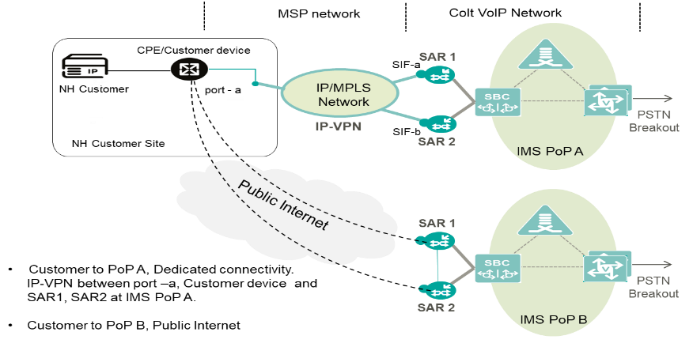
Primary dedicated and secondary public internet; customer single site

CASE 2: Customer with two sites
Two trunks will be configured for these types of connection.
- Trunk 1 will be configured between customer site 1 and IMS PoP A.
- Trunk 2 will be configured between customer site 2 and IMS PoP B.

It is the responsibility of customer to route traffic between the trunks. The transport such as dedicated connectivity or public internet will not allow a customer site to send Voice traffic to both the PoPs from each site. Site 1 will send traffic to PoP A and site 2 will send traffic to PoP B only. For all incoming calls to Colt, if customer needs overflow/failover between the PoPs then customer should do the voice routing across PoPs (A or B) at their end. But for all outgoing calls to customer from Colt, the overflow + failover functionality will be provided by Colt. In this case if trunk1 fails/overflows then trunk 2 will be used to send the call from Colt to customer.

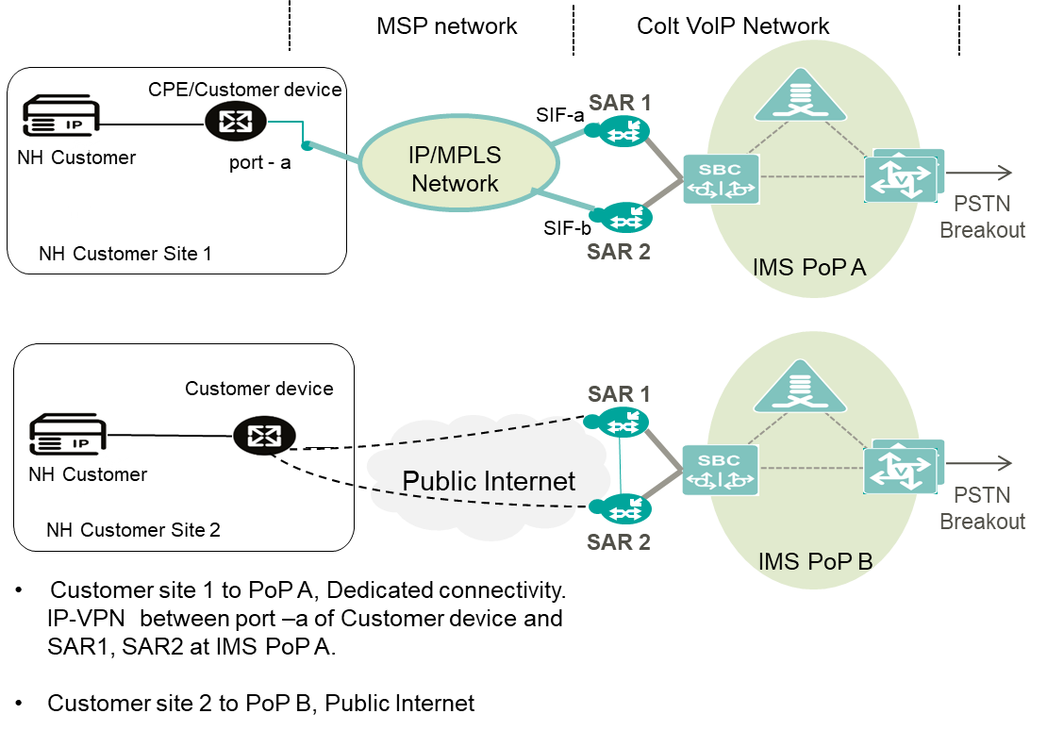
Primary dedicated and secondary public internet; customer with two sites

Primary Dedicated, Secondary Dedicated
If a customer is connected to two PoPs then two separate IP VPNs will be required. The reason for choosing two IP VPNs is to avoid bandwidth choking between Pes.
Resiliency for the traffic flow from Customer site to IMS PoP is the responsibility of a customer. Colt will offer resiliency of trunk for calls from IMS PoP to customer site.
(Overflow + Failover), (Load balancing + Failover) will be offered in this combination of connection type i.e. primary-dedicated, secondary-dedicated.

CASE 1: Customer with single site + PoP resiliency + 2 trunks
Two trunks will be configured for these types of connection.
- Trunk 1 will be configured between customer site 1 and IMS PoP A.
- Trunk 2 will be configured between customer site 1 and IMS PoP B.

Single/dual MSP CPE

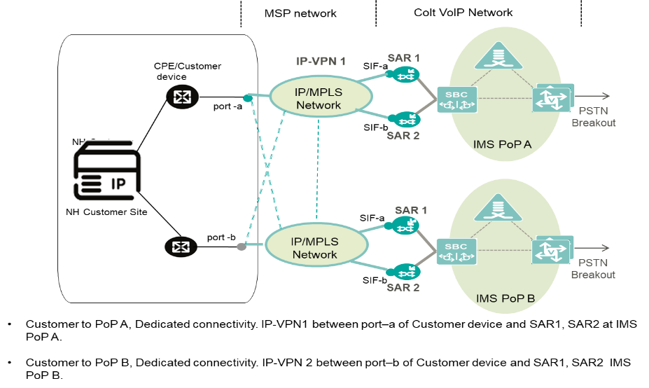
Primary/secondary dedicated; customer single site; single/dual MSP CPE

CASE 2: Customer with 2 sites + PoP resiliency + 2 trunks
Two trunks will be configured for these types of connection.
- Trunk 1 will be configured between customer site 1 and IMS PoP A.
- Trunk 2 will be configured between customer site 2 and IMS PoP B.

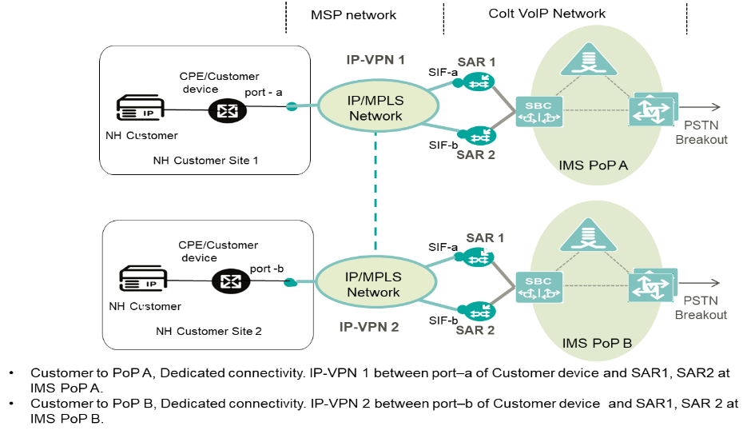
Primary dedicated, secondary dedicated; 2 customer sites; 1 MSP CPE at each site, 2 trunks.

CASE 3: Customer with 2 sites + PoP resiliency + 4 trunks
Four trunks will be configured for these types of connection.
- Trunk 1 will be configured between customer site 1 and IMS PoP A.
- Trunk 2 will be configured between customer site 1 and IMS PoP B.
- Trunk 3 will be configured between customer site 2 and IMS PoP B.
- Trunk 4 will be configured between customer site 2 and IMS PoP A.
Single MSP L2 CPE at each site

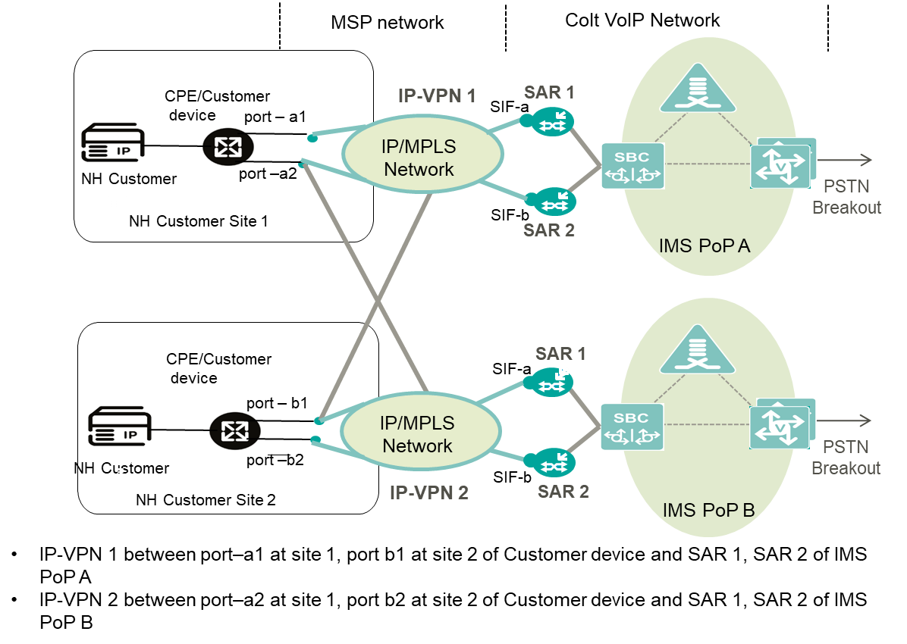
Primary- secondary dedicated; 2 sites; 1 MSP CPE at each site; 4 trunks

Primary Internet, Secondary Internet
Trunk configuration will be same for CASE1 and CASE2.
Two trunks will be configured for these types of connection:
- Trunk 1 will be configured between customer site 1 and IMS PoP A.
- Trunk 2 will be configured between customer site 1 and IMS PoP B.

Resiliency for the traffic flow from Customer site to IMS PoP is the responsibility of a customer. Colt will offer resiliency of trunk for calls from IMS PoP to customer site.
Overflow, load balancing and Failover will be offered in this combination of connection type i.e. primary-internet, secondary-internet.

CASE 1: Customer with single site
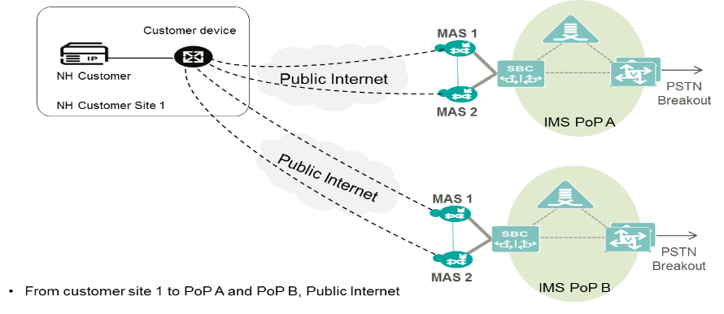
Primary internet and secondary internet; 2 trunks; 1 site

CASE 2: Customer with two sites
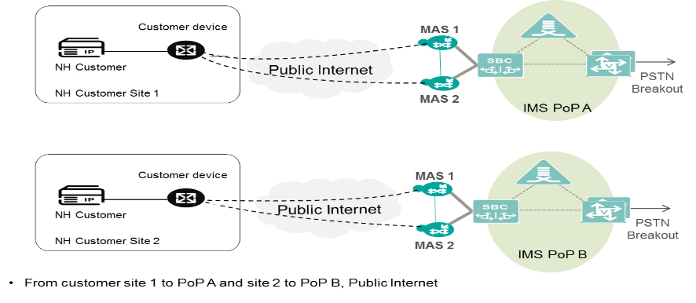
Primary internet and secondary internet; 2 trunks; 2 sites

Trunk Resiliency
Trunk resiliency secures communication against any failure between the customer IP-PBX and Colt SBC. Resilient trunks can also be used for load sharing across multiple SIP peers. One primary trunk can have maximum up to 26 secondary or resilient trunks.
Any of the trunk topologies described in the previous section can be used to provide resiliency or load sharing. For geographic redundancy, secondary trunks can be built on a separate SBC and POP.

Call Routing
Outgoing Call Distribution (Customer to Colt)
For outgoing calls, resilient trunks operate in active/active configuration – calls can be sent to any trunk. The customer decides the outgoing call distribution.
Incoming Call Distribution (Colt to Customer)
For incoming calls, resilient trunks can operate as follows:
- Active/Standby - In this method a sequential route selection is used. Calls will first be attempted on the primary or active trunk. In the event of primary trunk is unreachable (no response to SIP Invite or TCP timer expiry) or the number of calls exceeds the call limit set, calls will be attempted on the next available secondary (or standby) trunk.
- Load share - In this method round-robin route selection is used routing call which results in 50:50 load-share across available trunks. Therefore, it is also called as load sharing. Whenever trunk exceeds call limit set or unreachable will be put off from selection till it restored to normal.

Trunk Out of Service and Recovery Methods
Resilient trunks make use of the following failure detection and recovery mechanism.

Failure Detection
1st Call (Failure Detected): The Colt SBC attempts call on Trunk 1. When the SIP INVITE transaction or TCP connection timer expires the SBC attempts the call on Trunk 2. An additional PDD is incurred. The SBC blacklists the endpoint ip address belonging to Trunk 1.
Subsequent Calls: SBC attempts call on Trunk 2, no additional PDD.
The following timers are configured:
- SIP-UDP: INVITE retry timer expires – 1.5s (1 retry)
- SIP-TCP: TCP Timeout – 5 Secs
Failure detection using SIP OPTIONs ping is also possible as bespoke configuration.

Recovery Mechanism
Two types of recovery methods are supported a) timer based b) SIP OPTION ping.
When a trunk endpoint is blacklisted a recovery timer is used to determine when the endpoint can be removed from the black list. The recovery timer is set to 180sec (3mins)
After the recovery timer expires calls are attempted again on Trunk 1.
An alternative recovery algorithm is available which uses a SIP OPTION Ping. When an endpoint is blacklisted, the SBC sends a SIP OPTION message every 3s. As soon as the endpoint responds with 200 OK, trunk will be put back into in-service.

Emergency Service Numbers & Short Number calls

Colt Wholesale SIP supports calls to Emergency Service access numbers. Call routing might require special digit translation rules before terminating the call.
Colt Wholesale SIP supports calls to short code access numbers. These numbers are significantly shorter than full telephone numbers and usually associated with special services (enquiry, social help etc.).
In all countries, the supported format is +CC [Dialled Emergency number or short code]

List of supported numbers

Please refer to our website to view the list of Emergency Service Numbers and Short code access numbers by country: NGN SPECIAL NUMBER PRICING | Colt Docs

Emergency calls service is supported only for CLIs hosted on Wholesale SIP. All forwarded Emergency calls are blocked.
Short numbers call service is supported only for CLIs hosted on Wholesale SIP.
Your responsibility remains to optimize the dialled digits by your end-customers, into international format.

Emergency Call Routing (ECR)

Colt supports emergency calls in all countries. The processing on the network depends on national regulation. In each country, legal and/or regulatory requirements stipulate the manner in which a telephone call from a given end-customer to an emergency services number should be routed.
Emergency call routing based on ELIN is not applicable / supported in our country footprint.
Correct ECR can only be supported for known CLIs, i.e., new Colt CLIs activated/ported in for you or your own numbers hosted by Colt. It is also essential that you send national emergency calls on the correct national country trunk.
Once Colt collects emergency calls from you, Colt must deliver these calls in a specific number format, respecting the legal & regulatory requirements.

Emergency call processing is split into 3 different groups:
- Centralized, meaning all calls will be routed to the same Emergency service.
- LAC based, meaning calls will be routed to the Emergency service based on the LAC/first digits of telephone number.
- Location based, meaning calls will be routed to the Emergency service based on the end-customer’s address.
Please find below overview of the availability per country:
Country | Routing
Austria | LAC based (nomadic/personal numbers )
Belgium | Location based
Czech Republic | Location based
Denmark | Location based
Finland | Location based
France | Location based
Germany | Location based
Luxembourg | Centralized
Ireland | Centralized
Italy | LAC based
Netherlands | LAC based
Norway | Location based
Poland | Location based
Portugal | LAC based
Romania | Location based
Slovakia | Location based
Spain | Location based
Sweden | Location based
Switzerland | Location based
United Kingdom | Centralized

It remains the customer’s responsibility regarding calls to Emergency Services to:
- Keep accurate and up to date end-customer information.
- Optimize the digits dialled from your end-customer into international format.

Germany
We insert the end-customer’s address in the SIP header of the emergency call and the PSAPs can then retrieve the address from the SIP header.
According to latest TR-Notruf the customer can send a geolocation header containing location information, which Colt transparently forwards to the emergency call centre. The current version of the Specification of the NGN Interconnection Interface of UAK-S/AKNN must be observed.
Details are described in Appendix A.

Switzerland & Portugal
We insert the end-customer’s address in the SIP header of the emergency call and the PSAPs can then retrieve the address from the SIP header. The address cannot be sent dynamically by the Wholesale SIP customer but will be inserted by Colt based on the address captured for the CLI in the original number activation or port-in order and held in our database.

VoIP Performance Reporting

Colt offers you its VoIP Online Performance Reporting tool to track your VoIP and data KPIs.
IP Statistics  Colt provided connectivity only (IP VPN) | VoIP Statistics
- Network performance.  - Jitter network performance:  - Reachability  - Packet loss  - MOS (calculated on IP statistics between customer CPE and Colt VoIP backbone). | - Answer seizure ratio, network efficiency ratio.  - Answered calls, unanswered calls, and failed calls.  - Mean conversation time, mean holding time per seizure, total conversation time.  - Data measured per trunk group or destination
VoIP Online Performance Reporting tool is an optional and chargeable option. For more information, please contact your Account Executive.

Glossary
Term | Description
AT | Austria country
B2B | Business to Business
BE | Belgium country
CC | Country Code (SIP trunking related)
CdPN | Called Party Number or ‘B’ Number (SIP trunking related)
CDR | Call Detail Record
CgPN | Calling Party Number or ‘A’ Number (SIP trunking related)
CH | Switzerland country
CLI | Calling Line Identification (SIP trunking related)
CLIP | Calling Line Identification Presentation (or Caller ID) (SIP trunking related)
CLIR | Calling Line Identification Restriction (SIP trunking related)
Colt Online | Colt Web-based portal to manage your services.
CPS | Call per Second (SIP trunking related)
DE | Germany country
DK | Denmark country
DN | Default Number (SIP trunking related)
ES | Spain country
FCC | Federal Communications Commission (US Regulatory Authority)
FQDN | Fully Qualified Domain name (SIP trunking related)
FR | France country
FTP | File Transfer Protocol
GB | Great Britain (United Kingdom / UK) country
GN | Generic Number (ISUP) (SIP trunking related)
GNP | Geographic Number Portability
HTML | Hyper Text Markup Language
HTTP | Hypertext Transfer Protocol
HTTPS | Hypertext Transfer Protocol Secure
ICR | Inbound Call Re-Routing (Product Feature) (SIP trunking related)
IE | Ireland country
IT | Italy country
LAC | Local Area Code
LOA | Letter of Authorization
MAN | APNF’s CLI authentication platform in France
MGW | Media Gateway (SIP trunking related)
NAT | Network Address Translation (SIP trunking related)
NL | The Netherlands
NOA | Nature of Address (SIP trunking related)
NP | Network Provided (Screening) (SIP trunking related)
NSN | National Significant Number (SIP trunking related)
OOH | Out of Office
PAI | P-Asserted-Identity header field used in SIP signalling (SIP trunking related)
PANI | P-Access-Network-Info SIP Header
PDD | Post Dial Delay (SIP trunking related)
PI | Presentation Indicator (ISUP) (SIP trunking related)
PN | Presentation Number (SIP trunking related)
PNR | Partial Number Replacement (Product Feature) (SIP trunking related)
PoP | Point of Presentation (SIP trunking related)
PPI | P-Preferred-Identity (SIP) (SIP trunking related)
PT | Portugal country
PTT | Public Telegraph Telephony [operator]: Any fixed-line network operator but typically the major incumbent operator within the country,
RDN | Redirecting Number (SIP trunking related)
RPI | Remote Party Id (SIP) (SIP trunking related)
RMD | Robocall Mitigation Database (owned by US FCC)
SBC | Session Border Controller (SIP trunking related)
SDES | Secure Descriptions (SIP trunking related)
SE | Sweden
SI | Screening Indicator (ISUP) (SIP trunking related)
SIP | Session Initiation Protocol (SIP trunking related)
SMTP | Simple Mail Transfer Protocol
SRTP | Secure Real Time Protocol (SIP trunking related)
Surrendering (Donor) Carrier | The carrier being requested to port the numbers to Colt.
TLS | Transport Layer Security (SIP trunking related)
TN | Telephone Number
Trunk | Logical entity used for VoIP signalling and media, defined between a unique pair of IP addresses on the Colt SBC and Customer VoIP platform
Trunkgroup | A group of trunks that share the same DDI number ranges and typically used for resiliency
URL | Uniform Resource Locator
VPN | Virtual Private Network

Appendix A: Germany: user-provided geolocation header

According to TR-Notruf 2.0 section 7.1.5, the customer can send a geolocation header containing location information, which Colt transparently forwards to the emergency call centre. The current version of the Specification of the NGN Interconnection Interface of UAK-S/AKNN must be observed.
The following requirements must be met:
- The total length of the header, including the associated message body, must not exceed 2000 characters.
- The parameter `loc-src` must not be used.
- The header `Content-Disposition: by-reference; handling=optional` must be present in the message body.
Transmission of location information is intended only for emergency calls. Colt has no influence on the end-to-end transmission for other use cases. The location information can only be received and interpreted by IP-based emergency call centres.
The location information can be transmitted as geographic coordinates or as a postal address/civic address, as described below and shown in the following examples.
COLT propose to use the “postal address”.
Known constraints
- The “postal address” format has been tested with the Berlin PSAP only.
- Colt cannot guarantee that it will work with all 400 German PSAPs.
- This is supported on a best endeavours basis, as the visibility of user-provided data depends on the application / software in use by the PSAP..Colt cannot guarantee that the examples are error-free.

A.1 Geographic coordinates:
The SIP Geolocation header field can also be used to transmit a geographic location. The Geography Markup Language (GML), which is an application of XML, is used. According to clause N4.3.3 of TR-Notruf [uaks-28], one of the following geographic location formats as defined in Table 1 shall be used.
Table 1: Encoding of a Geographic Location
Geographic Location Format |  | Reference clause / annex in
ETF RFC 5491  [uaks-17] | TR-Notruf [uaks-28] | IETF RFC 5491  [uaks-17] | Spec UAKS NGN  Ici Interface V5.0.0
Point | Geographische Koordinate  Geographic coordinate | 5.2.1 | 14.3.2.3.1
Ellipse | Geographische Koordinate mit Unsicherheitsellipse  Geographic coordinate with uncertainty ellipse | 5.2.4 | 14.3.2.3.2
Polygon | Polygon | 5.2.2 | 14.3.2.3.3
Arc Band | Gebiet mittels Kreisringsegment  Area defined by a circular ring segment | 5.2.5 | 14.3.2.3.4
n/a | Beschreibung der Funkzelle  Description of the mobile Cell | n/a | n/a

As per clause 5.2.3.1.3 of TR-Notruf [uaks-28] the European Terrestrial Reference System 1989 (ETRS89) should be used as the coordinate reference system. The coordinate is identified using the European Petroleum Survey Group (EPSG) Geodetic Parameter Dataset, as formalized by the following Open Geospatial Consortium (OGC)
URNs:
- 2D: ETRS89 (latitude, longitude), as identified by the URN urn:ogc:def:crs:EPSG::4258. This is a two-dimensional coordinate reference system.
- 3D: ETRS89 (latitude, longitude, altitude), as identified by the URN urn:ogc:def:crs:EPSG::4937. This is a three-dimensional coordinate reference system.
It is important to ensure the accuracy - In total 8 digits (which is the sum of the number of digits before and after the decimal point) for both latitude and longitude.
A description and an encoding example for each of these different formats are given in the following subclauses. Requirements on how to transmit a Mobile Radio Cell Identification and a Confidence value (which can both be used independently of the actual geographic location format) can be found in subclauses 14.3.2.3.6 and 0.

Example of geographic coordinates:

Geolocation: <cid:emergency_call_location@test-customer.de>
Content-Type: application/pidf+xml
Content-Disposition: by-reference; handling=optional
Content-ID: <cid:emergency_call_location@test-customer.de>
<?xml version="1.0" encoding="UTF-8" standalone="no"?>
<presence xmlns="urn:ietf:params:xml:ns:pidf" xmlns:cl="urn:ietf:params:xml:ns:pidf:geopriv10:civicAddr" xmlns:gp="urn:ietf:params:xml:ns:pidf:geopriv10" entity="pres:+492112222@test-customer.de">
<tuple id="2112222_2020-01-01T10:59:49883CET">
<status>
<gp:geopriv>
<gp:location-info>
<gml:Point xmlns:gml=http://www.opengis.net/gml srsName="urn:ogc:def:crs:EPSG::4258">
<gml:pos>48.1234567 11. 1234567</gml:pos>
</gml:Point>
</gp:location-info>
<gp:usage-rules>
<gbp:retransmission-allowed xmlns:gbp="urn:ietf:params:xml:ns:pidf:geopriv10">yes</gbp:retransmission-allowed>
<gbp:retention-expiry xmlns:gbp="urn:ietf:params:xml:ns:pidf:geopriv10">2020-01-01T11:51:02147CEST</gbp:retention-expiry>
</gp:usage-rules>
</gp:geopriv>
</status>
<timestamp>2020-01-01T10:59:49883CET</timestamp>
</tuple></presence>
Please note:
It is important to have the Content-ID in < >
An example of a Content-ID: cid:emergency_call_location@test-customer.de

A.2: Postal address / civic location
For emergency calls the only mandatory location information elements for a civic location are Country, A1 (State) and A3 (Town Name). Any further location information needed to fully describe the civic location should also be transmitted in the corresponding PIDF-LO Element. The encoding is described in Table 3 and is based on IETF RFC 4119 [uaks-22] and IETF RFC 5139 [uaks-16].
UTF-8 encoding should be used with a Unicode character set that includes Basic Latin (US ASCII repertoire) and the Latin-1 Supplement that is Unicode code points U+0000 – U+00FF, and the Latin Extended-A Supplement that is Unicode code point U+0100 – U+017F. This means that special characters (e.g. German umlauts) should be encoded according to UTF-8 encoding.
If the address database contains special German characters in a converted format (e.g. oe, ue, ae, ss, sz) this format should be transmitted unchanged.
Note that UTF-8 requires a 2-byte encoding of Unicode code points U+0080 – U+00FF.
The following Table shows the encoding of the special German characters.

Table 2: Encoding of German Characters
Character | Unicode | UTF-8 | Octal
Ä | U+00C4 | C3 84 | 303 204
ä | U+00E4 | C3 A4 | 303 244
Ö | U+00D6 | C3 96 | 303 226
ö | U+00F6 | C3 B6 | 303 266
Ü | U+00DC | C3 9C | 303 234
ü | U+00FC | C3 BC | 303 274
ß | U+00DF | C3 9F | 303 237

Table 3: PIDF-LO Encoding of a Civic Location
PIDF-LO Element | Content | Example | Data-Type | Value Range | Parameter  type
Country | Land (Note 1)  Country | DE | UTF-8 string | DE | m
A1 | Bundesland (Note 2)  federal state/province | BB | UTF-8 string | 2 letters  A-Z | m
A2 | Landkreisname  rural district / county | Märkisch-Oderland | UTF-8 string |  | c1
A3 | Gemeindename  Municipality | Hoppegarten | UTF-8 string |  | m
A4 | Ortsteilname  district/quarter | Hönow | UTF-8 string |  | c1
A5  Public network provider only | Amtlicher Gemeindeschlüssel Notruf (AGS N)  offical emergency municipality-id | 06 4 11 000a | UTF-8 string |  | c1
A6 or  RD | Straßenname ohne Zusatz  Street name without addendum | Brandenburgische | UTF-8 string |  | c1
STS | Zusatz zu Straßenname  street-name addendum | Str | UTF-8 string |  | c1
HNO | Hausnummer  house-number | 158 | Integer | 1 to 4 digits  0 - 9 | c1
HNS | Hausnummer Zusatz  house-number extension | -162 | UTF-8 string |  | c1
PC | Postleitzahl  postal code | 15366 | Integer | 5 digits  0-9 | c1
FLR | Stockwerk  Floor | 3 | UTF-8 string |  | c1
UNIT | Einheit  Unit | D1 | UTF-8 string |  | c1
ROOM | Raumnummer  room-number | 3.D1.14 | UTF-8 string |  | c1
BLD | Gebäude  building |  | UTF-8 string |  | c1
LMK | Name des Unternehmens  Company-name | Deutsche Seniorenstift | UTF-8 string |  | c1
LOC | Zusätzliche Informationen  additiona information | Pflegewohnstift Hönow | UTF-8 string |  | c1
c1: IF corresponding data for the respective PIDF-LO element is needed to fully describe the civic location, THEN m, ELSE n/a
Note 1: Country according to ISO 3166-1 ALPHA 2 norm
Note 2: State according to the last two letters of the ISO 3166-2:DE norm
Example for a civic location
Geolocation: <cid:emerg@test-customer.de>
Content-Disposition: by-reference; handling=optional
Content-ID: <emerg@test-customer.de>
Content-Type: application/pidf+xml
<?xml version="1.0" encoding="UTF-8"?>
<presence xmlns="urn:ietf:params:xml:ns:pidf" xmlns:gp="urn:ietf:params:xml:ns:pidf:geopriv10" xmlns:cl="urn:ietf:params:xml:ns:pidf:geopriv10:civicAddr" entity="pres:69667736450@test-customer.de">
<tuple id="teaaab606">
<status>
<gp:geopriv>
<gp:location-info>
<cl:civicAddress xml:lang="de">
<cl:country>DE</cl:country>
<cl:A1>BE</cl:A1>
<cl:A3>Berlin</cl:A3>
<cl:A6>Uhlandstrasse</cl:A6>
<cl:HNO>181</cl:HNO>
<cl:HNS>-183</cl:HNS>
<cl:PC>10623</cl:PC>
</cl:civicAddress></gp:location-info>
<gp:usage-rules/></gp:geopriv>
</status>
<timestamp>2026-05-05T06:13:30Z</timestamp>
</tuple>
</presence>
Please note:
It is important to have the Content-ID in < >
An example of a Content-ID: <emerg@test-customer.de>

A.3 References (as of July 2026)

German Interconnections spec:
https://www.aknn.de/oeffentliche-dokumente/uak-s/
https://www.aknn.de/fileadmin/uploads/oeffentlich/Spec_UAKS_NGN_Ici_Interface_V_5_0_0.pdf
section 14.3

Emergency call guide:
https://www.bundesnetzagentur.de/DE/Fachthemen/Telekommunikation/Unternehmenspflichten/Notruf/TechnischeRichtlinie/artikel.html?nn=697798
https://www.bundesnetzagentur.de/DE/Fachthemen/Telekommunikation/Unternehmenspflichten/Notruf/_DL/TR_%20Notruf2_1.pdf
section 7.1.5

Call will be re-routed to an alternate SIP trunk if available
Specific to STIR/SHAKEN (CLI Authentication France)
Call originated from Location Independent Number is routed to a default central location
Nomadic (0720) and personal numbers (050,0517,057,059): Colt set default LAC 01 (Vienna). Wholesale SIP customer may send emergency calls to Colt in the format +43 <LAC>-<emergency number>, with the LAC corresponding to the location of the caller.

